
Where smart sleep meets effortless style: Introducing CoZee® Sense
A first-of-Its-kind bedside crib that soothes baby back to sleep
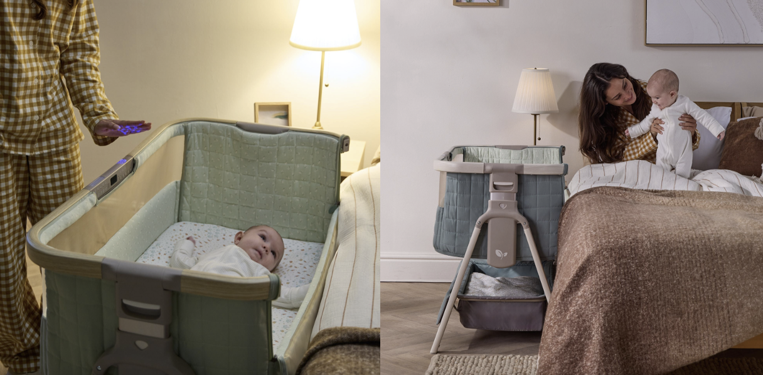

Tutti Bambini unveils the CoZee® Sense Bedside Crib - a first-of-its-kind sleep solution that combines smart sensory technology with effortless, contemporary style. Designed to help soothe babies back to sleep while keeping them safely by your side, CoZee Sense pairs trusted bedside co-sleeping functionality with an innovative, fully detachable Sensory Bar that brings light, sound and comfort together in one beautifully considered design.
The early weeks with a newborn are precious and often exhausting. CoZee Sense has been thoughtfully created to support families from day one, blending intelligent innovation with premium comfort to help make night-times feel calmer and more manageable for everyone.
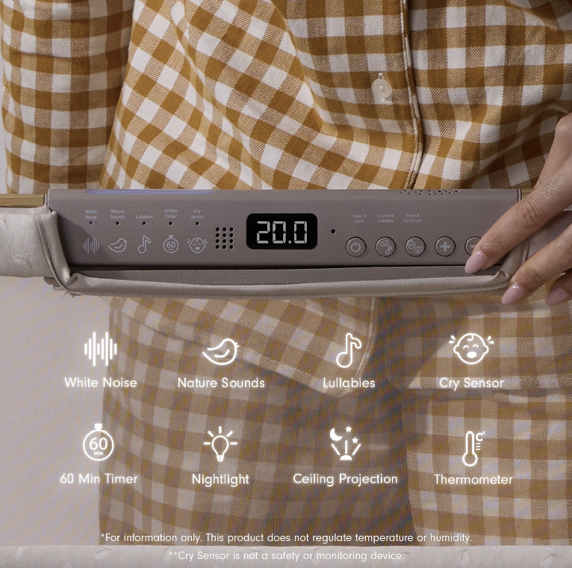

At the heart of CoZee® Sense is its integrated Sensory Bar, an all-in-one calming system designed to create a reassuring, womb-like atmosphere. Gentle ceiling projections, a soft nightlight and a curated selection of white noise, nature sounds and lullabies work together to help little ones drift off more peacefully.

What truly sets it apart, however, is the built-in Cry Sensor. Cleverly designed to listen for baby’s sounds, it automatically reactivates the last selected light and audio settings if crying is detected - restoring familiar cues without parents needing to leave their bed. It’s a small yet powerful innovation, offering reassurance in those half-awake early hours.
A 60-minute timer allows bedtime routines to run quietly in the background, while an integrated room thermometer helps parents keep a watchful eye on the sleep environment with ease. And because the Sensory Bar is fully detachable, the same comforting combination of light and sound can move with baby as they transition into their next sleep space, maintaining comforting consistency beyond the bedside crib stage.
Alongside its sensory innovation, CoZee Sense delivers the premium detailing parents have come to expect from Tutti Bambini. Luxurious quilted fabrics create a soft and cocooning feel, while double breathable mesh panels promote optimal airflow and visibility. Additional side barrier ventilation holes further enhance breathability - an essential feature for newborns who are unable to reposition themselves independently during sleep. A super-soft bamboo jersey mattress cover completes the sleep space, offering gentle comfort night after night.
The result is a crib that feels as reassuring as it looks – cosy yet carefully considered.
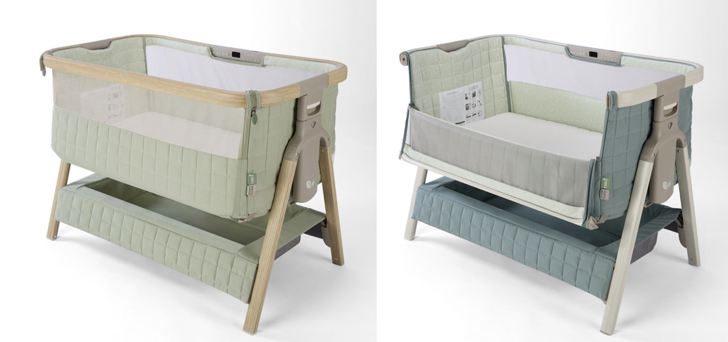

Understanding the realities of life with a newborn, CoZee Sense has been engineered with ease at its core. A 30-second open-fold mechanism makes assembly refreshingly simple, while six adjustable height positions ensure compatibility with most adult beds. An incline function provides gentle support for babies experiencing reflux or congestion, helping to ease discomfort during sleep. A deeper under-crib storage tray keeps night-time essentials close to hand, simplifying feeds and changes in the small hours.

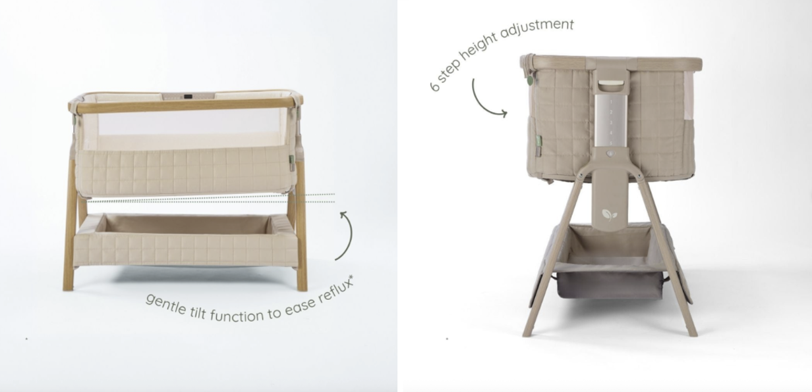

For families visiting grandparents or heading away for a short break, the crib folds flat and comes complete with a travel bag, making it easy to recreate a familiar sleep environment wherever you are.
Available in four contemporary colourways: Toasted Oak / Sand, Drifted Oak / Eucalyptus, Whitewash / Kelp, and Soft Walnut / Cocoa - CoZee Sense has been designed to complement modern interiors as seamlessly as it supports modern parenting.
By combining first-of-its-kind sensory innovation with breathable comfort and refined design, the CoZee Sense Bedside Crib offers a beautifully balanced solution for families seeking closeness, calm and effortless style from the very first night.
For further information and to get one now, visit www.tuttibambini.com
- ENDS -
For PR requests, images and further information contact:
- Kelly Jones, Cake PR Kelly@cakepr.co.uk
- Chloe Bailey, Cake PR, chloe@cakepr.co.uk
- Emilia Fuller, Cake PR, emilia@cakepr.co.uk

