

IS YOUR OVEN A HIDDEN HEALTH HAZARD? EXPERT REVEALS HOW OFTEN YOU SHOULD CLEAN IT
- Leading appliance manufacturer highlights the importance of regular oven maintenance for safety, efficiency, and better-tasting food
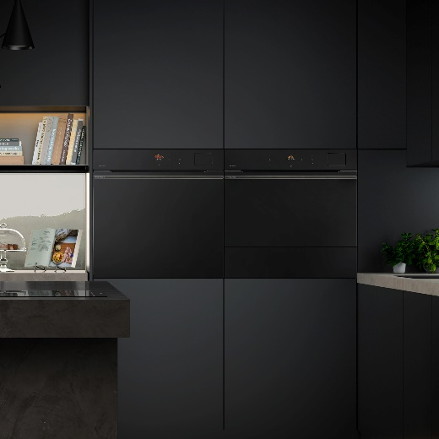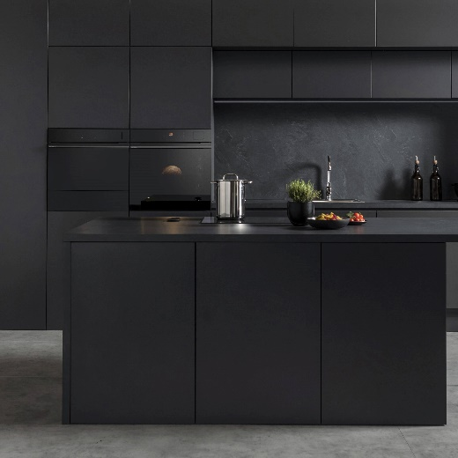
Having a clean home is a priority for most, but when was the last time you gave your oven a thorough clean? While it’s easy to overlook, regular oven maintenance is essential, not just for aesthetics, but for safety, efficiency, and even food quality.
According to Chloe Blanchfield, Product Marketing Manager at Hisense UK, a well-maintained oven ensures optimal performance and can significantly extend its lifespan.
“Ovens should be deep cleaned every three to six months, depending on how frequently they’re being used,” says Chloe. “If you cook daily or prepare a lot of roast dinners, you may need to clean it more often. Neglecting regular cleaning can lead to grease buildup, unpleasant odours, and even impact the way your food tastes.”

The Risks of a Dirty Oven
“A common misconception is that a dirty oven is simply unsightly,” says Chloe. “In reality, built-up of grease and food residue can be a fire hazard and make your oven less efficient, leading to uneven cooking and higher energy consumption. Worse still, lingering grease and grime can transfer unwanted flavours to your food.”

How to Keep Your Oven in Top Condition
Cleaning your oven may seem like a daunting task, but with the right approach, it doesn’t have to be. Chloe shares her expert tips to help homeowners keep their ovens in tip top condition:
- Tackle spills immediately – Wipe down the oven as soon as it has cooled to prevent food and grease from hardening. Pay special attention to sugar-based spills, as they can cause permanent damage and would require excess scrubbing.
- Deep clean regularly – Remove oven racks and trays for a thorough scrub using a non-abrasive cleaner. Cleaning the oven door, especially around the seal, will help keep the heat inside the oven and maintain energy efficiency.
- Choose the right cleaning tools – Avoid steel wool and rough scouring pads, which can scratch the surface. Instead, opt for soft microfibre cloths, non-abrasive sponges, or plastic scrapers to remove residue safely.
- Keep it dry – Moisture buildup can lead to mould and mildew, so always dry the inside of your oven thoroughly after cleaning.

The Rise of Self-Cleaning Ovens
Many homeowners are turning to technology for an easier cleaning solution. Google Trends reports a 130% surge in searches for “self-cleaning double oven” in the past month alone.
“If your oven comes with a self-cleaning function, take advantage of it,” advises Chloe. “The Hisense Hi8 BlackLine oven features a pyrolytic self-cleaning function, which heats the oven to an extremely high temperature to burn away grease and food residue, reducing it to ash that can be easily wiped away. We recommend giving the inner glass a wipe down to remove any build up of grease before using the pyrolytic function as this will eliminate the risk of burning the grease while the setting is active.”
“For an even more effortless solution, the Hisense Hi8 BlackLine oven range also has a model which offers a steam-cleaning feature. Simply place a baking tray filled with water in the oven, select the ‘Steam Clean’ option, and let the steam loosen stubborn grease in just 30 minutes. Once cool, a quick wipe-down is all that’s needed.”

Cleaning your oven isn’t just about keeping it looking spotless, it’s about ensuring it operates at peak performance.
“The key to prolonging your oven’s lifespan is regular maintenance,” says Chloe. “Small, consistent cleaning habits can prevent costly repairs and replacements, ensuring your oven remains efficient, safe, and ready to cook delicious meals for years to come.”
For more information about Hisense’s cooking range, visit: https://uk.hisense.com/products/cooking-and-baking/c/hisensecook00.

ENDS
For more information, please contact the Hisense UK team at Hatch: hisense@hatch.group / 0113 361 3600.
About Hisense
Founded over 50 years ago in China in 1969, Hisense is a leading global home appliance and consumer electronics brand and was Official Partner of the UEFA EURO 2024™, following on from past tournament sponsorship in 2016 and 2020, and a successful sponsorship of FIFA World Cup 2022™.
Hisense UK is headquartered in Leeds. The brand has a core range of televisions and cooling appliances, alongside a portfolio of cooking and laundry products, featuring hobs, hoods, ovens, dishwashers and washing machines.
According to Omdia, Hisense ranked No. 2 globally for TV shipments and No. 1 in 100" TVs in both 2023 and Q1 2024. The company has expanded quickly to operate in more than 160 countries and specialises in multi-media goods, home appliances, and intelligent IT information. Hisense continuously invests in research and development and has over 100,000 employees worldwide. For more information visit https://uk.hisense.com/

