Disney 100 Capsules
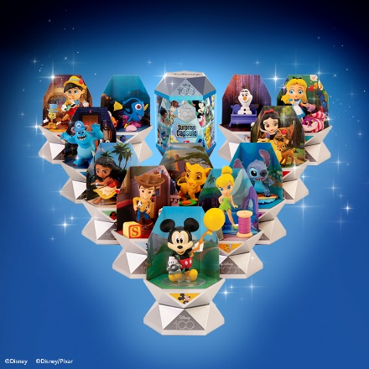
The Disney 100 anniversary is well and truly here! On October 16th 2023 we celebrate the wonderful world of Disney, and KAP Toys have just the product to enjoy this magical Disney moment in the run up to Christmas.
The Disney 100 capsules have successfully launched in the market. TV advertised and supported with incredible PR, securing a ‘This Morning!’ feature and top trend of 2023 status.
These spectacular magical capsules offer a brand-new way to unbox and collect many of the beloved Disney characters, from across the years. A perfect gift for any Disney fans - young or old!
Each silver hexagonal prism shaped capsule is wrapped in spectacular Disney cinematic images and contains an iconic character from within the Disney archives. There are 14 characters to collect in Series 1, including two rare characters.

Through an unboxing journey of discovery you will find your magical Disney character, by discovering 7 astonishing surprises. You must first use water to reveal the scene clue on the magical clue card. Then you will need to scratch the second clue card to reveal the next hint. You will find a collector card inside the capsule listing all the characters to collect and three scene cards that can be used to display your character. Finally, inside the secret chamber you will find three special packages – one including your character, one including a major accessory to go with your character and one including a minor accessory. Once your character is unveiled you can transform your magical capsule into a magnificent plinth to display your character, along with the accessories and scene cards to enjoy for years to come.

For more info please visit the KAP Toys website:
Disney 100 - KAP Toys

