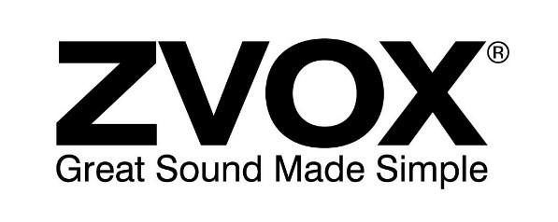

The ZVOX AV157 Voice-Clarifying Speaker Offers 12 Levels of

Dialogue Boost Making It Easier than Ever to

Understand the Muddled Dialogue on TV

AV157 AccuVoice Speaker is Alexa® Ready and Sets New Standard
For Dialogue Intelligibility with Addition of SuperVoice Technology

Swampscott, MA, July 13, 2021 - The AV157 is the latest addition to ZVOX Audio’s “hearing” products designed to help consumers who have difficulty understanding the dialog on their TV programming. ZVOX, the industry leader in dialogue clarification, features two dialogue clarifying technologies in its AV157. It uses ZVOX’s patented hearing aid algorithms to make dialogue clearer – and adds new programming – called SuperVoice – designed to reduce the level of background sound in TV programs.

“The best way to understand our SuperVoice technology is to picture a stage,” says ZVOX founder Tom Hannaher. “But instead of a row of actors, imagine a row of sounds. Our proprietary AccuVoice technology, that we introduced in 2016, clarifies voices and brings them forward on the stage. Our SuperVoice technology takes the other sound effects into the background – ‘pushing them backstage’ – so they don’t interfere with voice intelligibility.”

The AccuVoice AV157 speaker combines six levels of AccuVoice dialogue boost, but also allows the consumer to add SuperVoice algorithms to each of those levels – giving the user 12 levels of dialogue boost…and unprecedented voice clarity. “With 12 levels of dialogue clarifying technology,” Hannaher says “the AV157 is perfect for people who have no hearing issues at all (but want better sound than what you get from a flat-screen TV) and it’s also beneficial for people with fairly serious hearing issues. It is an extremely smart, versatile product.”

In addition to 12 levels of dialogue boost the AV157 also includes ZVOX’s new “Alexa® Ready” feature which allows a user to connect an Alexa Echo® device to Input 2 and use it while listening to TV programming. For example you can be watching a football game and ask Alexa for the score of another game. The AV157 automatically turns down the sound of the football game long enough for you to hear Alexa’s answer through the speaker, then automatically turns up the soundtrack for the game.

Priced at $299.99 the AV157 is available at ZVOX.com, Amazon.com and Walmart.com.
- Measurements: 17” x 3 3/8” x 2 7/8”
- Includes remote control.
- Can be programmed to respond to most infrared remote controls.
- Simple one-wire hookup – digital optical or analog.
- One year warranty.

About ZVOX.
ZVOX, a pioneer of simple home theater solutions and dialogue clarification, is recognized for introducing the first commercially successful sound bar in 2004, the first SoundBase TV audio system in 2008, and the first speaker dedicated to dialog clarity in 2016. The company is committed to bringing hearing enhancing solutions to millions of consumers with mild to moderate hearing loss. Based in Swampscott, MA, the company was founded in 2003 by audio enthusiasts looking to create great sound using simple, elegant designs. For more information visit: www.zvox.com.

For More Information or Review Samples:
Trujillo Public Relations
Sara Trujillo/sara@trujillopr.com
917.295.5491

