Personalised Advent Calendars: a unique way to countdown to Christmas
This year, make the countdown to Christmas extra special with a Personalised Advent Calendar that celebrates treasured memories. Whether you’re looking for something suitable for children, pets, vegans, chocolate or non-chocolate – CEWE has the perfect advent calendar to help relive cherished moments as you begin the celebrations for the most wonderful time of the year.
Photo Advent Calendar (insert price)
This Christmas, create an advent calendar that will give you a reason to smile every day throughout December. With this unique design, you can look back at special memories that mean the most as each door reveals a treasured photo every day. This advent calendar is totally personal to you and allows you to countdown to Christmas in a unique and heart-warming way. It’s also perfect as an alternative to the usual chocolate calendars!
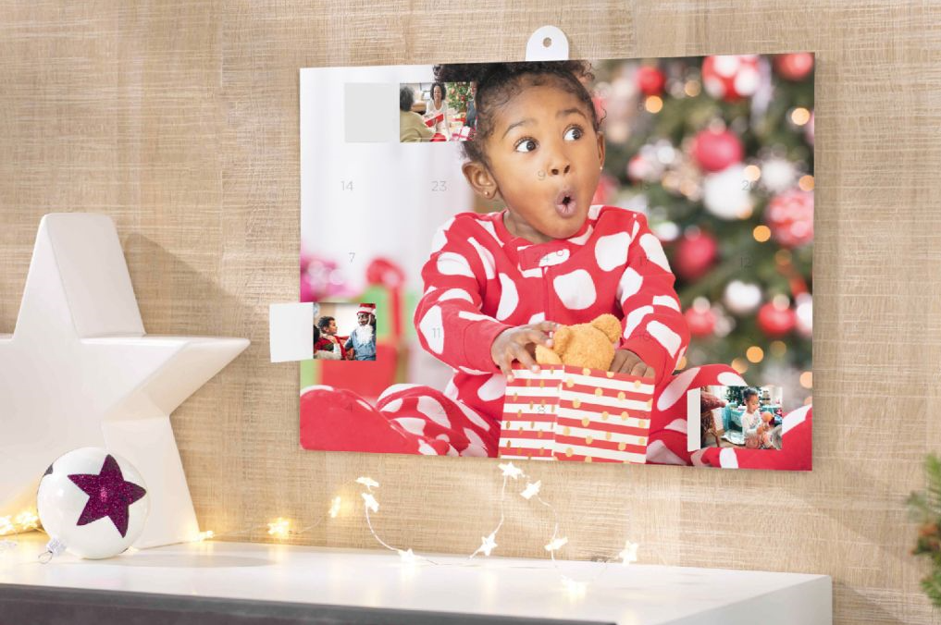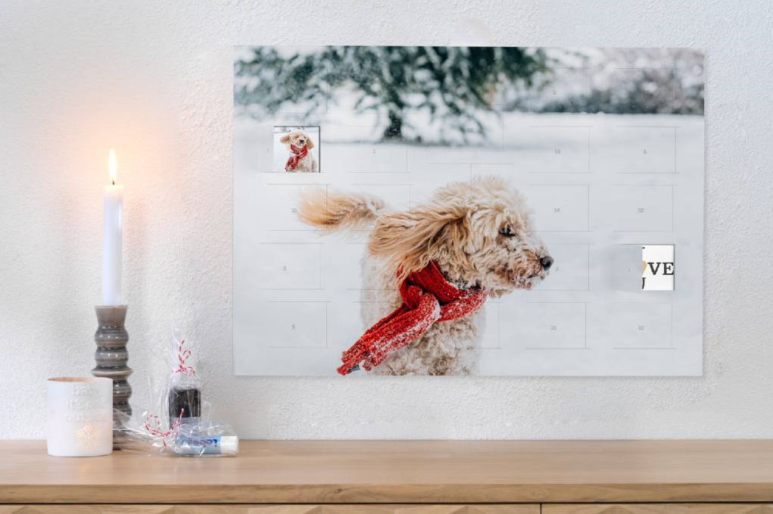
Advent Calendar with kinder® Chocolate (insert price)
This advent calendar is one that children are sure to love! It contains three varieties of kinder® Chocolate to help them welcome the festive season with a delicious sweet treat each day. Not only does this advent calendar contain tasty chocolate, but it can also be personalised with an image of your choice. Choose from a family memory, a self-portrait or a drawing they’ve created themselves. This unique design is unlike any on the high street and will allow them to have a countdown to the big day that is rich in memories, as well as delicious chocolate. Also available with 24 individual photos behind each door for an extra special treat.
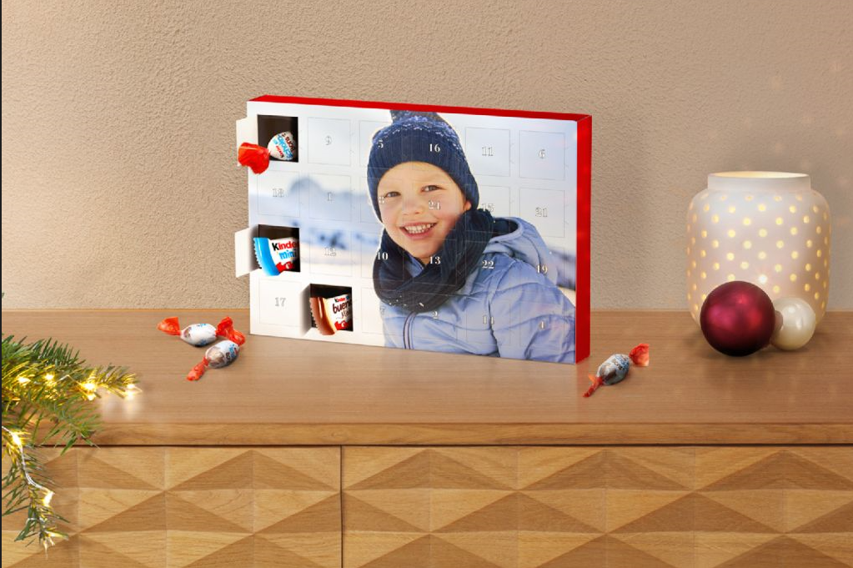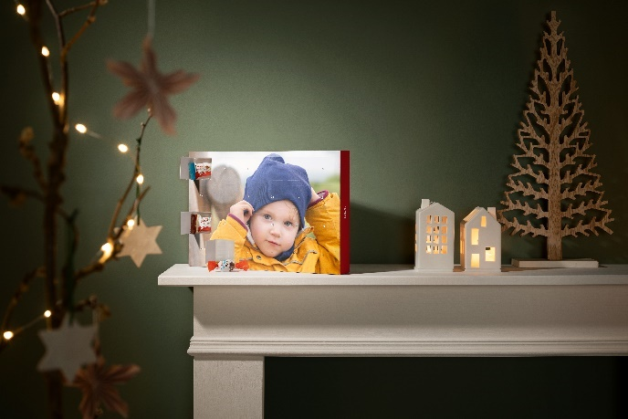

Advent Calendar with Ferrero Chocolate (insert price)
If you’re looking for a luxurious countdown to Christmas, this one-of-a-kind advent calendar is the perfect choice. It allows you to personalise the front with an image of a cherished memory and comes with three different varieties of Ferrero chocolates behind each door. The perfect special treat that helps you countdown to Christmas in a unique and delicious way! Also available with 24 individual photos behind each door for an extra special treat.
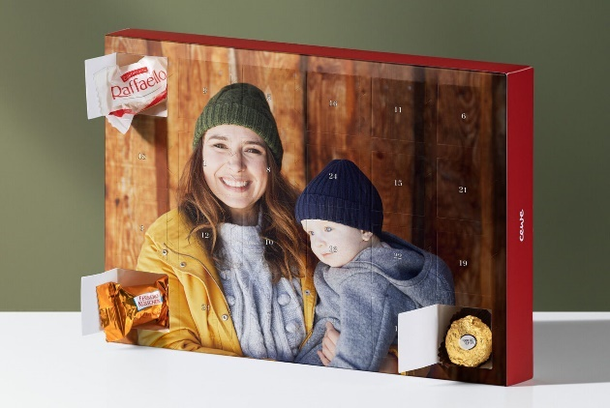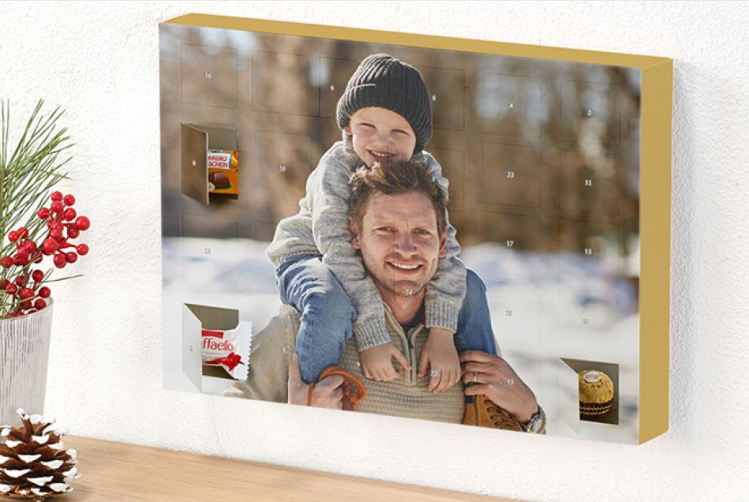
Fill Your Own Advent Calendar (insert price)
If you want to go the extra mile this year and get creative, this ‘Fill Your Own’ Advent Calendar is for you. Catered to suit the recipient, this truly unique product, allows you to personalise the image on the front with a photo of your choice in addition to the entire contents behind each window. Now with a 100% biodegradable insert, you can rest assured that your advent calendar is good for the planet, as well as the perfect way to make the countdown to Christmas more exciting. You can add your favourite sweets, small toys, treats for pets, vegan snacks or even miniature beauty items to create the most personal countdown to Christmas!
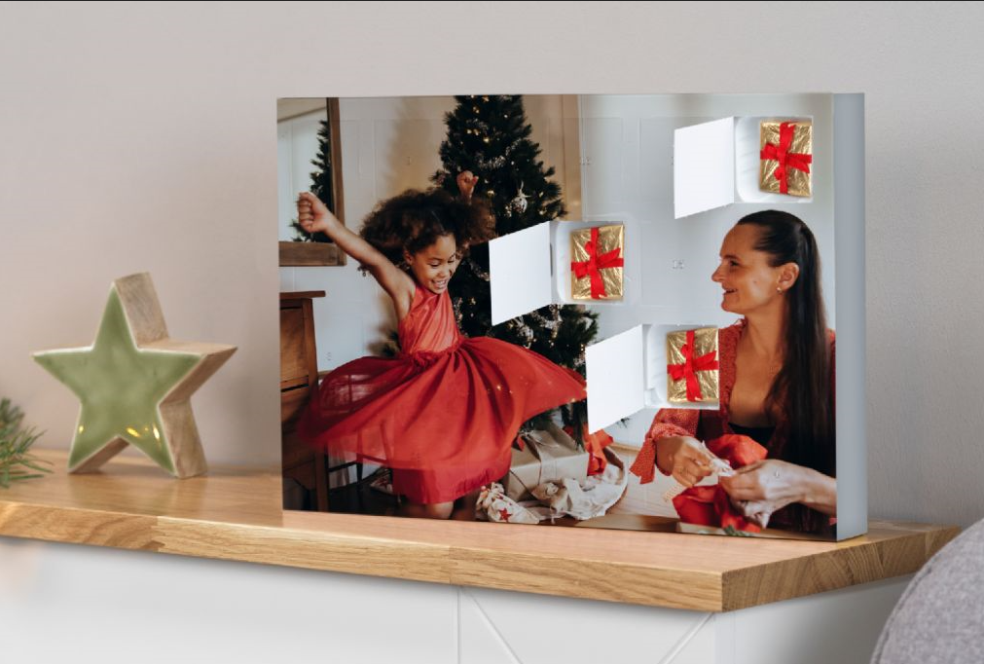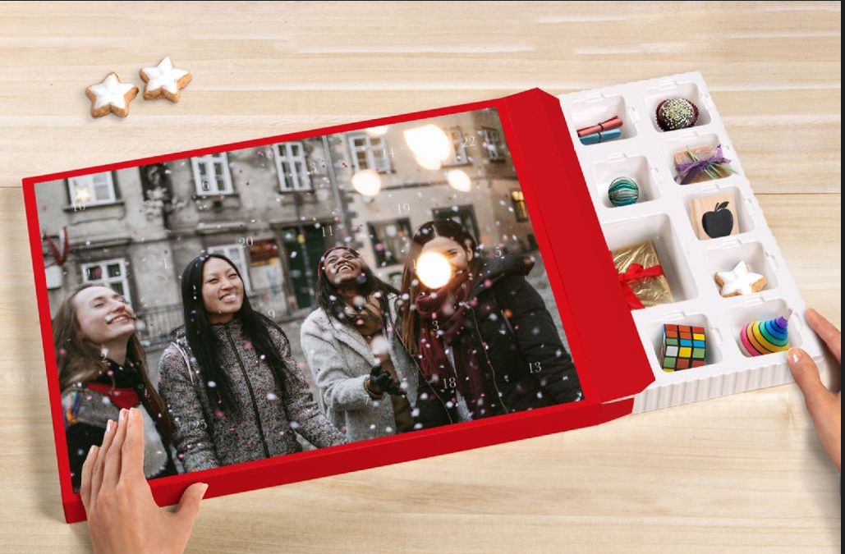
For more advent calendar inspiration, please visit: https://www.cewe.co.uk/advent-calendars.html

ENDS

Notes to editors:
For more information, contact the CEWE PR team on cewe@prohibitionpr.co.uk or call 0113 4304 160
About CEWE
From photo books to prints, wall art to gifts, CEWE is there to help turn your favourite photos into something extra special. In fact, CEWE loves printing memories almost as much as people love making them!
CEWE is Europe’s largest photo printing company, a company with over 50 years of experience in all things photo printing.
Based in Warwick near Royal Leamington Spa, the company’s state of the art production facility houses some of the very latest in printing technology, and delivers millions of personalised photo products each year.
From printing holiday snaps to producing wedding photo books, printing greeting cards to creating a special gift, CEWE make items people treasure from the memories they love.
For more information about CEWE gifts, visit: https://www.cewe.co.uk/photo-gifts.html

