INTRODUCING STIHL’S CUTTING EDGE FSA 80 AND FSA 80 R

The FSA 80 and FSA 80 R are the first brushcutters available in STIHL’s AK System of battery-powered tools, offering impressive cutting performance for tough garden jobs.

The lightweight, quiet, and ergonomic FSA 80 is the first in the AK System to feature a bike handle, ideal for cutting open areas of dense grass and brambles. For maximum comfort when working, the FSA 80 R features an adjustable loop handle with the lever under the handle allowing for easy, tool-free adjustment. Both models are compatible with a wide range of attachments for every type of challenge, from mowing line heads to metal or polymer grass blades, allowing for greater versatility.
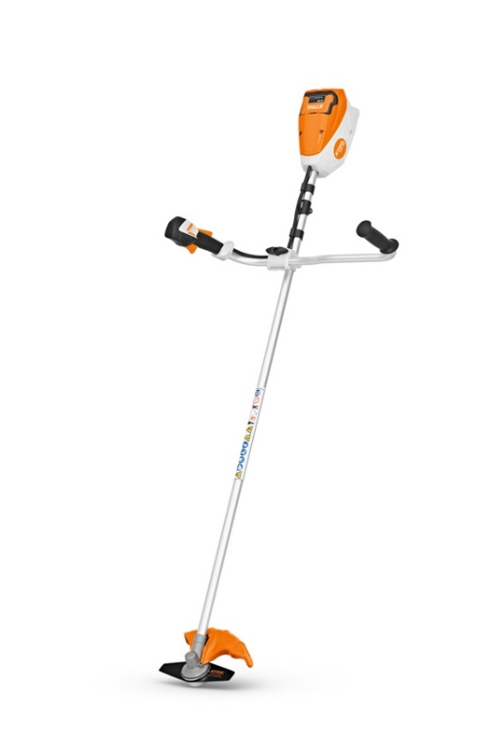
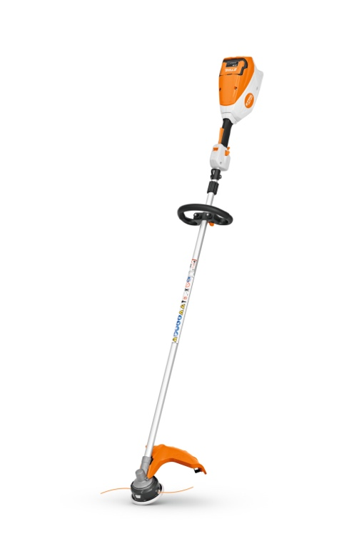

Figure 2 FSA 80 R
Figure 1 FSA 80

Both new brushcutters include two speed settings, a variable trigger for greater control, and ECO Mode for maximising the working time of the battery when cutting lighter grass. With adjustable harness hooks, the harness attachment points on both brushcutters can be moved along the shaft for optimum balance, with no tools required.

The high-quality Lithium-ion battery provides a working time of up to 60 minutes when used with a metal cutting blade, ensuring most tasks can be completed on a single charge. Like many of STIHL’s battery-powered tools, the FSA 80 is low vibration, easy to maintain, and significantly quieter than a petrol alternative.

The RRP for the FSA 80 is £309.00 for the tool only, or RRP £459.00 for the set, which includes an AK 30 battery and AL 101 charger.

The RRP for the FSA 80 R is £289.00 for the tool only, or RRP £439.00 for the set, which includes an AK 30 battery and AL 101 charger.

The new FSA 80 and FSA 80 R brushcutters are available to buy now from STIHL Approved Dealers nationwide. For more information, please visit www.stihl.co.uk.

-ENDS-

About STIHL

It all started with a chainsaw, and to this day, it's still the product for which the STIHL brand is best known worldwide.

Ever since Andreas Stihl invented the first portable chainsaw, the STIHL name has stood for revolutionary technology, driven by significant investments in research and development and a single-minded passion for making people's lives easier when working in nature. It's because of this that STIHL has been the world's best-selling petrol chainsaw brand since 1971.

But the STIHL name is now synonymous with many other industries too, as well as with home gardeners looking for premium quality tools. The extensive STIHL range includes hedge and grass trimmers, multi-tools, pressure washers, construction tools, lawn mowers, lawn tractors, robotic mowers and of course, chainsaws.

A family-owned business based in Germany; STIHL employs more than 20,000 people worldwide and sells products in more than 160 countries globally.

STIHL GB is a wholly-owned subsidiary of the global STIHL Group. In Great Britain, STIHL products are available from more than 700 specialist Approved Dealers who offer expert advice and after sales support. Selected tools are also available from quality garden centres and from STIHL's own online store https://shop.stihl.co.uk/

Whatever STIHL tool you choose and however it's powered - battery, petrol or electric - each features countless innovations, exceptional performance and lasting quality.

Issued on behalf of STIHL GB by HROC Ltd. For further information please contact:

HROC Limited
Tel: 0121 454 9707
E: prstihl@hroc.co.uk

