NETGEAR ORBI WIFI 6E MESH SYSTEM NOW SHIPS AS A TWO PACK

NETGEAR Releases its Best-in-class Performance, Capacity and Range Orbi 960 Series as a Two Pack, Making Mesh More Accessible to a Wider Audience.

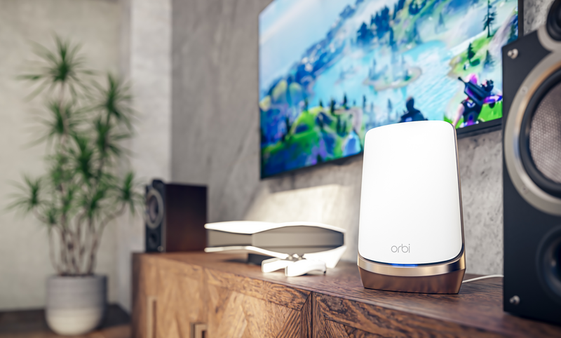

BRACKNELL, UK – April 25th, 2023 – NETGEAR®, Inc. (NASDAQ: NTGR), the leading provider of award-winning connected products has made its renowned Orbi™ Quad-band Mesh WiFi 6E System (RBKE960 Series) available in a two pack. The Orbi RBKE962 adds the newly available 6GHz WiFi band to deliver quad-band technology with faster Internet speeds to more devices simultaneously with less interference and wait time. It supports multi-Gigabit Internet throughout the home, improving WiFi performance for the growing number of devices in today’s homes while paving the way for new devices and experiences to come.

New WiFi, New Orbi
The new Orbi Quad-Band WiFi 6E system adds a fourth band for the newly available 6GHz WiFi. This new band provides the much-needed additional WiFi spectrum to handle multi-Gigabit WiFi speed on new smart phones and laptops, free of interference from other devices on the existing 2.4GHz and 5GHz bands. And the WiFi 6E ecosystem is poised for rapid growth. Many devices already support WiFi 6E such as the Samsung Galaxy S21, and Fold 3 mobile phones, Dell Latitude 5520 and Lenovo Thinkpad T14 laptops, Samsung Neo QLED 8K TV and Intel WiFi 6E PCIe card, with more to come before Christmas.

Devices running on the 2.4GHz and 5GHz WiFi bands will also experience an improvement in coverage and increased speeds.To augment the increased WiFi speed, the Internet connection has also been upgraded to support up to 10 Gigabits, the fastest Internet speed available now or in the near term. Additional 2.5 Gigabit Ethernet ports have been added on the router and satellites to provide an option for wired connections for customers with the latest multi-Gigabit Ethernet devices.

The industry’s first quad-band WiFi 6E system, Orbi ensures maximum throughput with 16 WiFi streams – the highest specification available -- at all 3 bands, 2.4, 5 and 6GHz. Furthermore, similar to the previous tri-band Orbi systems, the RBKE960 series uses a dedicated WiFi 6 backhaul, pioneered by NETGEAR, for data exchange between the router and satellites without impacting the performance of connected devices.
Orbi WiFi 6E 2 pack (RBKE962) provides lightning-fast, wall-to-wall Internet access to homes of up to 5,000 square feet for WiFi 6 connections and is easily expandable for larger spaces or denser coverage of WiFi 6E connections with the addition of extra satellites.

Technical Specifications:
- Industry-first quad-band WiFi System–– Supports four WiFi bands -2.4, 5 and 6GHz, for connecting the router/satellite to all your devices and an additional dedicated fourth 5Ghz WiFi band for connecting the router to the satellites.
- Supports all-new WiFi 6E 6GHz WiFi band – The 6GHz WiFi band adds more than double the bandwidth of 5GHz, resolving issues with interference and congestion in the 5GHz WiFi band, and enables amazing multi-Gigabit WiFi speed for connected WiFi 6E devices.
- 16 WiFi Streams - to provide the best speed, range and performance to blanket your home with Internet speeds similar to what you receive from your Internet provider.
- 10 Gbit Ethernet port for Internet – Future-proof your home network with support of up to 10 Gbps Internet speeds.
- 2.5 Gbps Ethernet port for wired connections –Multi-gig Ethernet port for wired connection to network storage, LAN gaming, in-home media streaming, or use it to set up a wired multi-gig connection between the router and satellites with structured Ethernet wiring in your home.
- More Flexibility to Manage your Home Network with support for four different WiFi Networks – Main mesh WiFi Network for all your devices using the latest WPA3 for secure connections; IoT Network for all your legacy and IoT devices; 6GHz Only WiFi Network for all latest WiFi 6E devices and Guest WiFi Network.
- Orbi® App— Easily set up your WiFi System, manage your network remotely, pause the Internet on any device, track your Internet data usage and more.

State-of-the-Art Security and Services
The Orbi Quad-band WiFi 6E Mesh System supports the new, more secure WiFi Protected Access 3 (WPA3). With 128-bit encryption, the next generation of WPA protects against weak passwords that are easily cracked by hackers.

The new Orbi system also supports four separate WiFi networks. In addition to the default home WPA3 mesh network for 2.4, 5 and 6GHz devices and a guest network, users have the option to set up their new 6E devices on an exclusive WiFi 6E network to ensure these devices realize the best speeds and performance possible. There is also an IoT network for smart home devices such as smart plugs, lights, sprinklers, etc. that only support WPA2. These discrete networks allow for flexibility of network configuration, maximum performance and the separation of less secure devices from the main network.

For added peace of mind, Quad-band Orbi WiFi 6E includes a free 30-day trial of the newly enhanced NETGEAR Armor™ service to protect the connected home from online threats. Unlike traditional endpoint Internet security products, NETGEAR’s Armor is built into the router as a comprehensive security solution to monitor activity going to and from the Internet, protecting all the devices on a network, including Smart TVs, security cameras, game consoles, smart speakers, streaming players, and other smart home gadgets which typically would not be able to be loaded with Internet security protection software by users. NETGEAR’s Armor also protects the traditional computing devices such as smart phones, tablets, laptops and desktops, while eliminating the need for multiple security subscriptions or software on each of these computing devices. Also available as a paid subscription on the new system is NETGEAR’s Smart Parental Controls™, which help parents easily manage their children’s time and access online across all connected devices– ultimately promoting safe and healthy screen habits.

Availability
The award-winning design of Orbi has made it an elegant and unobtrusive element in some of the world’s most sophisticated homes. The Orbi Quad-band Mesh WiFi 6E System RBKE963 (router and two satellites) will be available for preorder today in the US and shortly in the UK on NETGEAR’s online stores (NETGEAR.com and NETGEAR.co.uk) -- shipping in time for the holidays -- and in other regions as WiFi 6E is approved. NETGEAR will also offer the Orbi WiFi 6E Black Edition for a limited time on NETGEAR.com. For larger homes looking to expand WiFi 6E coverage throughout every room NETGEAR will offer additional satellites and bundles on NETGEAR.com as well.

Pricing: Orbi Quad-band Mesh WiFi 6E System
- RBKE962: Router and 2 Satellites – EUR, £1,199.99 GBP

About NETGEAR, Inc.
NETGEAR® (NASDAQ: NTGR) has pioneered advanced networking technologies for homes, businesses, and service providers around the world since 1996 and leads the industry with a broad range of award-winning products designed to simplify and improve people's lives. By enabling people to collaborate and connect to a world of information and entertainment, NETGEAR is dedicated to delivering innovative and advanced connected solutions ranging from mobile and cloud-based services for enhanced control and security, to smart networking products, video over Ethernet for Pro AV applications, easy-to-use WiFi solutions and performance gaming routers to enhance online game play. The company is headquartered out of San Jose, Calif. with offices located around the globe. More information is available from the NETGEAR Investor Page or by calling (408) 907-8000. Connect with NETGEAR: Twitter, Facebook, Instagram and the NETGEAR blog at NETGEAR.com.

©2021 NETGEAR, Inc. NETGEAR the NETGEAR logo, Nighthawk and Orbi are trademarks and/or registered trademarks of NETGEAR, Inc. and/or its affiliates in the United States and/or other countries. Other brand and product names are for identification purposes only and may be trademarks or registered trademarks of their respective holder(s). The information contained herein is subject to change without notice. NETGEAR shall not be liable for technical or editorial errors or omissions contained herein. All rights reserved.
UK Media Contact: Zaboura Consultancy, netgear@zaboura.com
UK Sales Inquiries: 01344 458200, UKsales@netgear.com
UK Customer Inquiries: 01344 458200

