LYRE’S LAUNCHES THE WORLD’S MOST COMPREHENSIVE RANGE OF AUTHENTIC TASTING NON-ALCOHOL SPIRITS
- Australian non-alcoholic spirit pioneers Lyre’s launches in the UK
- Lyre’s offers the world’s most comprehensive range of alcohol-free spirits & liqueurs, including Gin, Rum (white, dark & spiced), Whiskey, Orange Sec, Amaretti and Campari
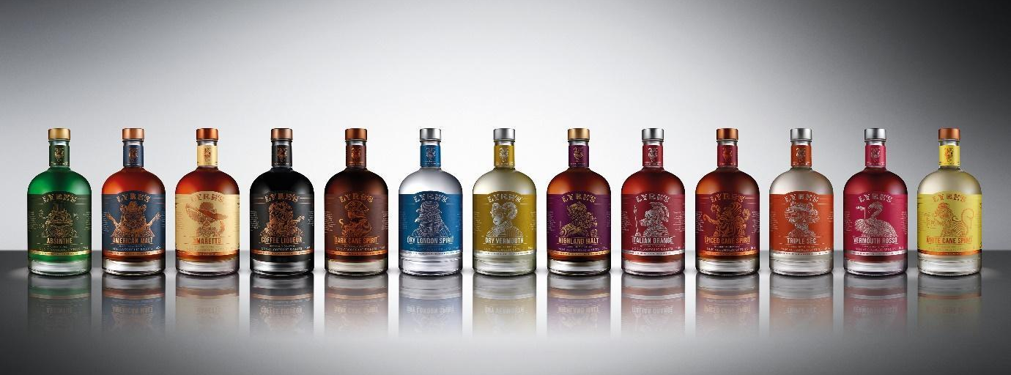
TUESDAY 19TH NOVEMBER: Lyre’s – the innovative non-alcoholic Australian spirit brand – is ready to tantalise the taste buds of mindful drinkers across the nation.
Having successfully launched in the USA and Australia, the revolutionary brand is set to transform the way the nation socialises, offering Brits the world’s most comprehensive range of alcohol-free spirits and liqueurs, for the very first time.
With 12 different spirits and liqueurs, including Gin, Whisky, Rum, Campari, Dry and Rosso Aperitif, Absinthe, Orange Sec, Amaretti and Coffee Originale, Lyre’s is ready to offer drinkers the freedom to enjoy their favourite cocktails when they want without the worry of the morning after at home or in a bar.
Named after the Australian Lyrebird – the world’s greatest mimic – Lyre’s is a completely unique way for no and low drinkers to enjoy a sophisticated tipple.
This Christmas, sample the magic of Lyre’s and enjoy iconic drinks like rum & coke (Lyre’s American Malt & coke), gin & tonic (Lyre’s Dry London Spirit) or cocktails like the Negroni (Lyre’s Dry London Spirit, Lyre’s Italian Orange and Lyre’s Rosso Vermouth) guilt free.
For over three years, Lyre’s has been developing each individual product to faithfully replicate the taste of the original spirits and liqueurs these products pay homage to. Working with some of the world’s most recognised sommeliers, with over 6,000 ingredients at their disposal, these impossibly crafted non-alcoholic spirits combine all-natural essences, extracts and distillates to match the aroma, taste, appearance and tell-tale burn of time-tested spirits. These really are the finest range of non-alcoholic spirits the world has ever seen.
With freedom at its heart, Lyre’s offers the rising number of mindful and no and low drinkers in the UK an opportunity to enjoy terrific tipples without the worry of the morning after. Whether you’re looking for a stocking filler, hosting friends or looking to cut down on your alcohol without compromising on flavour, make it a Lyre’s.
Lyre’s products are priced at £20.95 and are available to buy from various retailers including Master of Malt, Booze Free and available to enjoy in many bars including Be At One, Botanist and Simmons.

Ends
Some of our favourites, available from Master of Malt:
Lyre’s American Malt, £20.95
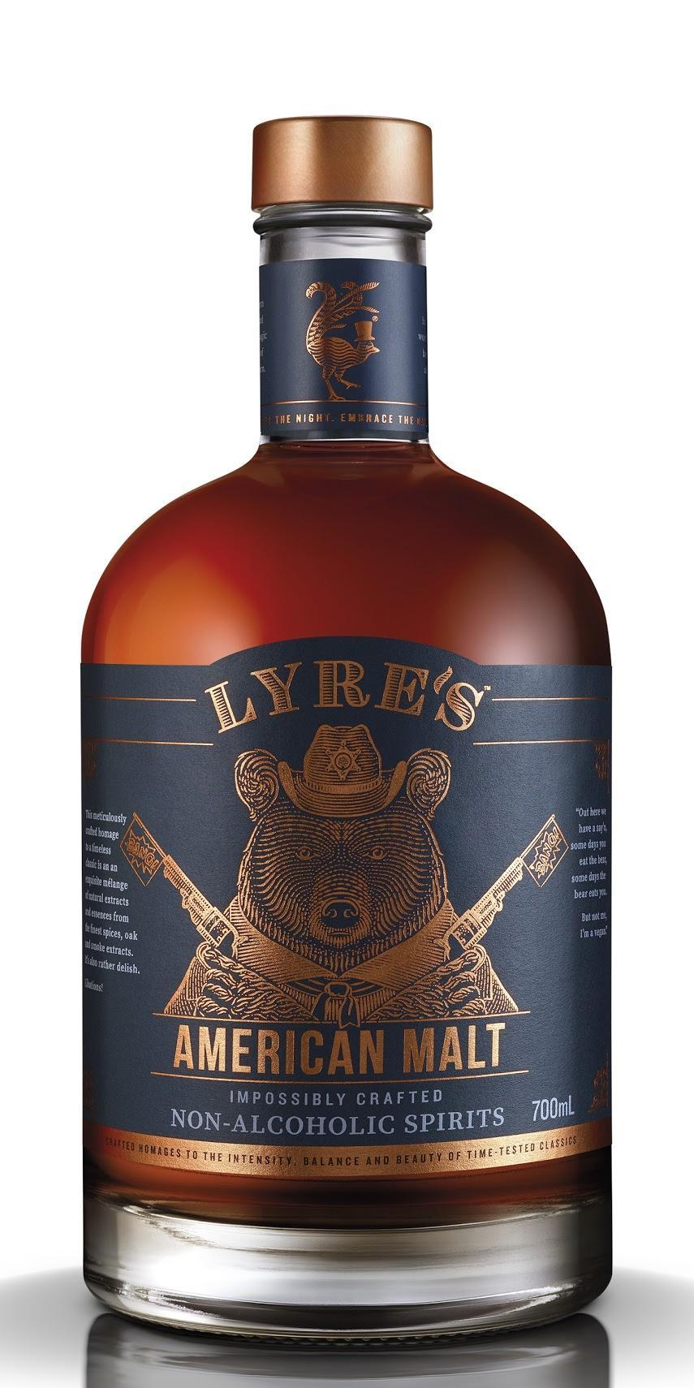
A honey-coloured spirit generously flavoured with notes of vanilla, toasted nuts, sweet spice, caramel and accents of charred oak, with a mellow and dry finish. Try as a long drink mixed with apple juice or, for a take on the classic Manhattan, gently stir with Lyre’s Rosso Vermouth, bitters and orange peel.
Lyre’s Dark Cane Spirit, £20.95
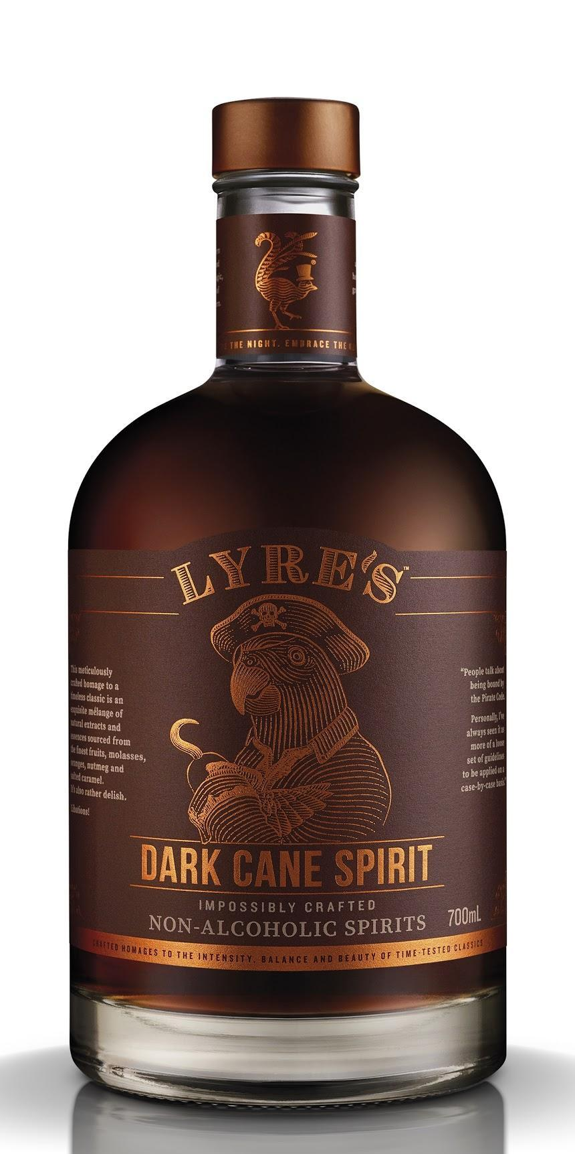
This spirit has been crafted to encapsulate the essence of a dark rum. A richly dark, caramel-coloured spirit that offers a full-flavoured profile, with notes of caramel, fudge, fig, toasted nuts, maple and vanilla, and a long and smooth finish. This spirit can be used as classic mixer, or mixed with Lyre’s Orange Sec and lime juice for a non-alcoholic take on the Mai Tai.

Lyre’s Dry London Spirit, £20.95
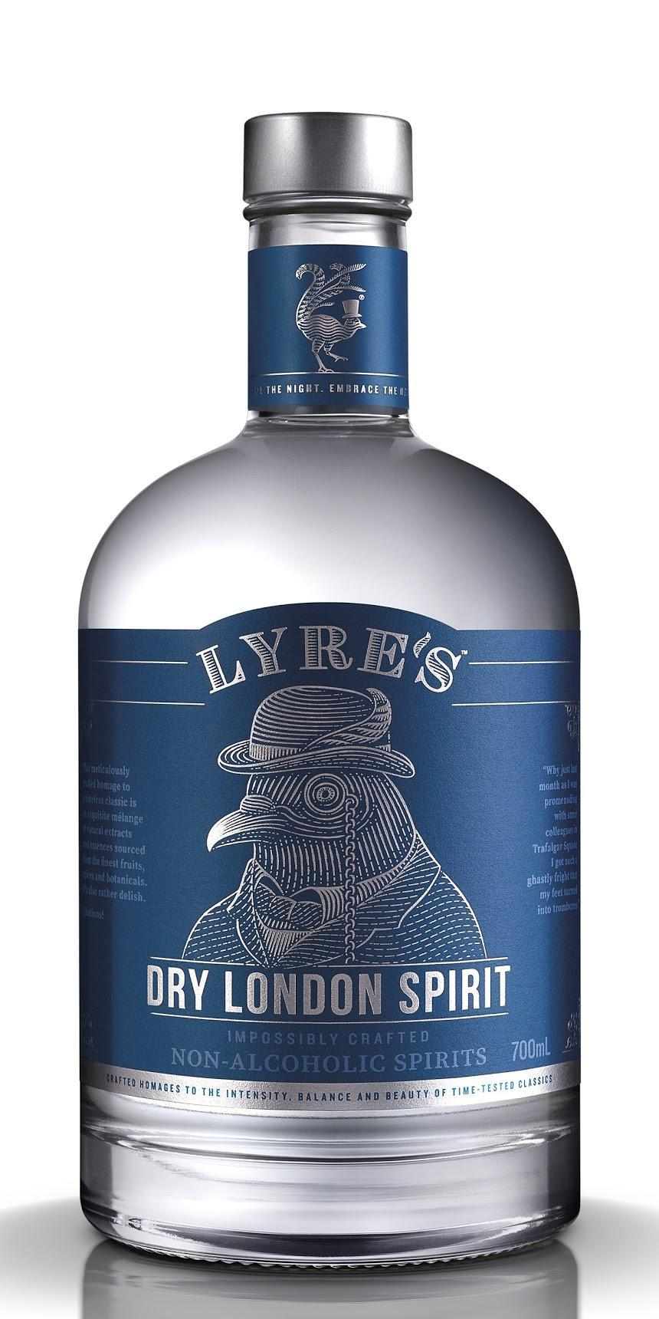
This spirit captures the essence of the classic London spirit, with aromatic, floral flavours of juniper and citrus. Notes of pepperberry adds warmth and delivers a generous, dry finish. Enjoy as a classic G&T with a wedge of lime or mint to garnish.
Lyre’s Italian Orange, £20.95
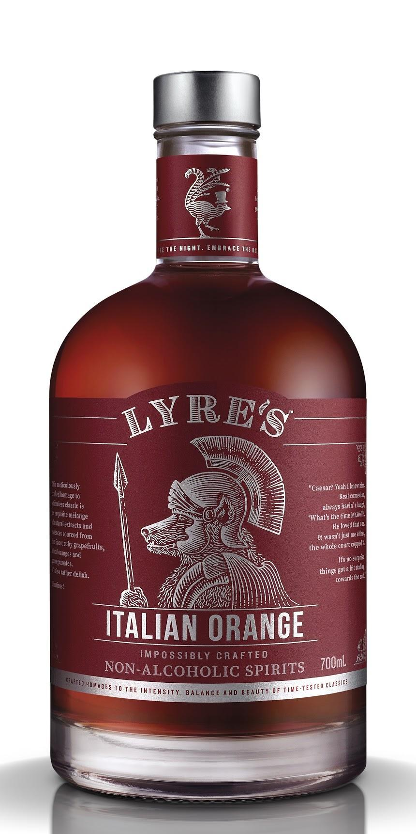
A bitter orange aperitif which offers rich flavours and aromas of blood orange, ruby grapefruit, maraschino pomegranate and cassia. Try with soda or tonic water garnished with a wedge of orange to create a refreshing aperitif or create a Lyre’s Negroni by mixing with Lyre’s Dry London and Lyre’s Rosso Aperitif.

Lyre’s White Cane Spirit, £20.95
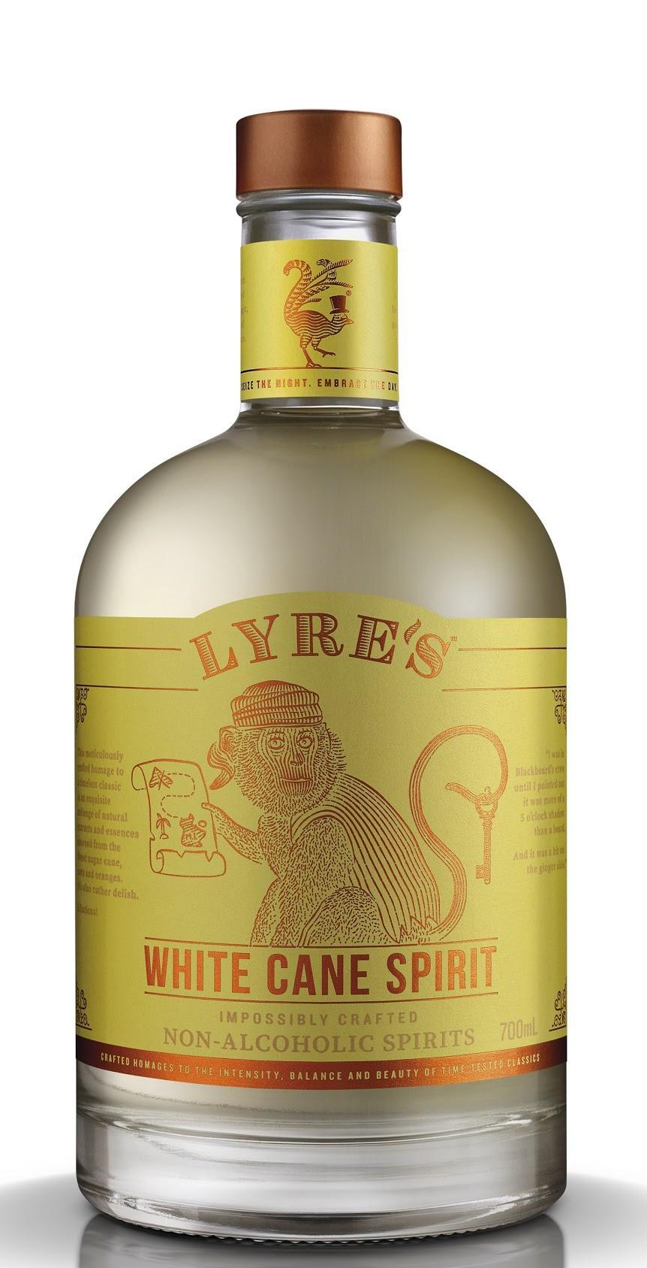
This spirit captures the essence of a gently aged white rum, with notes of sugar cane, oak, marzipan, orange and coconut and a peppery finish. Mix with lime, mint and a dash of soda water for a take on the classic Mojito, or shake with Lyre’s Triple Sec and your favourite fruit juice to recreate a delicious Daiquiri.
Lyre’s Amaretti, £20.95
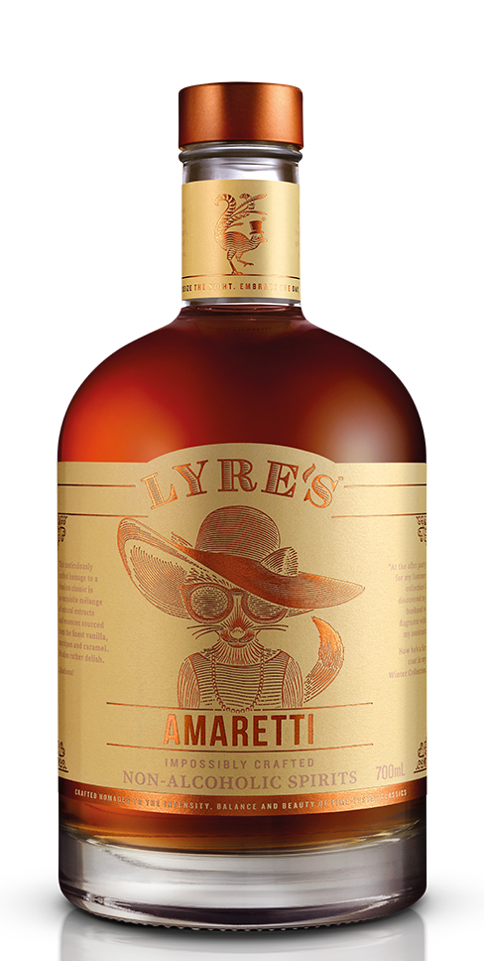
Flavours of toasted almond, vanilla, marzipan, caramel and accents of maraschino are all captured in this tangy amaretto liqueur. Try poured over the rocks or use to recreate a classic Amaretto sour by mixing with lemon, orange and maraschino.
Lyre’s Orange Sec, £20.95
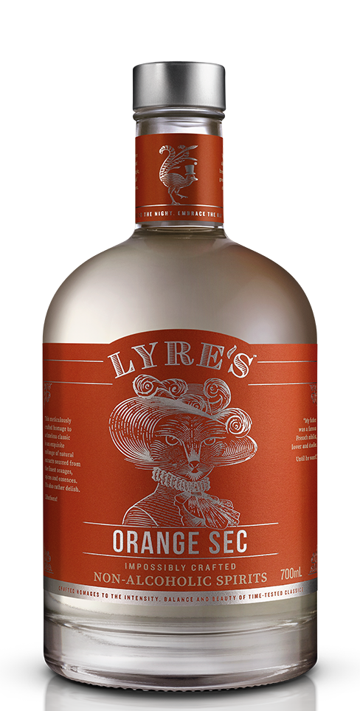
Crafted to capture the essence of an orange liqueur, this aromatic, balanced spirit offers notes of sweet and bitter orange, zest and orange confectionary, with subtle hints of jaffa and mint. Use Lyre’s Orange Sec to recreate classic cocktails such as the elegant White Lady or tropical Mai Tai.
Notes to editors
Assets
- High-res packshot and lifestyle imagery is available to download here
Press office details
For further information, please contact:
- Joe Lamb – joe.lamb@visiblepr.co.uk / 07748368384
- Natalie Kutscher – natalie@visiblepr.co.uk / 07766797866
About Lyre’s
It’s a truly revolutionary concept. Lyre’s Non-Alcoholic Spirits haven’t created confusing, original botanical flavours. Instead, each drink is designed to be a faithful replica of its alcoholic original. The range already consists of an astonishing 13 different spirits and liqueurs, with more to follow. Bartenders can now conjure up an espresso martini, amaretto sour, negroni without having to compromise on taste or cocktail flare.
Lyre’s Non-Alcoholic Spirits is distributed in the UK by Proof Drinks.
To find your nearest Lyre’s stockist, please visit https://www.lyres.co/.

