Dualit Launches Smart, Sustainable Travel Mug
Keeping beverages at the perfect temperature wherever you are

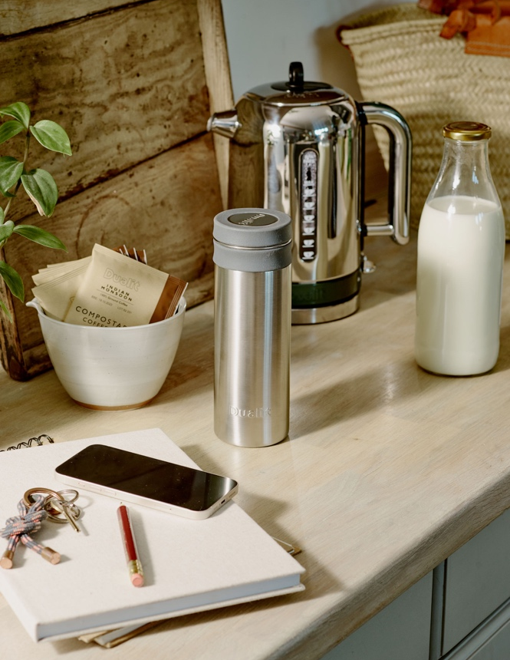

Iconic British brand, Dualit has expanded its award-winning beverage range to include a complementary product, the Travel Mug. With its portfolio of products already including coffee machines, pods and bags, it was a natural move to introduce a drinking vessel to bolster the at-home barista message of the existing range. Dualit’s trusted engineering expertise along with thorough customer research has resulted in a Travel Mug that ticks all the boxes.

Built from high-quality, brushed stainless steel with silicon trims, the Travel Mug is completely plastic-free. Not only does this make it a sustainable choice, but also eliminates the risk of flavour tainting or lingering odours in the mug. Five layers of advanced vacuum insulated technology keeps drinks hot for up to 7 hours* or chilled for up to 12 (even longer with ice cubes). The outer mug will also stay cool to hold, no matter how hot the liquid inside. An ideal mug for everyday use thanks to its compact design yet generous 500ml capacity, it can also be taken apart and put in the dishwasher for ultimate hygiene. As with all of its premium products, Dualit has designed and built the Travel Mug to last; the carefully selected materials mean that even after months of use, it will still look as good as new.

Following customer research to uncover the issues identified with existing Travel Mug options on the market, Dualit has tackled the main findings such as:
- Colour and flavour tainting – Dualit’s is made from stainless steel and removable silicon trims which are dishwasher safe to guarantee a thorough clean.
- Flow speed too fast –Dualit’s precisely engineered baffle acts as a spill barrier to control the flow of liquid. This ensures the ideal amount flows through at the optimum speed, so whether walking or driving, liquid won’t end up spilling or scalding. The baffle can also be removed for pouring liquid into cups if required.
- Inconvenient size – Dualit’s Travel Mug holds a larger than average 500ml of liquid, and benefits from a narrow design to make it easy to hold and also fit in most vehicle cup holders.
- Lid leaks – The heavily tested leak-proof lid offers peace of mind when the Travel Mug is loose in a bag.

For morning coffees on the train, keeping warm on the school sideline, a toasty hot chocolate for that long walk or refreshing water on a hot summer’s day, Dualit’s Travel Mug caters for everyone and every beverage.
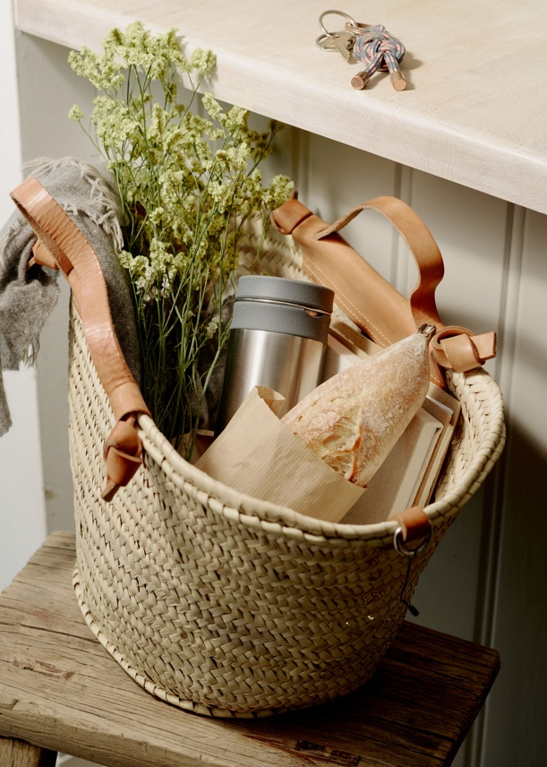

NEW Dualit Travel Mug – RRP £29.99

ENDS

STOCKISTS
Available from Dualit.com and Amazon at launch

NOTES TO EDITORS
*in a pre-warmed mug above 50degrees c

CONTACT
For more information, high resolution images or samples for review, please contact: Chloe MacDonagh or Olivia Collins at Sellers PR on 01962 977 950 or email chloe@sellerspr.com / olivia@sellerspr.com

