STRANGER THINGS TOYS UPDATE – SEPTEMBER 2022
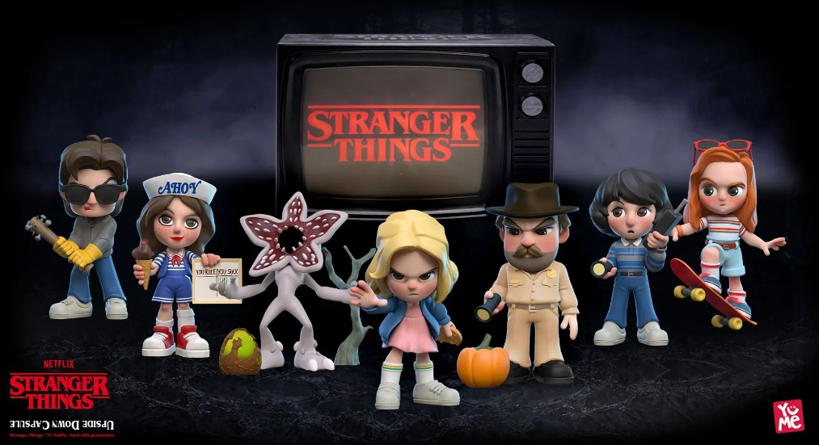
Background
In 2016 the first series of Stranger Things aired. A show set in Indiana in the 1980s. Brim full of nostalgia and developing a new audience for the streaming platform, Netflix. Buoyed by the success of Series 1,2, and 3 Netflix launched Series 4 to a now hungry fanbase! Nobody could have foreseen the impact this show would have on our Summer! Kate Bush had no idea that her song, Running up that hill, would become the smash hit song of the year! That’s 37 years after it was released!
We brought these toys into the UK the week before the series launched. We were told “they won’t sell as they aren’t toys”.
We sold 44,000 units in 4 weeks and breaking merchandise sales records in HMV and the item became the number 1 best seller in its category on Amazon.
In HMV only Harry Styles new album kept us off their top spot!
The sales have been so strong globally we have 100% sell through at our retailers with people searching for these items everywhere!
We know that Smyths will have some stock first week in October, Tesco will have some stock at the end of October and we know that will get stock to resupply all our retail partners at the end of November!
Truly a phenomenon for all involved!

Items
- SRP £14.99 Stranger Things Mystery Capsules – try Tesco, Amazon, Smyths, HMV and independent toy stores!

Images & More Details
STRANGER THINGS

