MAKE SEASONAL PRODUCE LAST LONGER WITH
FRESH & SAVE VACUUM FOOD STORAGE SOLUTIONS FROM ZWILLING

ZWILLING has a long history of championing perfect food preparation and culinary innovation, almost 300 years in fact, and with food waste at an all-time global high, this German company has taken the lead by launching its new Fresh & Save vacuum food storage solution. Not only will this collection of kitchen products help to reduce food waste by keeping food fresh for up to five times longer, but it will also preserve food’s flavours, nutrients and vitamins, locking the goodness in.

Food waste has become a by-product of modern shopping habits and much of our seasonal produce can go bad pretty quickly. This includes fruit and vegetables such as berries, bananas, tomatoes, peaches, avocadoes, green beans, kale and lettuce. Even that lovely fresh fish, meat and dairy bought from the farmer’s market can soon spoil if not stored correctly. There are some simple tricks that can be used to make ingredients last longer. For instance, avoid washing and chopping the items until ready to cook or consume and, most importantly, store them for optimum freshness.

This is where the ZWILLING Fresh & Save vacuum food storage solution can help. It not only keeps seasonal produce fresh for up to five times longer, but it can also be used for leftovers, packed lunches and batch cooked meals. Perfect for helping us to organise our food, fridge and freezer, the collection of vacuum boxes and bags will also keep items fresh, save time and money while tackling waste – both food waste and wasteful packaging - so it’s a sustainable option too.
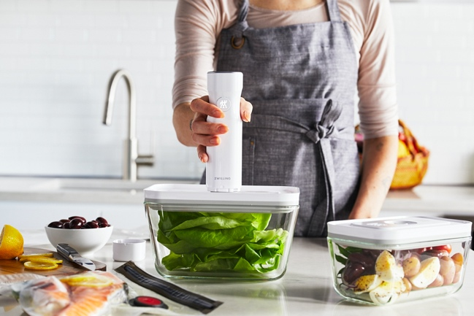

ZWILLING Fresh & Save Vacuum Food Pump, £69.95; Medium Glass Vacuum Box, £14.95 and
Large Glass Vacuum Box, £19.95
The ZWILLING Fresh & Save collection comprises glass and plastic Vacuum Boxes and Vacuum Bags in various sizes, which use the Vacuum Food Pump to seal in freshness. This enables cooks to keep seasonal produce for up to five times longer – and they can be used for the freezer too for even longer storage. The vacuum bags are also ideal for sous-vide cooking, re-heating pre-prepared meals and making the most of leftovers. All products feature a QR code for use with the ZWILLING Culinary World app {available to download from the App Store and Google Play}, which reminds the user of the food’s extended shelf life date. Each Fresh & Save product features ZWILLING’s Double Sealing Technology and a 24-month guarantee. Customers can choose to buy products individually or in a set such as the 7 Piece Glass Vacuum Starter Set, £89.95, which includes the Vacuum Pump, a large and medium Glass Container and four Vacuum Bags {two small and two medium sizes).
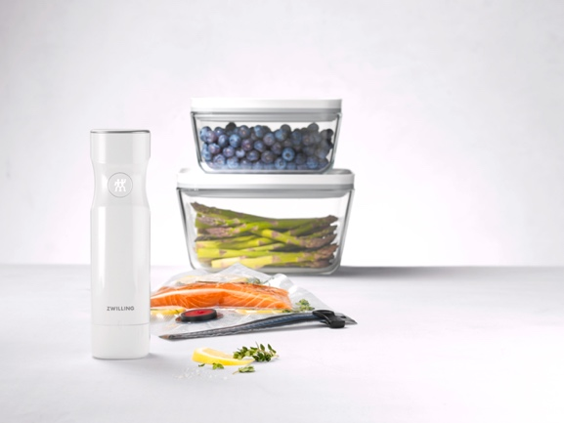

ZWILLING Fresh & Save Vacuum Food Pump, £69.95
The wireless operated Fresh & Save Vacuum Pump is always ready to use, as it doesn’t need complicated setting up and simply starts at the touch of a button, automatically stopping once the correct vacuum is achieved. It only takes a few seconds to complete the process and the Pump can be recharged using the USB cable included. Whisper-quiet, easy to use and ultra-convenient – it’s the perfect solution to extending the life of much loved seasonal produce and more.
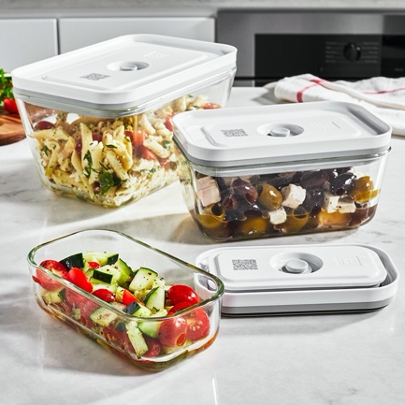
ZWILLING Fresh & Save Set of 3 Vacuum Glass Boxes, £39.95
ZWILLING’s Fresh & Save Vacuum Boxes are so versatile and are available in both glass and plastic to suit every food storage need. The cold and heat-resistant glass boxes come in small, medium and large sizes as well as a gratin dish and a flatter box ideal for cold meats and deli items. The glass vacuum boxes are topped with a BPA-free plastic lid with vacuum function, which keeps food fresh for up to five times longer, while preserving food’s flavours, vitamins and nutrients. As well as making seasonal ingredients last longer, they can also be used for leftovers and pre-prepared meals or to freeze raw produce without the risk of freezer burn. Suitable for use in ovens up to 180°C {with lid removed}, microwaves {with vacuum seal released} and dishwashers, the glass boxes can also be stacked inside one another to save space after use.
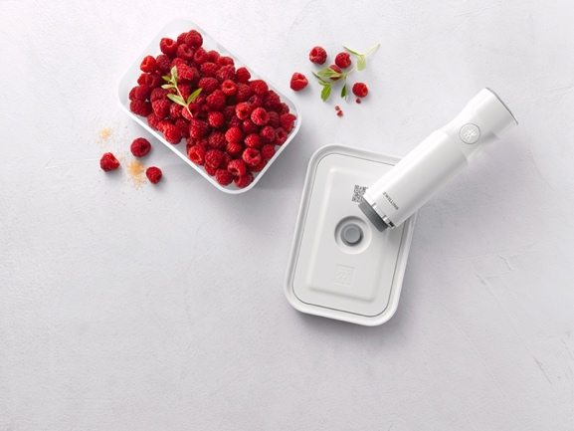

ZWILLING Fresh & Save Vacuum Food Pump, £69.95 and Small Plastic Vacuum Box, £9.95
As well as the glass versions, the ZWILLING FRESH & SAVE Vacuum Boxes also come in plastic, which are sturdy, lightweight and BPA-free. Just like the glass designs, the lids include a vacuum valve made of silicone and boxes are available in small, medium and large sizes as well as a handy lunchbox. The plastic designs can also be stored in the fridge or freezer and are microwave {with vacuum seal released} and dishwasher-proof. As with the glass boxes, the plastic Vacuum Boxes feature a QR code on the lid for the ZWILLING Culinary World app to remind users of the food’s best before date.
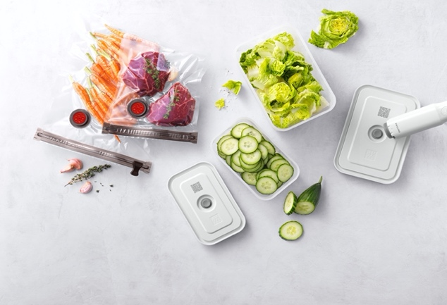

ZWILLING Fresh & Save Vacuum Bags, from £5.95 for 3 Large Bags; Vacuum Food Pump, £69.95 and Vacuum Boxes in Plastic, from £9.95
The ZWILLING FRESH & SAVE range also includes BPA-free, reusable Vacuum Bags, which can be sealed securely and simply using the included zipper. Perfect for marinating meat or fish as well as sous-vide cooking, there’s even a marinating aid that stops liquid from entering the pump. The Vacuum Bags are temperature resistant (-18˚C to +100˚C) and suitable for heating food in the microwave. The bags also feature the QR code for use with the ZWILLING Culinary World app.

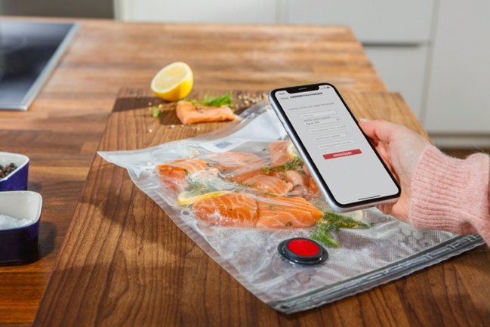

The ZWILLING Culinary World app can really help make seasonal produce go even further, as it gives users of its Fresh & Save products the ability to have a clear overview of their food storage with best before dates clearly visible. Simply scan the QR code on the Vacuum Bag or Vacuum Box lid with a smartphone or tablet and type in the contents. Select whether it’s going to be stored in the cupboard, fridge or freezer and the app will calculate the extended shelf life, reminding the user before the prepared meal or food expires. The app also includes a host of additional practical food features such as shopping lists, recipes and more.
ENDS

ZWILLING FRESH & SAVE is available from https://uk.zwilling-shop.com #freshnessextended!

For more information, high res imagery or product loans for testing and photoshoots, please contact francesca@sellerspr.com | katherine@sellerspr.com or call 01962 977950

