HARRY POTTER TOYS UPDATE – SEPTEMBER 2022
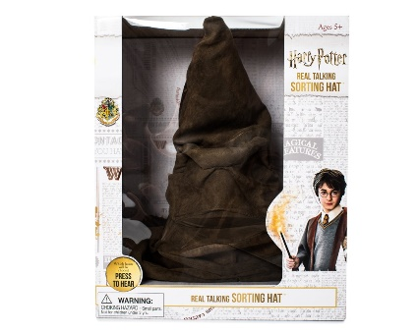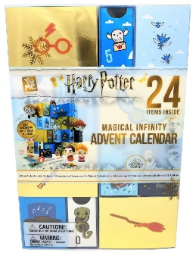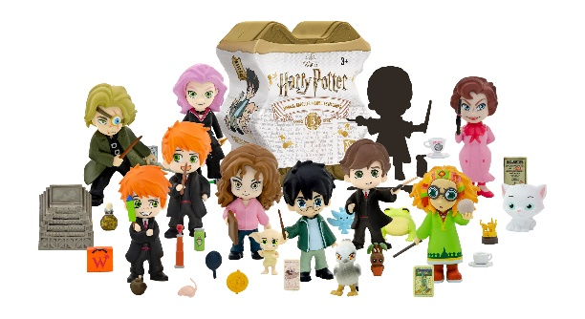
Background
In 1997 JK Rowling published her first book! Who would have thought that 25 years later we would still be seeing the level of excitement about the wizarding world that she created! Our business has been privileged to distribute Harry Potter toys since 2018 and we have seen some phenomenal results! The Real Talking Harry Potter Sorting Hat, the magical infinity advent calendar, and our Harry Potter Magical Capsules are stand out hero items across a broad range of price points!

Items
- SRP £11.99 Harry Potter Magical Capsules – on sale in Tesco, HMV, Smyths and Amazon

- SRP £39.99 Harry Potter Magical Infinity Advent Calendar – on sale on Amazon and Toynado.co.uk

- SRP £39.99 Harry Potter Sorting Hat – on sale at Smyths and Amazon

Images & More Details
HARRY POTTER

