PRESS RELEASE

Give the Gift of British Style this Christmas

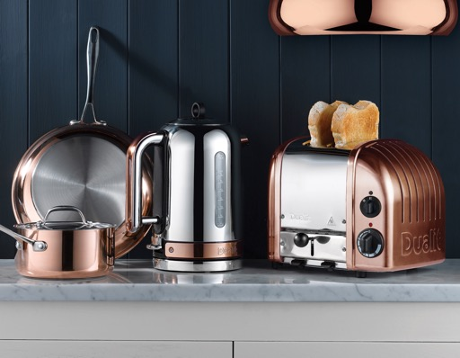

Iconic British brand, Dualit is based in the historic county of West Sussex, creating award-winning, ‘best in class’ appliances for kitchens across the world.

Whether looking for gifting ideas for Christmas or kitting out the kitchen for guests over the festive season, Dualit’s range of well-designed, expertly engineered products have got it covered.

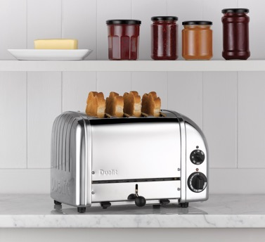

Dualit Classic NewGen 2-Slot Toaster - $299.95
Available in White, Metallic Charcoal, Polished and Copper finishes
Dualit Classic NewGen 4-Slot Toaster - $379.95
Available in White, Metallic Charcoal, Glacier Blue, Eucalyptus, Polished and Copper finishes

Bring a slice of British style into the kitchen with the iconic Classic NewGen Toaster from Dualit. Available in two- or four-slot versions, as well as an array of colours, this well-designed, award winning toaster has been hand built in the UK wince the 1950s. Every part of this stylish countertop accessory is fully replaceable or repairable for a sustainable design that will stand the test of time. Key features include award winning ProHeat® elements, a mechanical timer, the option to toast bagels and buns and an adjustable rear foot to compensate for uneven surfaces. Each toaster also features the name of the assembler proudly presented on the base plate.

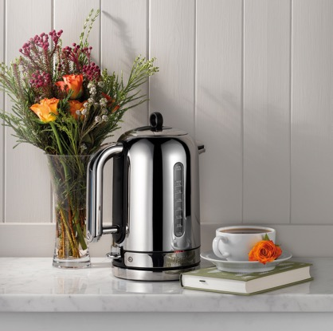

Dualit Classic Kettle - $169.95
Available in Polished and Copper finishes
Dualit’s Classic Kettle is a must for anyone who loves a designer touch in their kitchen. Adding instant wow factor to countertops, the cordless 360˚ swivel base kettle comes in two different finishes – Polished or Copper. Combining a distinctive design with engineering elegance, it also features Whisper Boil™ for a quiet boil - ideal for open-plan kitchens or a late-night drink - and is fitted with a fast 1.5kW element for a speedy boil. With a 1.7L capacity, it has two BPA-free measuring windows with cup and litre indicators so only the amount required is boiled along with anti-wobble feet, integral cord storage and boil-dry safety cut-off for peace of mind.

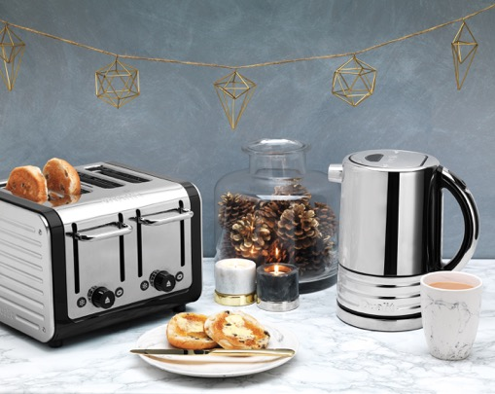

Dualit Design Series 4-Slot Toaster - $169.95
Available in Black
Dualit’s Architect range offers curvaceous styling with contemporary appeal. Patented Perfect Toast Technology® calculates the temperature of the toaster and surroundings to deliver the perfect slice every time – making it the ideal gift for breakfast lovers. Its patented Peek & Pop® function also allows users to check on the bread without stopping it from toasting.

Dualit Design Series Kettle - $129.95
Available in Black
Create the perfect gifting duo with the matching rapid boil Architect Kettle. Its Patented Pure Pour® Spout provides a uniquely smooth pouring action to prevent any drips. Handy cup level indicators and an illuminated window make gauging water levels easy for maximum efficiency and energy saving, whilst the 360-degree axis power base ensures ease of use. In addition, the push button opening mechanism keeps hands safe from hot steam, as it is not necessary to pull the lid to open it.

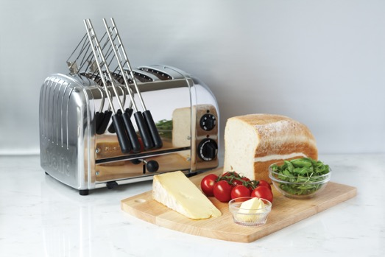
Dualit Sandwich Cage - $19.99
Available for the Classic Toaster
Turn the Dualit Classic Toaster into a toasted sandwich maker with the dedicated Sandwich Cage. The integral drip tray prevents spillages inside the appliance, meaning a wide variety of ingredients can be used. Simply clamp gently around the bread and filling, pop inside a slot holding the heatproof handles and lift out once ready.

Stockists
Appliances all available from Williams Sonoma
Dualit Sandwich Cages available from Amazon.com

About Dualit
Founded by Max Gort-Barten (CBE) in 1945, the independently owned, third generation family business continues to nurture Max’s inventive and entrepreneurial spirit. Best known for its popular Classic Toaster collection, Dualit’s most iconic appliance is still hand built in its factory in West Sussex, England. A commitment to innovation, pushing the boundaries and listening to its customers as well as relying on gut instinct to create products that combine reliability, performance and enduring design is Dualit’s mission. Invention is key to its success and inspires the Dualit family, which is reflected in over 100 patents (granted, pending or expired), design registrations and trademarks the company currently holds.

ENDS

For more information, high resolution cut out or lifestyle images, please contact: Sophie Anderson or Chloe MacDonagh at Sellers PR on +441962 977 950 or email sophie.anderson@sellerspr.com chloe@sellerspr.com

