Bottega Gold DOC Prosecco

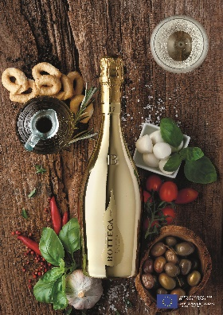
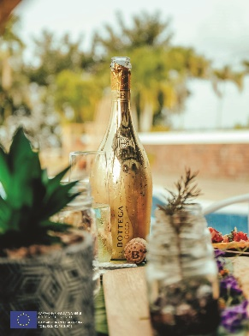
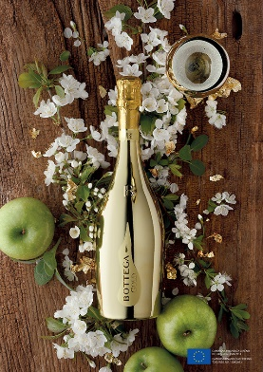

Bottega Gold DOC Prosecco, the global award-winning and high-quality Italian Prosecco, known for its luxurious gold bottle, fruity and floral notes, and crisp taste, is the perfect accompaniment for celebrations and special occasions.

The quality wine is crafted from handpicked Glera grapes grown in the hilly area of the Italian province of Treviso, in the heart of Italy’s prosecco region, close to the Venetian Prealps. Defined as “glamour sparkling” due to its distinctive gold bottle, Bottega Gold DOC is affordable and leads the accessible luxury segment of sparkling wine.

Characterised by its bright, straw-like yellow colour and a fine and persistent perlage, the Prosecco’s bouquet is refined with fruity (green apples, pear and citrus fruits) and floral (white flowers, acacia, wisteria and lily of the valley) notes with sage and spices in the finish. The taste is soft, harmonious, and elegant, with a light body and lively yet balanced acidity.

Bottega Gold Prosecco is an ideal Christmas gift or celebratory New Year’s evenings and sits beautifully as a festive table feature. Perfect also for weddings, birthdays and any other special occasion that needs the perfect festive bubbles.

A Perfect Pairing for Christmas Season
Bottega Gold is a perfect companion for festive celebrations and the perfect accompaniment as it pairs excellently with light seafood starters, steamed or raw fish dishes, grilled meat from the BBQ or delicate vegetable dishes. Or simply enjoyed as an aperitif to add sparkle to proceedings.

Bottega winery and distillery was founded in 1977 by the Bottega family, who have been vintners since 1635. The brand has a belief of marrying luxury and sustainability. The iconic gold bottle is sustainably crafted and made from environmentally water-based dye to create the sleek and sparkling bottle.

Bottega Gold DOC Prosecco, is award-winning, which includes two recent gold medals at the “The Fifty Best Sparkling Wine Tasting” and “The Prosecco Masters” by The Drinks Business.

For media enquiries, please contact:
NOTES TO EDITORS

More Information:
- Awarded with more than 50 prizes since 2010, the latest prizes include: Gold Medal at the Prosecco Masters of The Drinks Business 2021, Gold Medal at The Champagne & Sparkling Wine World Championship 2020 and Gold Medal at the Fifty Best Sparkling Wine Tasting 2021; Travel Retail Awards 2022 winner voted by shoppers.
- Bottega Gold products are available on board major airline companies and prestigious cruise ships as well as listed in upscale hotels, restaurants, clubs and casinos

About Bottega:
The Bottega company, led by Sandro, Barbara and Stefano Bottega, is both a winery and a distillery. Founded in 1977 by Aldo Bottega with the name Distilleria Bottega, the company is based in Bibano di Godega (TV), 50 km north of Venice, where it produces grappas, wines, and liqueurs for the high and medium-high market. Among the grappas, sold under the Alexander and Bottega brands, stand out the fine selections of single-grape varieties and distillates aged in barriques.

The range of Bottega wines features Prosecco, including the well-known Bottega Gold, and other sparkling wines of great character. In two direct management wineries, in Valpolicella and Montalcino, the company produces Amarone, Ripasso, Brunello di Montalcino, and other great reds. The Bottega offer is completed by the Creams & Liquors line, which features an extensive range of fruit liqueurs and creams, including Limoncino, Gianduia, and Pistacchio. The Bottega company distributes its products in 155 countries around the world.

