GETTING IN THE FESTIVE ‘SPIRIT’
Ellers Farm Distillery reveals the perfect gift for the eco-conscious this Christmas
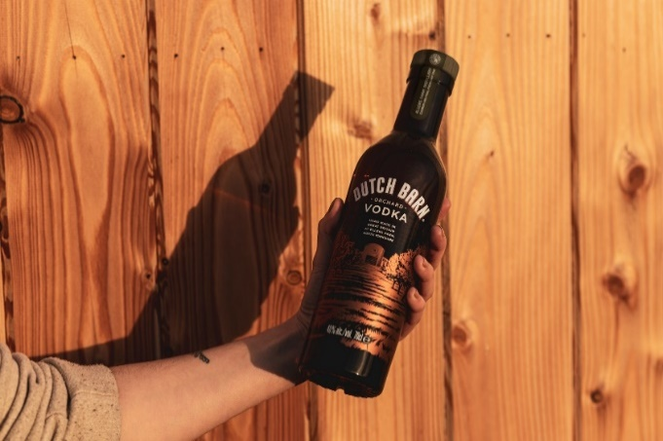
It wouldn’t be Christmas without a tipple or two, and Ellers Farm Distillery, based in North Yorkshire, has a fantastic range of versatile and unique spirits, to cater for everyone. Not only do they have a flavour combination to suit all tastebuds, but it is the perfect way to show your loved ones you care about them… and the planet.
Not only is it the perfect stocking filler, it’s also ideal to take to those Christmas gatherings for an evening of festive fun.
Whether smooth, crisp vodka is their thing, or they prefer something with a slightly fruiter flavour profile, Ellers Farm Distillery has something for all.

Dutch Barn Orchard Vodka – RRP £29
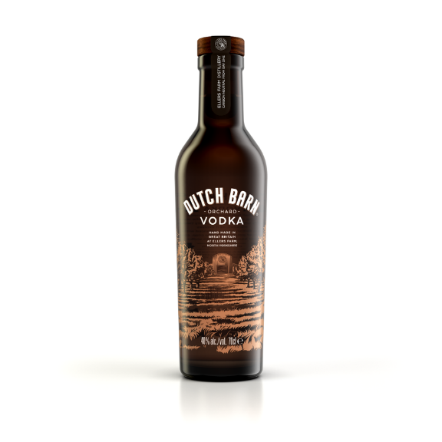
Made like no other vodka in the world by Master Distiller Jamie Baggot, Dutch Barn Orchard Vodka is tasted every 20 minutes as it evolves from British apples, balanced with a touch of potato spirit until it develops into a crisp, clean, and exceptionally smooth vodka at 40% ABV.
Coming in a standout brown glass bottle sourced from a local manufacturer, the unique bottle is scientifically proven to protect the delicate taste of vodka better than clear glass bottles, meaning it tastes just as good as the day it was bottled. On top of that, the bottle is made from 60% recycled glass, much higher than the UK average for clear glass, at just 38%.
So, if you’re looking for the perfect bottle to gift this Christmas, or even the perfect bottle to take to your Christmas get together, look no further.
Dutch Barn Orchard Vodka is available to buy direct from the website, Amazon, and Waitrose.
RRP £29 (70cl bottle)

Small Batch Spirits (4 flavours available) – RRP from £16
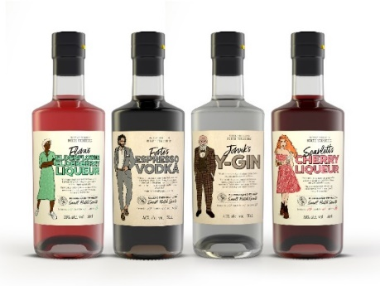
Keep spirits high this Christmas with Ellers Farm Distillery’s range of Small Batch Spirits, packed full of flavour to appeal to all sorts of tastes. Containing seasonal favourites and forgotten classics, the range includes Espresso Vodka, Y-Gin, Cherry Liqueur and Elderflower & Elderberry Liqueur – all made in the most ethical and sustainable manner possible.
Produced in limited runs of 500 bottles and hand made at the distillery to ensure each one delivers exceptional flavour, make your loved ones feel even more special this festive season.
Full of North Yorkshire character, not only do the spirits bring a modern twist to some classic flavour profiles, but they also serve as an excellent talking point, as each flavour features its own unique character: Forte, Scarlett, Prof. Jorvik and Flora, embodying the personality of the liquid inside.
Small Batch Spirits are available to buy direct from the website.
Liqueurs (Cherry and Elderflower & Elderberry) - RRP £16 (50cl bottle)
Espresso Vodka and Y-Gin (40% ABV) - RRP £24 (50cl bottle)
Gift Packs
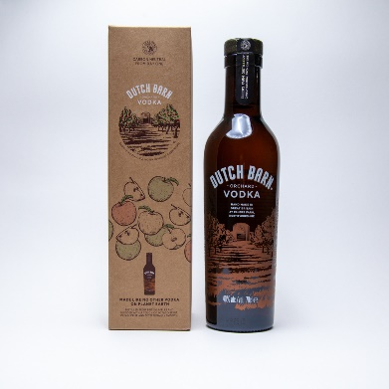

Small Batch Spirits RRP £20 & Dutch Barn Orchard Vodka RRP £40
Struggling to think of the best gift to give this Christmas? Ellers Farm Distillery has you covered! New to the range, especially for the festive period are limited edition gift packs of both Dutch Barn Orchard Vodka and Small Batch Spirits.
Small Batch Spirits gift pack allow your loved ones to try all the delicious classic flavour profiles to choose their favourite or gift a bottle of Dutch Barn Orchard Vodka with its new eco-friendly packaging. A perfect gift to treat your loved ones whilst also caring for the planet.

ENDS

Notes to Editors

For all media enquires please contact the Ellers Farm press team on ellersfarm@hatchpr.co.uk or 0113 361 3600.

About Ellers Farm Distillery
Ellers Farm Distillery is a new multi-million-pound distillery (production commenced in March 2022) based in North Yorkshire, with the ethos of balancing people, profit and planet in all aspects of operations.
Its name derives from the site it stands on – Ellers Farm - with water for all products sourced directly from the ground beneath it. In the future, Ellers Farm Distillery plans to plant 20 acres of apple trees to create an orchard that will bear fruit for its flagship product, Dutch Barn Orchard Vodka.
The distillery also produces the Small Batch Spirits Range, which includes Scarlett’s Cherry Liqueur, Forte’s Espresso Vodka, Flora’s Elderflower and Elderberry Liqueur and Jorvik’s Gin – all perfect ingredients for at home mixing.
Soon to come are distillery tours, welcoming people from near and far. Not only will the visitors be able to see working stills, but also be able to experience Ellers Farm Distillery’s sustainable ethos and enjoy a glass of one of its products.
Ellers Farm Distillery products are available nationwide from Waitrose as well as online at Amazon, its own website and multiple online drinks retailers.
To find out more, visit https://www.ellersfarmdistillery.com/.

About Dutch Barn Orchard Vodka
Dutch Barn Orchard Vodka is made like no other vodka on planet Earth. The liquid is distilled from British apples and balanced with a touch of potato spirit, and tasted every 20 minutes throughout the process until it develops into a crisp, clean, and exceptionally smooth vodka at 40% ABV.
It is a spirit looking to change the way we think about drinks in relation to our planet, built on two simple pillars: to make the world's best vodka and do it in the most sustainable and ethical manner.
Dutch Barn Vodka is in-store in Waitrose as well as online from Amazon, online drinks retailers and the Dutch Barn Orchard Vodka website at a RRP £29.
To find out more, please visit https://dutchbarn.com/ and follow @dutchbarnvodka.

York University Study comparing amber glass with flint in the protection of vodka

