Personalised Christmas gifts that celebrate treasured memories
Put the magic into Christmas this year by treating your loved ones to a gift that is completely unique and meaningful to them. Whether you’re shopping for a sentimental gift for a partner, something thoughtful for a friend or a fun stocking filler, CEWE has the perfect gift to help them celebrate their favourite memories this festive period.
Here’s a selection of CEWE’s most loved festive gifts for this year:
Stocking fillers under £10:
Photo Snow Globe – £6.99

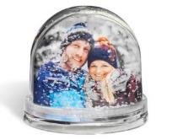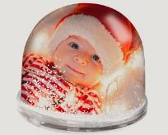

A gift that is perfectly festive and makes an ideal stocking filler. The Photo Snow Globe can be personalised with a photo and text of your choice and comes complete with artificial snowflakes, for that extra Christmas touch.

Photo calendars – from £9.99
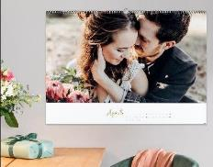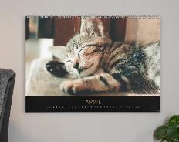
For a gift that they can appreciate all year round, a personalised photo calendar is the perfect choice. Every month throughout the new year they’ll be reminded of a happy memory, helping to brighten up their workspace or keep a busy home life organised. Choose the size and style that will suit them, from kitchen and appointment calendars, to desktop calendars and year planners.

Photo Mugs - from £7.99
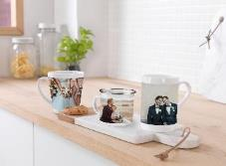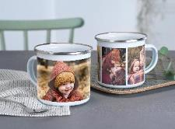
This thoughtful gift will be the perfect way to start their mornings, reminding them of a treasured memory with every brew! Choose a photo, drawing or text of your choice that is sure to put a smile on their face. This is the perfect secret Santa gift for a colleague or a unique present for a loved one.
Pocket & Mini Photo Book – from £5.99

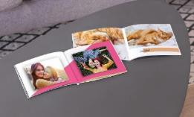

A pocket photobook is the perfect gift to share your favourite moments with your friends and family this Christmas. Its compact nature means they can take it with them wherever they go, and will always be reminded of their favourite memories.

Jigsaws – from £9.99

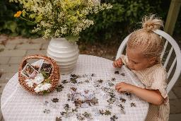

This gift is sure to provide plenty of entertainment over the festive period – for both kids and adults! Create a unique original Ravensburger jigsaw puzzle that features a photo or text of your choice. Choose from a portrait of a beloved pet, a group family photo or a piece of artwork by the kids.

Thoughtful gifts under £20:
Phone cases – from £14.99

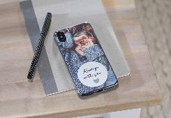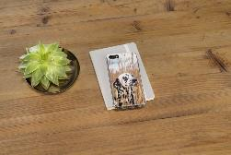

If you’re shopping for someone who always has their phone in their hand, a personalised photo phone case is the perfect gift! Add their favourite family photo, an image of a well-loved pet or something that will make them smile. A unique gift that they’ll utilise every day of the year.

Classic Canvas Prints - from £12.99
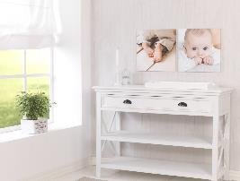
A beautiful gift for a loved one to display a treasured moment in their home. Choose from a family memory, a newborn photoshoot or your favourite photo of the two of the you – it’s something that they can appreciate all year round and will brighten up any room in the house.
Square and Heart Shaped Photo Magnets – from £14.99
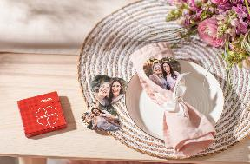
This set of 10 personalised magnets is a unique gift that will help them brighten up any magnetic space in their home or workplace. Customise them with all their favourite photos whether it’s a holiday or milestone. They’re sure to smile when they open this gift.

Unique gifts under £30:
Large Landscape Photo Book – from £20.99
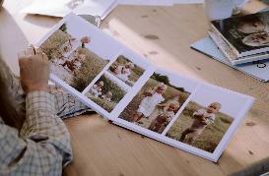

The perfect sentimental gift that shows them just how much you care this Christmas. With every page, they’ll be filled with joy as they get to look back at their favourite memories and moments you’ve shared. This large photo book would make the perfect gift to display wedding photos, travel memories or as a family photo album.

Photo Gift Box filled with Ferrero Chocolates– from £24.99

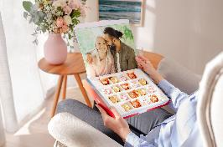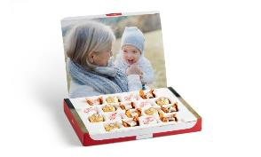

If you’re shopping for someone with a sweet tooth, this is the perfect gift for them! A photo gift box containing three varieties of Ferrero Chocolates. You can personalise the inside and outside of the gift box with text and images of your choice. A uniquely delicious Christmas gift.

Wood Prints - from £24.99

If the person you’re buying for has a rustic décor theme in their home, this is the perfect gift for them. A beautifully unique piece of wall art that captures a treasured memory and can be admired for the years to come.

ENDS

For more information, contact the CEWE PR team on cewe@prohibitionpr.co.uk or call 0113 4304 160
About CEWE
CEWE is Europe’s leading photo printing company, known for its passion for photography and commitment to delivering outstanding print quality. CEWE is dedicated to helping people share their memories by producing millions of personalised photo products each year.

One of its most successful innovations is the award winning CEWE PHOTOBOOK. Drawing on 50 years of printing experience, the CEWE PHOTOBOOK has been voted the best in the world by the experts at TIPA (Technical Image Press Association).

Based in Warwick near Royal Leamington Spa, the company’s state of the art production facility houses some of the very latest in printing technology and prints photo books, wall art, calendars, gifts and more. Combining your creativity with the CEWE craftsmanship is the best way to share the photographs you love the most. For more information about CEWE, visit: https://www.cewe.co.uk/

