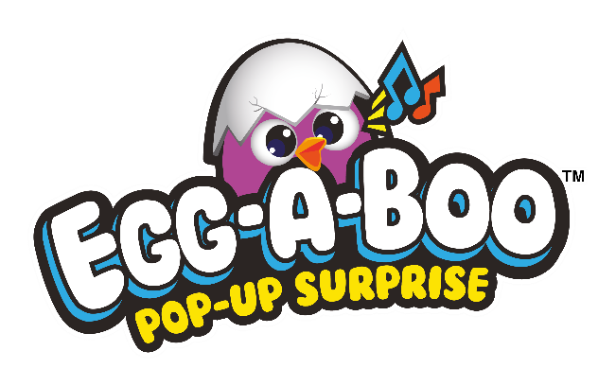

Play Peek-a-Boo with Egg-A-Boo!

Discover where the chick is hiding with this cracking new interactive surprise reveal egg hunt themed toy from Mookie!

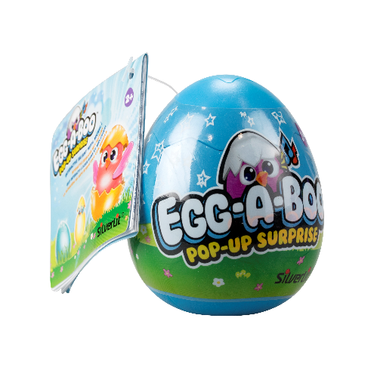
Hide and seek has never been so much fun with Egg-A-Boo (RRP £3.99), the brightly coloured interactive pre-school play set that will provide hours of ‘egg-citing’ hunt and reveal activities for little ones.

Containing two surprise eggs each with distinctive sounds and melodies, each Egg-A-Boo is a fun, indoor or outdoor hide and seek game where you can hunt to find each egg to reveal the cute little chick concealed inside!

With three modes of play to help you find the Egg-A-Boo, listen out for the hatchling tweets as a clue to where Egg-A-Boo is hiding. Simply tap the top of the egg with a metal spoon to hatch the chick and ‘egg’citingly reveal what’s inside! Once revealed, the Egg-A-Boo will happily tweet away and sing. For added fun, gently push up and down on top of the hatchling to encourage them to sing a variety of songs.

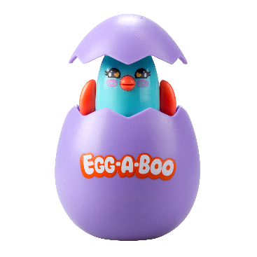
With six coll’egg’table Egg-A-Boos in the range, children aged 2+ can explore and play with this colourful, interactive toy – a perfect gift!

-Ends-

Notes to editor:
Egg-a-Boo is suitable for children aged 2+ and is available now from all good toy retailers and online.

