
Hisense Unveils AI-Powered ‘Dish Designer’ to Revolutionise Meal Planning and Smart Home Cooking
Latest software from the leading appliance manufacturer to offer UK consumers additional support in the kitchen and also help to reduce food waste with AI-powered meal planning tool
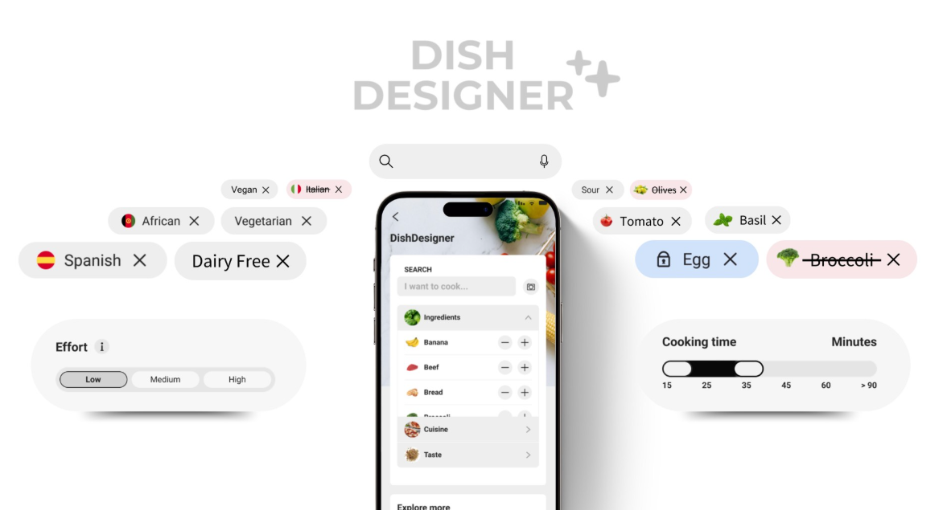
Hisense has announced the launch of ‘Dish Designer’, the next generation AI-powered meal planning tool as part of the brand’s ConnectLife smart home platform. Representing a significant evolution in intelligent kitchen living, Dish Designer brings personalised culinary experiences to everyday households, transforming the way people plan, cook, and enjoy meals.
Part of the latest software upgrade to the ConnectLife app, Dish Designer leverages generative AI to offer limitless customised recipe suggestions based on ingredients consumers already have in their kitchen, taking into account dietary restrictions of members of the household.
With convenience at the heart of the development, users can input time constraints and preferred effort levels, with Dish Designer generating matching recipes ranging from a variety of cuisines that can be tailored to special occasions. It is also designed with sustainability in mind, inspiring people to utilise leftover ingredients that remain within their fridges, and in turn helping to limit food waste.
Developed in collaboration with Microsoft’s Azure AI Studio, Dish Designer’s capabilities extend into meal planning with intelligent features such as AI Food Recognition. Consumers can simply take a picture of the food in their fridge or cupboards and the tool will automatically add all items to the inventory function in the app, with the Randomiser feature also generating creative recipe inspiration.
To enhance weeknight meals, users can even get an overview of their wine inventory from their wine climate cabinets and get pairing recommendations and serve their dinner to perfection.
Matthew Glynn, Senior Product Marketing Manager at Hisense, commented: “Dish Designer is a huge leap forward in smart kitchen technology. It reflects our commitment to using AI not just for automation, but for meaningful, everyday improvements.
“Whether you're a busy parent trying to make the most of what’s in your fridge, or a foodie looking for your next culinary fix, Dish Designer brings convenience and creativity into your kitchen with limitless possibilities that ensures we never have to have the same meals on rotation.”
ConnectLife is Hisense’s flagship smart home ecosystem, available on Apple iOS, Android, and through the VIDAA platform. With deep integration across Hisense smart appliances, the app provides seamless automation offering real-time monitoring, and energy-saving controls like AI Eco Mode.
For hands-free operation, users can assess ingredients in their fridge freezer with compatible models with a single tap, such as the Hisense RS9P628GPFE American-Style Fridge Freezer, while sending optimal preheating and cooking timings directly to their oven with just the click of a button.
As the smart home landscape continues to evolve, Hisense’s ConnectLife platform reaffirms the brand’s leadership in innovation, combining cutting-edge AI with intuitive design to deliver powerful, personalised experiences that adapt to busy modern life.
To find out more about the Hisense’s products, visit: https://uk.hisense.com/.

ENDS

For more information, please contact the Hisense UK team at Hatch: hisense@hatch.group / 0113 361 3600.

About Hisense
Founded over 50 years ago in China in 1969, Hisense is a leading global home appliance and consumer electronics brand and was Official Partner of the UEFA EURO 2024™, following on from past tournament sponsorship in 2016 and 2020, and a successful sponsorship of FIFA World Cup 2022™.
Hisense UK is headquartered in Leeds. The brand has a core range of televisions and cooling appliances, alongside a portfolio of cooking and laundry products, featuring hobs, hoods, ovens, dishwashers and washing machines.
According to Omdia, Hisense ranked No. 2 globally for TV shipments and No. 1 in 100" TVs in both 2023 and Q1 2024. The company has expanded quickly to operate in more than 160 countries and specialises in multi-media goods, home appliances, and intelligent IT information. Hisense continuously invests in research and development and has over 100,000 employees worldwide. For more information visit https://uk.hisense.com/.

