Gift Guide under £20

Looking for a unique gift for kids for under £20? STEM robotics toy manufacturer HEXBUG has a range of collectible toys and playsets that don’t break the bank.

The full range is available now on Amazon and the HEXBUG website, as well as Smyths Toys, The Entertainer, Toymaster and other local independent retailers.

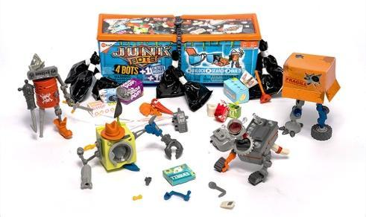
Junkbots Industrial Dumpster
RRP: £19.99
Get ready for the ultimate construction adventure with the Junkbots Industrial Dumpster. This epic set is perfect for little builders. As kids unbox and dig around in the trash for the Junkbot pieces, they’ll find over 50 pieces to help them build four different figures. They can animate their bots with a motor or dynamic vibrations, and add the light-up cover for even more fun.
Mobots: Ramblez
RRP: £14.99
Ramblez likes to drive around and explore. Clap your hands twice to make him enter into dance mode where he will drive around in fun patterns. You can also record voice messages and play them back with effects.

The HEXBUG nano® Flash Orbit Set
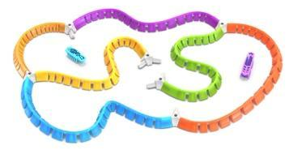
RRP: £14.99
Race your HEXBUGs around your course and prepare to be mesmerised as they shine their way through different environments, and land back on their feet if they overturn hitting obstacles thanks to their innovative technology.

HEXBUG nano Nitro 5 pack
RRP: £19.99
The next generation of the HEXBUG nano, the HEXBUG nano Nitro Five Pack is the ideal set for the nano collector. These little bugs are turbo charged and ready for action. Scaling up tubes, around corners and across the floor, nano Nitro is faster at covering more ground than ever.
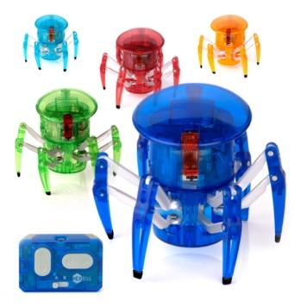
HEXBUG Spider
RRP: £19.99
The six-legged robotic creature that you control. Featuring 360 degree steering and an LED forward eye, you can manoeuvre it around objects and control precisely where it scurries. Available in red, green, blue, orange and teal.

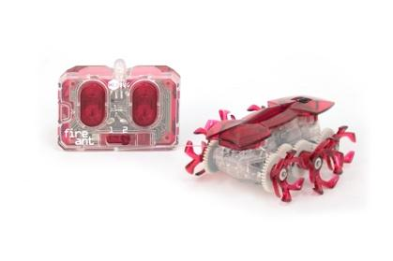
HEXBUG Fire Ant
RRP: £14.99
The high-speed robotic creature that you can control! This speedy robotic bug lights up and features six custom wheels to boost its ability to move around obstacles in its path.

The full HEXBUG range is available now on www.hexbug.com and Amazon.

ENDS

For further information, please contact Laurissa Hackett (laurissa@fullvolumepr.co.uk) or Cait Naven (cait@fullvolumepr.co.uk) at Full Volume PR.

