KID MADE MODERN TOYS UPDATE – SEPTEMBER 2022
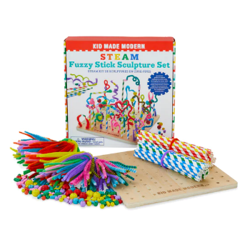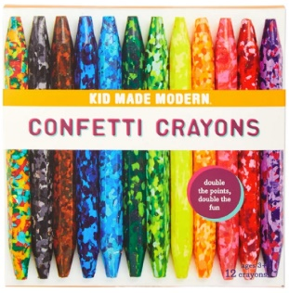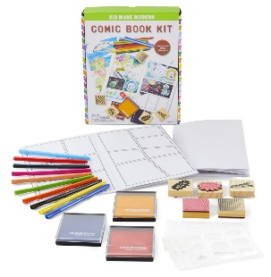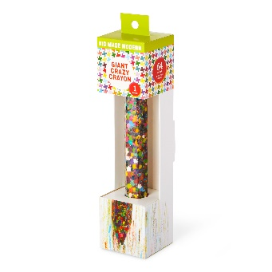
Background
In 2019 we brought Kid Made Modern to the UK & Ireland and we have now established this fantastic Arts & Crafts range in a number of high profile retail locations. Royal Academy of Arts and Selfridges to name just two! Each year we bring new items into the market and 2022 sees us introduce some STEAM approved product alongside some of our every day favourites such as the Comic Book Kit and those Confetti Crayons.

Items
- SRP £11.99 Confetti Crayons – on sale in Royal Academy of Arts, Selfridges and Very
- SRP £11.99 Giant Crazy Crayon – on sale in Selfridges and Very
- SRP £24.99 Comic Book Kit – on sale at Amazon
- SRP £24.99 STEAM Fuzzy Stick Sculpture Kit – on sale in Selfridges
- SRP £24.99 Head in the Clouds Craft Kit – on sale in Selfridges & Very
- SRP £29.99 STEAM Paint Exploration Kit – on sale in Selfridges
- SRP £32.99 Dino Themed Craft Kit – on sale in Selfridges & Very

Images & More Details
KID MADE MODERN

