SAVE THE TURTLES! NEW RUM OFFERS MORE THAN A TASTE OF THE CARIBBEAN
Hawksbill Caribbean Spiced Rum pledges support for endangered Hawksbill turtle
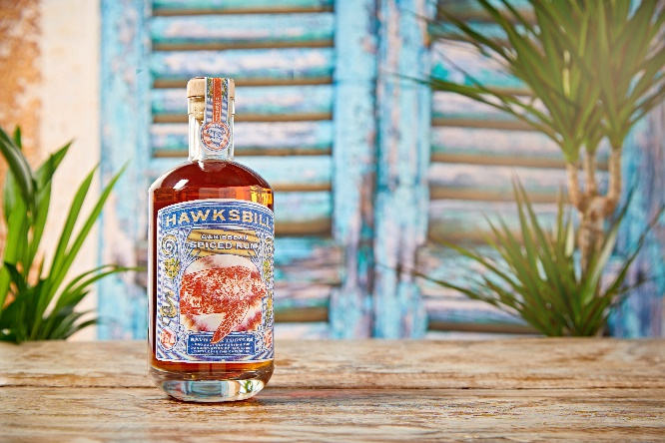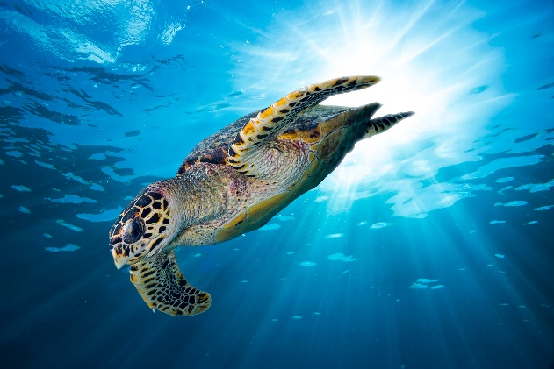
A new Caribbean spiced rum has launched with more than impeccable taste on its agenda. Hawksbill Caribbean Spiced Rum – the latest product launch from Intercontinental Brands (ICB), brings together the very best Caribbean rums from Trinidad and Guyana, along with its own distinctive blend of spices, and combines its delectable liquid with a truly worthy cause: helping to save the endangered turtles for which the brand is named.
Populations of the beautiful Hawksbill turtle have been in rapid decline, and Hawksbill has committed to helping reverse that deterioration and boosting populations of these incredible creatures. Hawksbill is partnering with the Barbados Sea Turtle Project, based at the University of the West Indies, whose mission is to recover marine turtle populations. 10% of the profits from Hawksbill sales will go directly towards turtle conservation projects in the Caribbean, helping to protect the environment of the Hawksbill Turtle and preserve its future.
Clare Gibson, Marketing Director at ICB, said: “We’re hugely excited about the launch of Hawksbill Caribbean Spiced Rum. This is a project which has been in the works for a while and is really close to our hearts.
“The opportunity to not only produce a drink that we hope will be hugely popular because of its superior taste and origin, but also create something which will make a tangible positive impact on these majestic creatures which so need our support, is something we’re really proud of and can’t wait to share with our customers.”
Hawksbill is available for £23 from Amazon.
To find out more about Hawksbill, check out @hawksbillrum on Instagram.
About the Hawksbill turtle
The critically endangered Hawksbill turtle is facing possible extinction. These beautiful creatures really do have it bad. If they’re not being hunted for their beautiful striking shell, they’re being harvested for their meat and eggs, resulting in populations which are severely depleted globally.
Like other sea turtles, Hawksbills make incredible migratory journeys in order to move from feeding sites to nesting grounds, normally on tropical beaches. Coastal development with luxury resorts have unfortunately made it difficult for our turtle friends to find a suitable nesting place.
[ENDS]
Notes to Editors
For all media enquiries please contact the Hawksbill Press Team on ICB@hatchpr.co.uk and 0113 361 3600.
About Hawksbill Caribbean Spiced Rum
Hawksbill Caribbean Spiced Rum uses a blend of rums sourced from Guyana and Trinidad, supplemented with a unique blend of spices. Sweet Vanilla floats across the palate before a wave of toasted nutmeg, cinnamon, and raisin breaks, allowing a hint of cardamom and sea salt to nestle on the taste buds. 38.8% ABV.
Hawksbill Caribbean Spiced Rum Serves
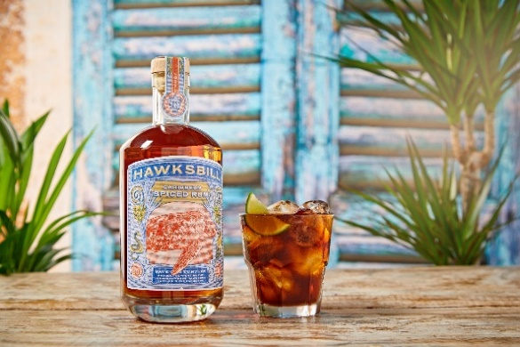
Spiced Cuba Libre
- 50ml Hawksbill Caribbean Spiced Rum
- Cola
- Lime
- Ice
Pour 50ml Hawksbill Spiced Rum into glass filled with ice. Top with cola, squeeze a wedge of lime and stir gently. Garnish with a fresh lime wedge and enjoy in good company.
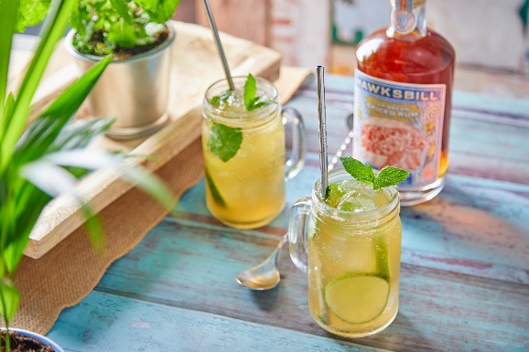
Hawksbill Mojito
- 50ml Hawksbill Caribbean Spiced Rum
- 10ml simple syrup (50/50 water and sugar)
- Ginger Ale
- Lime
- Ice
Muddle 2 lime wedges, mint and 10ml simple syrup in a glass. Fill with ice, 50ml Hawksbill Spiced Rum and top with ginger ale. Garnish with fresh mint sprig.

