Hawksbill Rum Cocktails

Download imagery here: https://we.tl/t-YqSCm0vCPQ

- Piña Colada
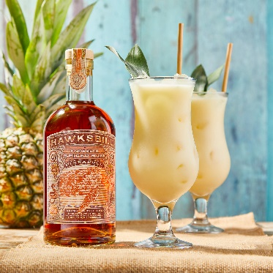
- 30ml Hawksbill Pineapple Rum
- 30ml White Rum
- 100ml Pineapple Juice
- 60ml Coconut Cream
- 10ml Lime Juice
Shake all the ingredients with ice and then pour into a tall glass filled with ice and then garnish with a pineapple wedge.

- Spiced Tea
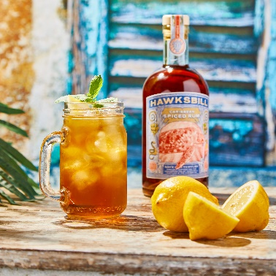
- 50ml Hawksbill Caribbean Spiced Rum
- 200ml Lemon Iced Tea
Build in a highball glass with cubed ice. Garnish with a lemon wedge and mint spring.

- Hawksbill Rum Punch Ice Lollies
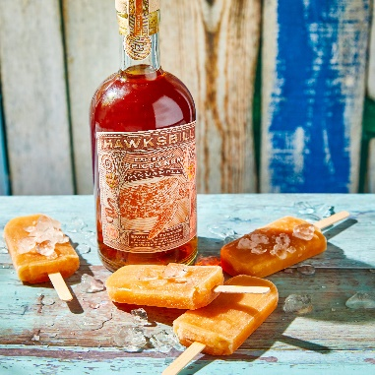
- 1 part Hawksbill Pineapple Rum
- 1 part Pineapple Juice
- 1 part Orange or Cranberry Juice
- Squeeze of Lime Juice
- A drop of Disaranno or Orgeat
Mix everything together in a jug and then pour into your ice lolly moulds. Freeze for 1-2 hours and then push lolly sticks into the mixture and then leave until fully set. As tempting as it is, don’t go too heavy on the rum otherwise they’ll take longer to set!

- Mango Coke Float
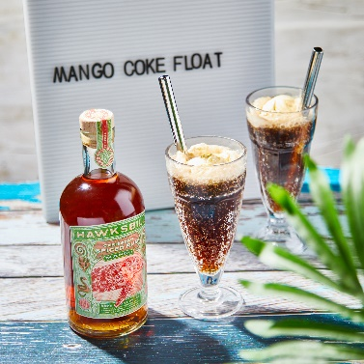
- 50ml Hawksbill Mango Spiced Rum
- 200ml Cola
- 1 Scoop of Vanilla Ice Cream
Add your Mango rum and coke to a glass with ice and stir. Top the glass with your scoop of ice cream and enjoy through a metal or bamboo straw.

- Hurricane
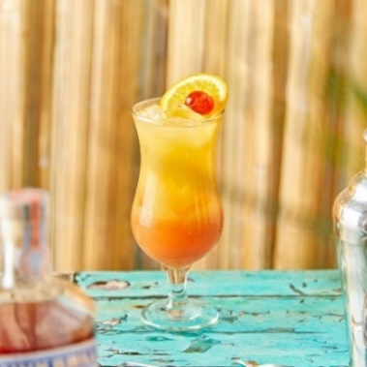

- 50ml Hawksbill Caribbean Spiced Rum
- 25ml lime juice
- 25ml passionfruit syrup
- 25ml Orange juice
- 10ml Grenadine

Shake all ingredients with ice until nearly fully dissolved. Pour into a hurricane glass filled with crushed ice and garnish with an orange slice and cocktail cherry.

- Dark ‘n Stormy
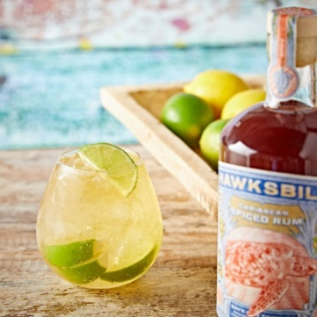

- 60ml Hawksbill Caribbean Spiced Rum
- Ginger beer
- A couple of lime wedges
Think of the Dark ‘n’ Stormy as a slightly elevated rum and coke. Pour the rum into a glass over ice, top with ginger beer and garnish with a couple of lime wedges, squeezing them before you drop them in. Enjoy!

- Mai Tai
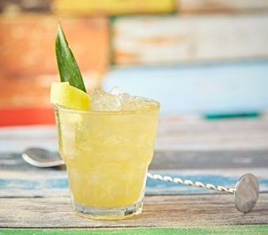

- 35ml Hawksbill Caribbean Spiced Rum
- 25ml rhubarb gin (We recommend Slingsby Gin)
- 10ml triple sec
- 10ml lime juice
- 15ml grapefruit juice
- 10ml orgeat syrup
- 50ml pineapple juice
Shake all ingredients over ice, then pour into a double old-fashioned glass. Fill to rim with crushed ice. Garnish with a pineapple leaf and grapefruit peel twist.

