SmartyPlants: The Smart Sensor Revolutionising Houseplant Care
Ben Beavers’ partner had a history of being a serial plant killer, with dozens of victims and a sole survivor, an incredibly resilient cactus that miraculously survived six years and four house moves. When she wanted to bring more greenery into their redecorated living room, Ben decided to tackle the challenge head on.
Drawing on his background in biology and technology, he set out to create a solution that would make plant care effortless. After countless prototypes, trials and refinements, he built a breakthrough device that gives plants a voice by monitoring moisture, light, temperature and nutrients in real time.
The result? SmartyPlants, a smart sensor and companion app that takes the guesswork out of plant care.

From Prototype to Kickstarter Success
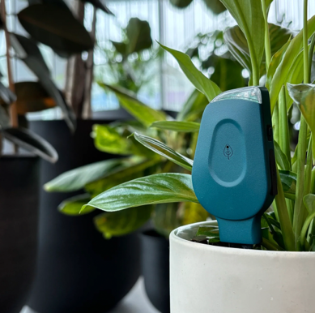
What started as a personal project quickly struck a chord with frustrated plant owners everywhere. After friends began asking where they could get one, Ben launched SmartyPlants on Kickstarter.
The campaign resonated globally, raising more than £140,000 from 1500 backers in 49 countries, proving just how widespread the need for this product is.
With more than 44.9 million houseplant owners in the UK alone*, it’s no surprise that millions of plants perish each year and in 90% of cases this is due to easily preventable issues like underwatering or poor light.
SmartyPlants combines sensor innovation with smart data analytics to solve this problem, so everyone can enjoy happier, healthier and hassle-free plants.
How it works
- Stick it in the soil: The sensor measures light, temperature, humidity, soil moisture and soil nutrients.
- Connect to the app: Data is analysed and turned into tailored, actionable plant care guidance, delivered in real-time via the free SmartyPlants app.
- Let your plant do the talking: Plant parents receive clear, simple care instructions so their greenery can thrive, with no more second-guessing.
With WiFi connectivity and rechargeable batteries lasting three months per charge, plant owners can check in from anywhere and keep their greenery thriving all year round.

Product Details (Available from late October at www.smartyplants.ai)
- SmartyPlants Single Stem: Available in green or grey - £39.99 each
- Multi-Pack Options: Available in green or grey - 3 Pack (£99.99), 5 Pack (£154.99), 10 Pack (£289.99)
-ends-
Media Contact:
Holly James | holly@hollyjamespr.com | 07578 929 729
Press Imagery: Download high-resolution images and logos at this link or via Press Loft.
Source: Barratt Homes Survey August 2025 – 78% of UK adults own houseplants, equating to 44.9 million people.
https://www.barratthomes.co.uk/advice-and-inspiration/a-beginners-guide-to-houseplants/

