AMONG US TOYS UPDATE – SEPTEMBER 2022
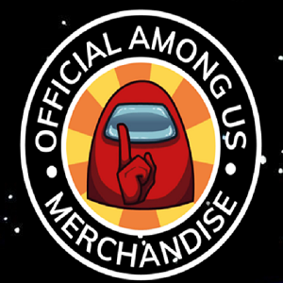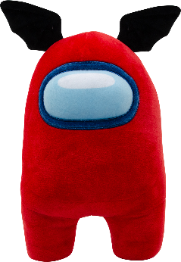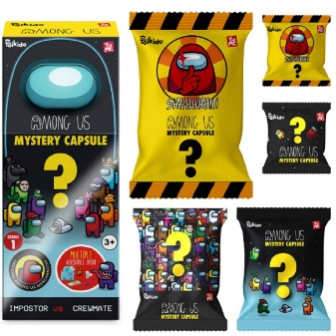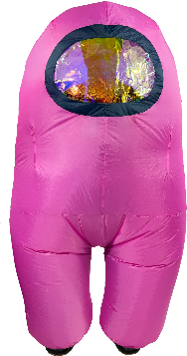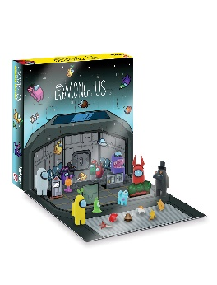
Background
In 2021 Among Us was downloaded in excess of 20,000,000 times in the UK & Ireland. This game became a phenomenon driven by lockdown but played by social gamers of all ages globally. It was against this backdrop that Toikido secured the rights to make toys for this game and KAP TOYS LTD distributed them for the UK & Ireland.
The items came late and the stock flew out so the sales trend has continued throughout 2022!
Items
- SRP £11.99 Among Us Mystery Capsules – on sale in Tesco, HMV, Smyths and Amazon
- SRP £19.99 12” Soft toys – on sale in Tesco, HMV, Amazon and Toynado.co.uk
- SRP £29.99 Among Us Advent Calendar – on sale at Toynado.co.uk
- SRP £29.99 16” Huggable plush – on sale in HMV, Amazon, and Toynado.co.uk
- SRP £29.99 12” Feature plush – on sale in HMV, Amazon, and Toynado.co.uk
- SRP £49.99 Kids Dress Up – on sale in HMV, Amazon, and Toynado.co.uk
- SRP £59.99 Adult Dress Up – on sale in HMV, Amazon, and Toynado.co.uk
Images & More Details
AMONG US
Awards that this range has won
BlogOn Toy Awards - Christmas - 1st Place
Among Us Official Advent Calendar
BlogOn Toy Award Imagination toys 1st Place
Among Us Official Inflatable Dress Up Suit
Plush/dolls 1st Place
Among Us Supersoft Huggable plush
BlogOn Toy Awards Collectibles 2nd Place
Among Us Mystery Capsules
Joint Blogger's Choice Award
Among Us Official Inflatable Dress Up Suit

