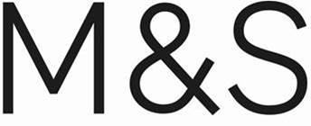

Everyday Style & Trusted Value

School Happens
Back to School 2024 at M&S

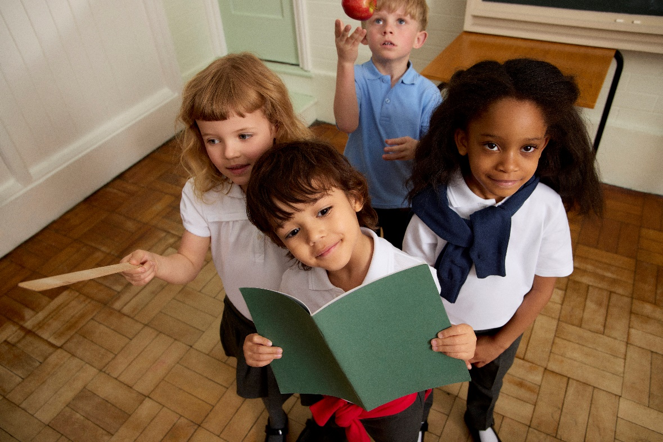

M&S 3PK UNISEX STAIN RESIST POLO SHIRTS (2-18 YRS) £7 - £15 / M&S 2PK BOYS' SLIM LEG TROUSERS (2-18 YRS) £11 - £17 / M&S 2PK GIRLS' JERSEY POLO SHIRTS (2-18 YRS) £7 - £10 / M&S 2PK GIRLS' JERSEY BOW SKIRTS (2-14 YRS) £12 - £18 / M&S 2PK UNISEX PURE COTTON JUMPER (3-18 YRS) £11 - £17 / M&S 2PK GIRLS' SLIM LEG TROUSERS (2-18 YRS) £11 - £17

DOWNLOAD HIGH-RES IMAGERY HERE

Designed to be durable and pass the ‘hand-me-down’ quality test, our school uniform range promises long-lasting quality at trusted value with a 100-day guarantee.*. With repellent finishes for added durability, crease-resistant fabrics and scuff-resistant shoes, our tried and trusted uniforms will let kids enjoy work and play from registration until home time.

At M&S Kids we offer thoughtfully designed, elevated, every day Kidswear for a New Generation. Across the Back to School range you’ll find innovative design features that grow with children, from growth proof hems and adjustable waistbands to parent-friendly innovations such as our clever StayNew™ technology that reduces bobbling and colour loss, keeping them looking smarter for longer.
From multi-pack shirts and jumpers to pinafores and trousers, M&S has everything you need to have the kids looking picture perfect on their first day back with sizes starting at age two through to 18 years.

Alexandra Dimitriu, Kidswear Director at M&S, commented: “As the UK market leaders during the Back-to-School season, trusted value, hand-me-down quality and exceptional service sit at the heart of what we offer. This year, we’ve done everything we can to bring this to life for families, from our hold on prices to investment in school uniform advisors, no matter how, when and where our customers are shopping, we’re making the Back-to-School shop as seamless as possible.”

Back to School Price Lock:
Invest in market leading quality uniform with multipack prices from just £5 - we are excited to announce the continuation of our price lock across our uniform offering for the fourth consecutive year since 2021.

Back to School Deals:
Also, back by popular demand, from July 2nd M&S will be offering an additional 20% off school uniform for early bird shoppers for a limited time only to help parent’s get prepped ahead of term.

Back to School Uniform Advisors:
No matter when, where or how you choose to shop, make Back-To-School shopping a breeze with our dedicated in-store uniform advisors. For 2024, M&S will offer expert advice in over 120 Clothing & Home stores to help parents navigate the busy Back-to-School season.

YoungMinds:
Here at M&S, we understand that first days can be daunting and that’s we’ve partnered with YoungMinds to support little one’s during the transition back into the classroom. Explore top tips with YoungMinds Mental Health Guide from first day nerves to navigating results day and find out how we can support young minds, because together, we’ve got this.

Another life.
Introducing Another life., the new home for M&S' recycling initiatives with Oxfam and HANDLE, as well as future circularity initiatives. Through this initiative, customers can donate their pre-loved M&S school uniform into our Another life boxes, located in all stores across the UK and ROI. Once donated, customers can scan the QR code located above the box to receive a fantastic 20% of Kids daywear offer through their Sparks account**.

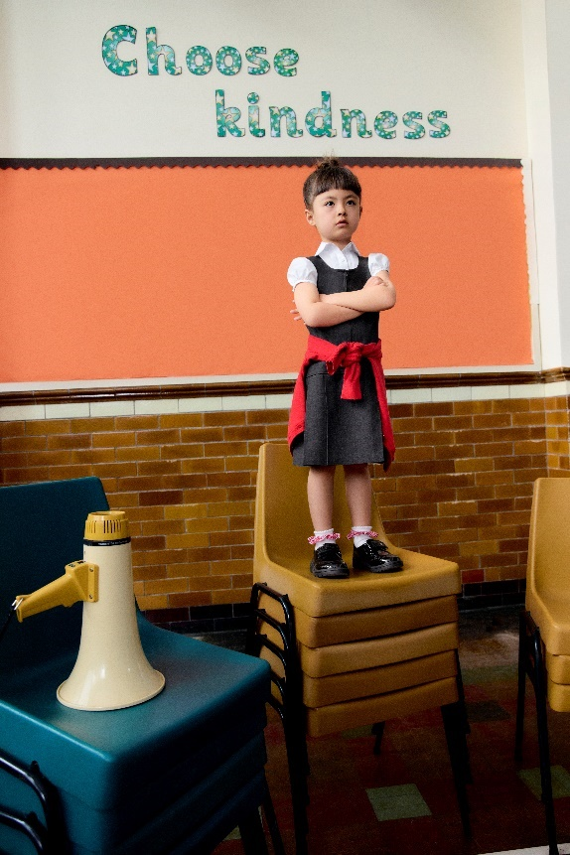  M&S 2PK GIRLS' PINTUCK EASY IRON SHIRTS (2-16 YRS) £9 - £15 / M&S 2PK GIRLS’ PLEATED PINAFORES (2-12 YRS) £12 - £16 / M&S 2PK GIRLS' CARDIGAN (3-18 YRS) £13 - £19 / M&S 4PK SCHOOL SOCKS (6 SMALL TO 7 LARGE) £6 - £7 |  | 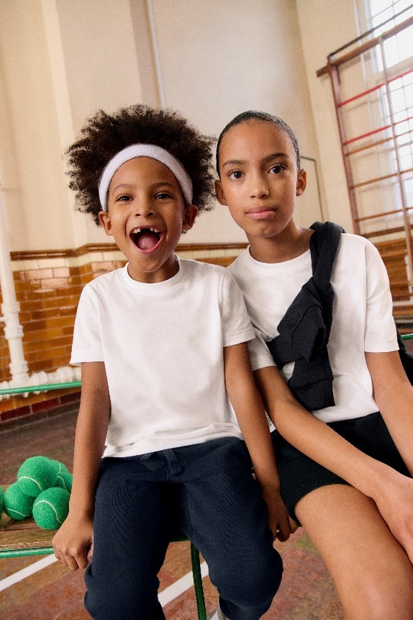  M&S 2PK UNISEX SCHOOL T-SHIRTS (2-16 YRS) £5 - £11 / M&S 2PK UNISEX SCHOOL JOGGERS (2-16 YRS) £14 - £20 / GOODMOVE UNISEX SCHOOL SWEATSHIRT (3-16 YRS) £6 - £9 / M&S GOODMOVE SCHOOL SKORT £6 - £9
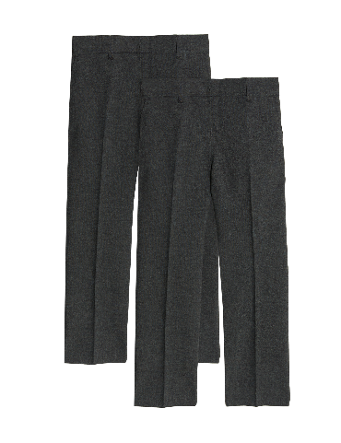 | 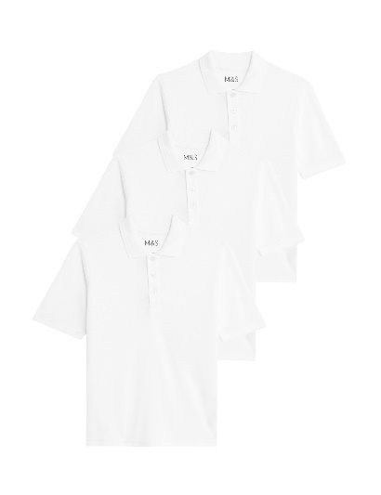 |  | 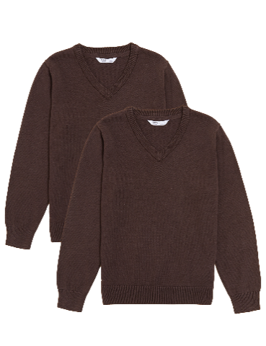
M&S 2PK BOYS' REGULAR LEG SCHOOL TROUSERS (2-18 YRS)  £11 - £17 | M&S 3PK UNISEX STAIN RESIST SCHOOL POLO SHIRTS (2-18 YRS)  £7 – £15 |  | M&S 2PK UNISEX PURE COTTON SCHOOL JUMPER (3-18 YRS)  £11 - £17
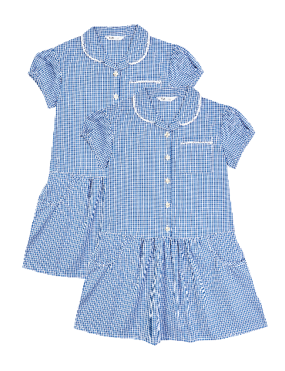 | 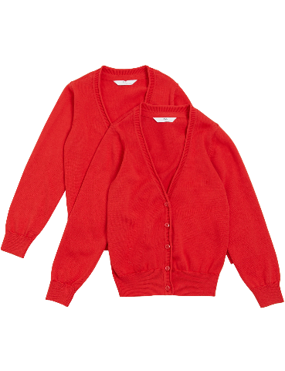 |  | 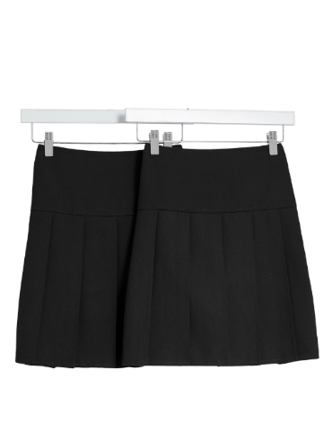
M&S 2PK GIRLS' COTTON RICH GINGHAM SCHOOL DRESSES (2-14 YRS)  £12 - £16 | M&S 2PK GIRLS' PURE COTTON SCHOOL CARDIGAN (3-18 YRS)  £13 - £19 |  | M&S 2PK GIRLS' PLEATED SCHOOL SKIRTS (2-18 YRS)  £10 - £16
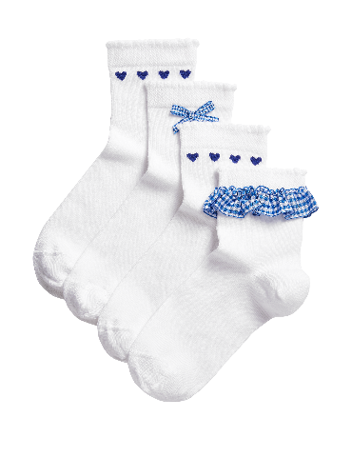 | 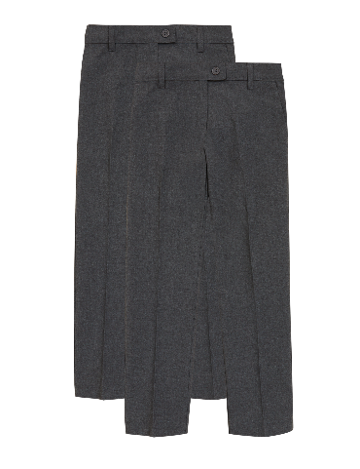 |  | 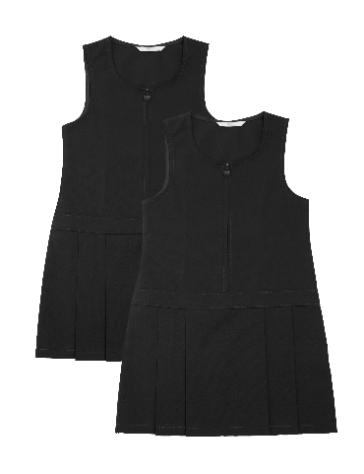
M&S 4PK SCHOOL SOCKS (6 SMALL – 7 LARGE)  £6 - £7 | M&S 2PK GIRLS' SLIM LEG SCHOOL TROUSERS (2-18 YRS)  £11 - £17 |  | M&S 2PK GIRLS’ PLEATED SCHOOL PINAFORES (2-12 YRS)  £12 - £16
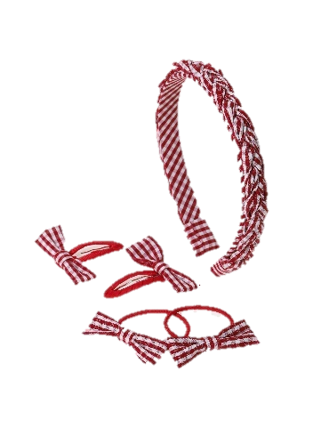 | 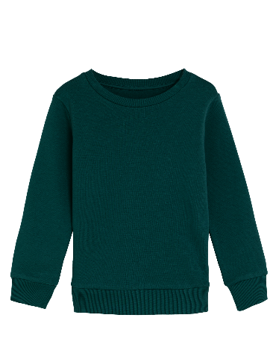 |  | 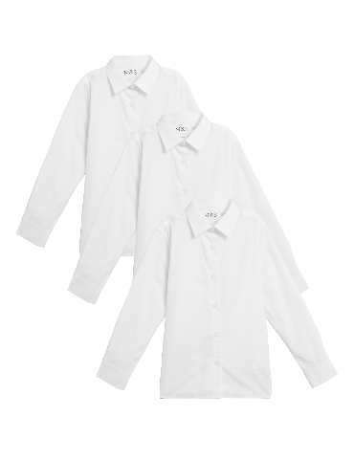
M&S BACK TO SCHOOL BUMPER PACK  £10 | M&S UNISEX CREW NECK SWEATSHIRT (2-16 YRS)  £6 - £9 |  | M&S 3PK GIRLS' EASY IRON SCHOOL SHIRTS (2-16 YRS)  £10 - £19
DOWNLOAD HIGH-RES CUTOUTS HERE
Available online now
For more information and imagery please contact:
Harriet.Allan@marks-and-spencer.com

Notes to Editor

Our Approach to Sustainability

- *Proof of purchase required.
- **Offer valid once per month and for Sparks Customers only.

- As the UK’s largest clothing retailer, quality and trusted value underpins everything we do. We source and make our clothes with care so they are hand-me-downable and exceptionally long-lasting, as they are too good to waste.

- For every M&S product, our clear goal is to only use responsibly sourced raw materials – including those that derive from animals.

- We ensure that 100% of the cotton in M&S clothing is responsibly sourced through the Better Cotton Initiative or with organic and recycled certifications.

- Our Responsible Cotton Sourcing Policy, excludes sourcing cotton from Xianjiang, Uzbekistan or Turkmenistan.

- 100% of the cashmere that we used in our pure cashmere products is certified by the Sustainable Fibre Alliance.

- 100% of the leather in our ladies footwear & accessories, men’s footwear and furniture is certified by the Leather Working Group.

- Our simple commitment is to send no clothes to landfill, ensuring any unsold stock is redistributed to our charity partner Oxfam.

- We have been supporting customers to give their clothing Another Life through our long-standing partnership with Oxfam. Since 2008, we have collected over 36 million items of clothing raising an estimated £23m for Oxfam’s vital work.

- Through our Beauty Takeback Scheme, we enable hard to recycle beauty packaging materials and components that commonly end up in landfill to be recycled and turned into new products.

- We’re working hard to reduce, reuse and recycle our use of plastic. Through our hanger reuse scheme, we’ve diverted over one billion hangers from going to landfill since 2007 by reusing or recycling them, even if they’re broken. In 2023, we introduced a ‘Bring your own Bag’ initiative for Click & Collect orders, saving 10 million pieces of plastic annually.

- We were the first retailer to transparently publish details of the 500+ factories that make M&S clothing on our interactive supplier map, which includes the factory location, name, number of workers and gender split.

- Ethical trading is core to how we do business and our Global Sourcing Principles set out our minimum global supplier ethical and environmental standards. These Principles are reviewed regularly – in partnership with our supplier partners and external organisations – to ensure they are fit for purpose and up to date.

- Sustainability now runs through all our strategic priorities to provide the foundation for our plans to reshape M&S for growth that is sustainable in every sense. Our 23/24 ESG report is available to view here.

