HAWKSBILL CARIBBEAN SPICED RUM RELAUNCHES FRUIT FLAVOURS MADE WITH WASTE FRUITS IN LIGHTER BOTTLE
Mango and Pineapple flavours are back by popular demand, now in a lighter weight bottle to help reduce CO₂ emissions
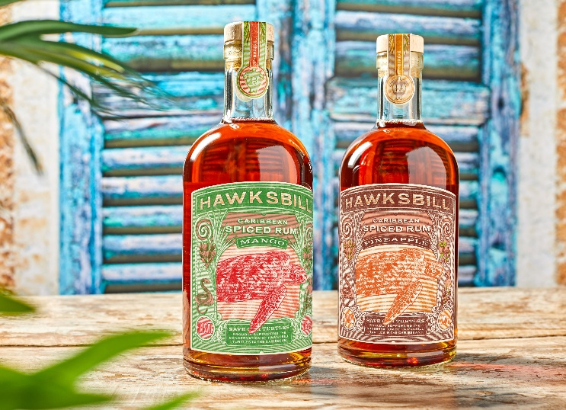
Following an increased demand for unique flavours across the spirits category and a rise in popularity for flavoured rums, Hawksbill Caribbean Spiced Rum, an ICB Ltd brand, has relaunched its Pineapple and Mango variants into its permanent Caribbean spiced rum range.
Taking its sustainability mission a step further, Hawksbill’s new Mango and Pineapple rums have been crafted using fruits that would have otherwise gone to waste, reducing the negative impact the brand has on the planet and its wildlife. Food waste fuels climate change and is a huge issue across the globe with UK households throwing away 6.5 million tonnes of it every year, 4.5 million of which is completely edible¹.
Both flavours were released in a limited run for Zero Waste Week in September 2021 and following popular demand Hawksbill has now reintroduced both to its core range, this time packaged in a lighter, more eco-friendly bottle.
The two new flavours not only include the original flavour packaging elements, such as the cork made from waste material and a sugarcane fibre label printed with plant-based inks, but also come in a lighter weight bottle (740g to 600g), saving over 100kg per pallet. This helps to decrease CO₂ emissions due to its reduction in weight when transporting to retailers and customers. The brand is also using a Flexi-Hex shipping solution for online orders, further increasing the recyclability of all product components.
In addition, the new flavours continue to support the endangered turtles after which the brand is named by donating 10% of the profits from every bottle sold to the Barbados Sea Turtle Project, a conservation project set up to help protect endangered and critically endangered sea turtles and their habitats.
Amy McLeod, Hawksbill Rum’s Marketing Manager, said: “We are very proud that Hawksbill’s new flavours will use real mango and pineapple that would have otherwise gone to waste, and that we have minimised its environmental impact in the process. It’s another step in the right direction for us and the industry.
“With concerns surrounding climate change on the rise and consumers paying more attention to the personal impact their choices have on the environment, it’s important that companies such as ours embrace sustainability and communicate that to our customers.”
The liquid itself brings together the very best Caribbean rums from Trinidad and Guyana, along with its own distinctive blend of spices. Sweet vanilla floats across the palate before a wave of toasted nutmeg, cinnamon, and raisin breaks, allowing a hint of cardamom and sea salt to nestle on the taste buds.
Hawksbill Spiced Caribbean Rum, Hawksbill Mango Spiced Rum, and Hawksbill Pineapple Spiced Rum are available at an RRP of £23 (70cl bottle) directly from their website as well as Amazon.
ENDS
Notes to Editors

For all media enquiries please contact the team at ICB@hatchpr.co.uk or 0113 361 3600.

Hi-res imagery can be found here: https://we.tl/t-vgjlmun8rH.
Hawksbill Caribbean Spiced Rum Mango, Hawksbill Caribbean Spiced Rum Pineapple, and Hawksbill Caribbean Spiced Rum Original are available directly from its website and Amazon, with an RRP of £23 (70cl).
About Hawksbill Caribbean Spiced Rum

Launched in October 2020, Hawksbill Caribbean Spiced Rum provides more than a taste of the Caribbean, with each bottle helping to save endangered Hawksbill turtles.

Hawksbill has partnered with the Barbados Sea Turtle Project, based at the University of the West Indies, whose mission is to recover marine turtle populations. 10% of the profits from Hawksbill sales will go directly towards turtle conservation projects in the Caribbean.

You can read more about Hawksbill’s conservation work here.

About Barbados Sea Turtle Project:
- The BSTP has been involved in conservation of the endangered marine turtle species for over 25 years
- Aim is to help restore marine turtle populations, protect its environment and future. Through research, education, public outreach as well as monitoring nestings and hatchlings.
- Research based conservation in action
- They have 1 full time member of staff – Carla and Volunteers from local community and overseas volunteers
- Throughout the nesting period they go out at night and patrol the beaches to make sure female turtles finding a suitable nesting place are safe as well as her eggs.
- They track post nesting turtles to foraging grounds and follow their journeys
- They operate a 24hour helpline and work with resorts to educate its visitors on the turtles and how to approach one
- Support comes from a number of different funds including US turtle charities keen to especially support them through struggles of Covid
- Check out their Facebook and Instagram pages as you’ll see some of the amazing work they do!

