THINK FAST WITH THE LATEST HARRY POTTER GAME FROM JOHN ADAMS!

Test your speed and observation skills with this fast-paced, frantic flip game.

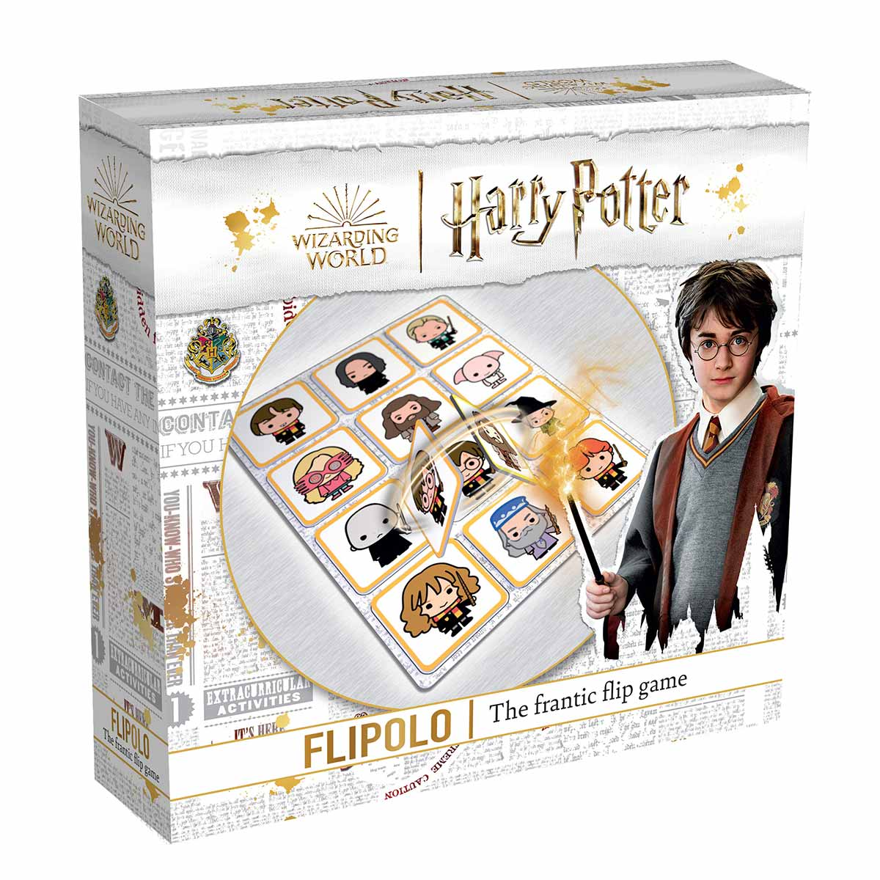
Jump in to the wizarding world of Hogwarts with the brand new magical matching game, Harry Potter Flipolo! Requiring both speed and keen observation skills, race to finish matching up all the tiles on the game board to become the champion!
All the beloved Hogwarts characters are there, but you must flip and switch, then switch and flip until all the tiles are in place and matched with the game board. Sounds simple? You will be surprised! All tiles are double-sided and you must tackle a different challenge every time.
The game includes 4 sets of 12 character tiles (each set has a different colour) and 4 double sided game boards, each taking just a few minutes to complete, giving plenty of quick-thinking.
At the end of each round, the player who finishes first receives 1 point. The second player to finish receives 2 points and so on. The less points you accumulate, the better! After 5 rounds the winner is the player with the least points.
The new Harry Potter Flipolo game (RRP £14.99) will be launching this Spring and will be available to purchase from all major toy retailers. The game is suitable for 2 to 4 players, aged 5 years and above, and even 3-4 year old players can get in on the fun, with the help of mum and dad, matching the character tiles on one board - great for aiding visual perception.
-Ends-
Notes to editors
The new Harry Potter Flipolo game from John Adams will be available from all good toy stores and online. For more information head to www.johnadams.co.uk
Further information, interviews and images are available on request.
Contact Venetia or Sophie at the John Adams Press Office
(Norton PR): +44 (0)1608 812830
Email: Venetia@nortonpr.com / sophie@nortonpr.com

