SmartyPlants: For Happier, Healthier, Hassle-Free Houseplants
Looking for a way to stop being a serial plant killer?! SmartyPlants takes the guesswork out of plant care, making it effortless, fun and hassle-free.
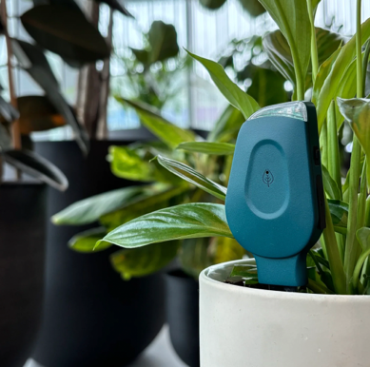
With more than 44.9 million houseplant owners in the UK, it’s no surprise that countless plants perish each year from things as simple as lack of water or the wrong amount of light. In fact, up to 90% of plant problems stem from these easy-to-fix issues.
That’s why SmartyPlants struck such a chord with plant lovers worldwide. The brand has raised more than £140,000 on Kickstarter from 1,500 backers, proving just how frustrating people can find indoor plant care.
But not for much longer, thanks to SmartyPlants! This smart sensor blends innovative technology with practical, personalised advice, helping users keep their houseplants happy all year round.
SmartyPlants Single Stem, £39.99. Available in green or grey from late October at www.smartyplants.ai
Moisture? Light? Nutrients? Thanks to this smart sensor, your plants can now tell you exactly what they need, before they start to suffer.
With rechargeable batteries offering over three months of use on a single charge and WiFi connectivity that lets you check in from anywhere, SmartyPlants is the hassle-free way to keep houseplants healthier and happier.
How does it work?
- Stick it in the soil: The sensor measures light, temperature, humidity, soil moisture and soil nutrients.
- Connect to the app: Data is analysed and turned into tailored, actionable plant care guidance, delivered in real-time via the free SmartyPlants app.
- Let your plant do the talking: Plant parents receive clear, simple care instructions so their greenery can thrive, with no more second-guessing.
For those with more than one plant, there’s a Three Pack (£99.99), Five Pack (£154.99) or Ten Pack (£289.99).
-ends-

Media Contact: Holly James | holly@hollyjamespr.com | 07578 929 729

Press Imagery: Download high-resolution imagery (cut out and lifestyle) and logos at this link or on Press Loft.

*Source: Barratt Homes Survey August 2025
https://www.barratthomes.co.uk/advice-and-inspiration/a-beginners-guide-to-houseplants/
Survey revealed that 78% of adult Brits own houseplants. There are 57.5 million adults in the UK, so 78% equates to 44.9 million people.

