Nairn’s unveils major re-brand
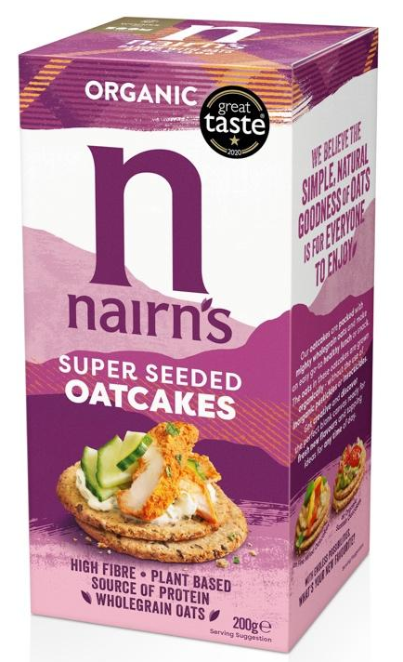
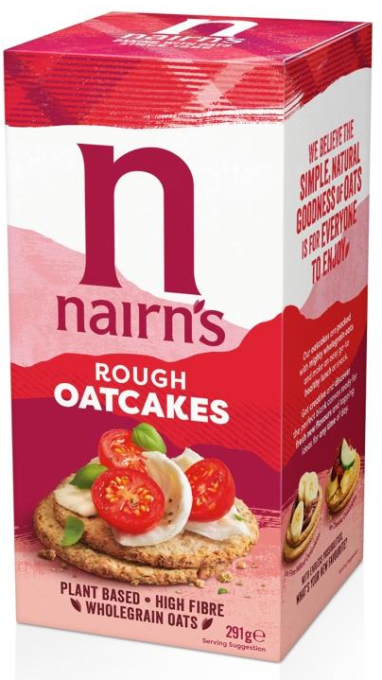
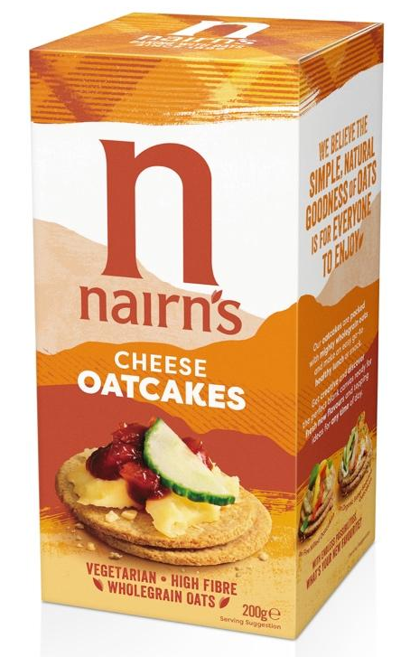
Following over a year of extensive consumer research, Nairn’s has revealed a transformational rebrand which will roll out across their full range of products.

Established in 1896 by John and Sarah Nairn in Strathaven, the company founded its reputation on its famous oatcakes, and has gone on to become the UK’s largest producer of oatcakes and one of the UK’s leading gluten free brands. The company’s product portfolio has grown considerably during this period, but it has never lost sight of its roots; oats are at the heart of everything it does and Nairn’s strive to make simple, natural, tasty food which can be enjoyed by everyone.
Emma Heath, Head of Marketing at Nairn’s, says:

“One of Nairn’s founding principles was for our products to be simple, natural, wholesome and delicious – a philosophy that still resonates with modern-day consumers and is embraced by Nairn’s loyalists in the UK and further afield. We worked extensively with consumer strategists at Map The Territory to better understand the changing health landscape and consumer needs, and this research has provided a solid foundation for the design work which is a significant step forward but still instantly recognisable as Nairn’s. The rebrand is designed to take our ever-expanding range of products to an even wider audience by making the brand more visible, modern, and appealing on shelf and highlighting its relevance to today’s healthy eaters as an integral part of their lifestyle, with taste and versatility at its heart.”

After appointing award-winning design agency This Way Up (who specialise in health and wellbeing brands) following a four-way pitch, the company has been keen to ensure that all aspects of the rebrand retain the signature tartan, synonymous with Nairn’s, but with a much richer, more vibrant colour palette.

Vicki Willatts, Design Director at This Way Up, says:

“Inspired by the rugged Munros of Scotland, the new design captures the textured and layered landscape, communicating all the natural, simple goodness of oats and celebrating the brand’s real roots. The colour palette references the rich, vibrancy of the natural landscape, whilst the informal style of real food imagery will inspire consumers to discover and enjoy the simple pleasures of uncomplicated wholesome eating.”

Striving to be seen as so much more than just a biscuit for cheese, the new branding shows the versatility and incredibly wide range of eating occasions and toppings in a more modern and appetising way.

Whilst one of the goals of the new packaging is to attract new, younger consumers, the new brand look was carefully researched to ensure it didn’t alienate existing consumers and that it remained instantly recognisable. Ultimately, the rebrand positions Nairn’s in more of a lifestyle-led sector – a category which contains brands that are for everyone looking to embrace wellbeing and balance in simple and achievable ways.

The phased roll out of the new look for Nairn’s will start with its flagship oatcakes range from January 2021 with other products following over the coming months.

Nairn’s products are widely available across multiple retailers and convenience stores, the health trade and food wholesalers.

-ENDS-

For more information, samples or images please contact Amanda Pegram or Ella Campbell amanda@ccdpr.com / ella@ccdpr.com

For information on the full range from Nairn’s Oatcakes, please visit
www.nairns-oatcakes.com

Notes to Editors:

Edinburgh based Nairn’s is proud of its heritage, and has been baking with oats since 1896. Nairn’s is now the UK’s number one producer of oatcakes, as well as one of the UK’s biggest gluten free brands (source: Mintel Free From report 2020) with an extensive, growing range of products including oatcakes, crackers, flatbreads, sweet biscuits, cereals and snacks. All Nairn’s products are deliciously simple, natural and wholesome and do not contain any artificial colourings, flavours or preservatives.

There has been a great deal of research into the positive health benefits of wholegrain oats. A rich source of vitamins and minerals, oats are also high in fibre and contain complex carbohydrates that give a natural and wholesome boost. Oats have also been shown to have a beneficial impact on the gut, which is widely referred to as the “second brain.”

In 2017, Nairn’s opened the doors of its bigger, ‘state of the art’ gluten-free bakery in Newtongrange, Midlothian, in response to growing demand for Nairn’s Gluten Free products. The new bakery has provided the capacity and technology to expand the range and, since it opened, Nairn’s have launched 18 new gluten-free products with more in the pipeline.

