Sumptuous Spring Bakes with Bonne Maman
As the spring flowers bloom and Easter approaches, surely it’s time for some sumptuous showstopper bakes filled with fresh, citrus flavours?
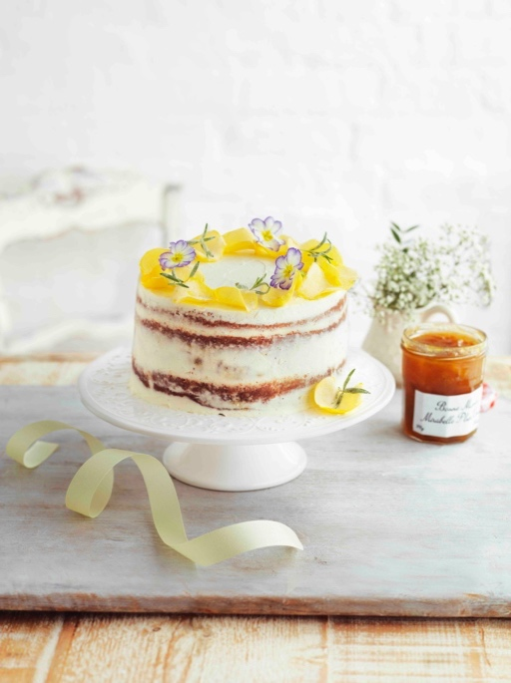
This Vanilla & Almond Plum Layer Cake with Ricotta Frosting decorated with rose petals, primroses and fresh rosemary is pretty as a picture and makes a gorgeous Easter tea centrepiece. Three sponge layers, filled with either Bonne Maman Mirabelle Plum, Peach or Apricot Conserve and fresh fruit and then encased lightly with a layer of ricotta frosting.

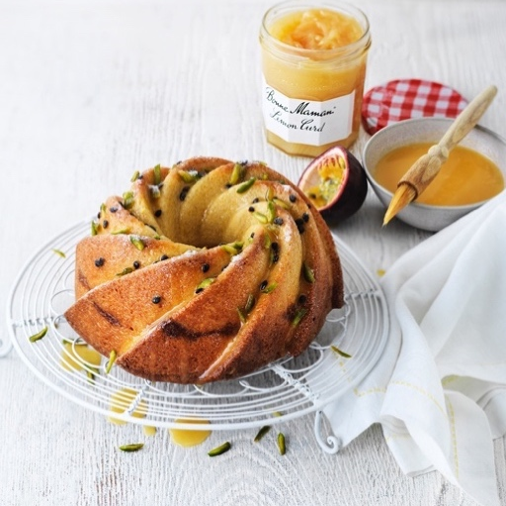
These two Bonne Maman Lemon Curd recipes are full of sunshine. This Lemon & Raspberry Meringue Tart, is simply made with a crushed biscuit layered with raspberries drenched in Lemon Curd. Whilst this Lemon & Passionfruit Drizzle Cake combines beautifully moist flavoured sponge with the contrasting flavours and textures of passionfruit seeds, pistachio nuts and icing sugar to serve.
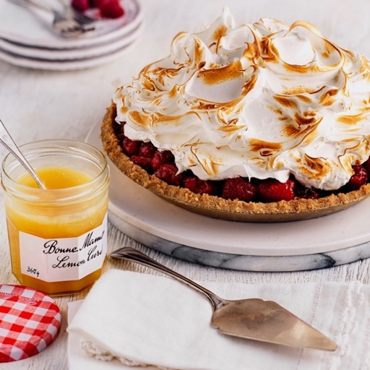

-Ends-

High resolution and other images, recipes and samples available – contact Pippa Evans on e:pippa@wixhill.co.uk or Holly Darke on e:holly@wixhill.co.uk or call WixHill on 01483 203992.
For further information, tips and recipes see www.bonnemaman.co.uk, like on Facebook @BonneMamanUK and follow on Instagram @bonnemaman_uk
- Stockists may vary
- Image copyright, Bonne Maman UK
About Bonne Maman: Bonne Maman is one of Britain’s best-loved conserves, famous for its signature gingham lids, use of simple, traditional methods and high quality, all natural ingredients. The full Bonne Maman UK range includes:
- Conserves - Rhubarb & Strawberry, Mirabelle Plum, Strawberry, Strawberry & Wild Strawberry, Wild Blueberry, Black Cherry, Fig, Apricot, Berries & Cherries, Raspberry, Peach, Damson Plum and Blackcurrant
- Intense Conserve – Strawberry, Apricot and Raspberry
- Curds – new Lemon
- Marmalades - Bitter Orange
- Caramels – Salted Caramel
- Hazelnut Chocolate Spread
- Compotes – Apricot, Cherry, Rhubarb and Peach
- Chilled Desserts – Strawberry Mousse, Chocolate Mousse, Rhubarb Mousse, Blackcurrant Mousse and new Clementine Mousse; Salted Caramel Crème, Coffee Crème, Dark Chocolate Crème with a Touch of Sea Salt and Milk Chocolate Crème; Crème Caramel, Crème Brûlee, Baba au Rhum and Riz au Lait plus Tarte au Citron and Red Fruit Tarte
- Yoghurts – Layered Yoghurts: Raspberry, Rhubarb and Apricot plus Large pot Fruit Yoghurts; Morello Cherry, Rhubarb & Strawberry, Violet Fig plus Raspberry & Blackberry.

February 2022

