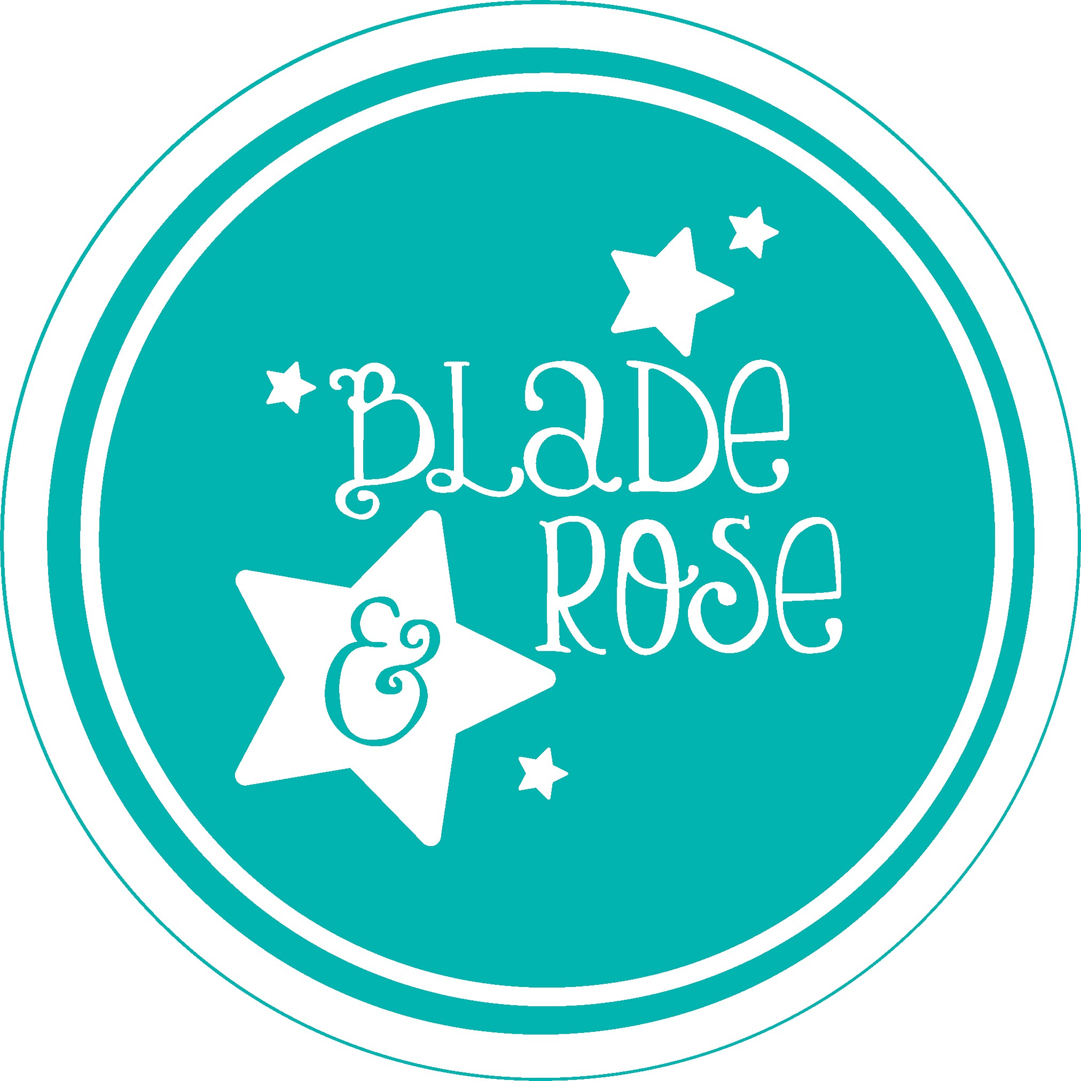

Go on a space adventure with the new Blade and Rose To The Moon and Back Collection

With space exploration becoming a real possibility for the next generation, what better collection to launch than To The Moon and Back. The super soft and comfy dark blue, white, and yellow wide striped leggings feature a bright and colourful space rocket taking off, followed by a rainbow plume. All our leggings and socks come with the Blade and Rose name embroidered into the waist band or cuff so consumers can buy with confidence. The coordinating long sleeve top is a lovely deep blue which highlights the beautifully embroidered space rocket in an array of rainbow colours surrounded by night stars. Green and yellow rocket socks complete the outfit. Available in sizes 0m – 4 yrs.
Blade and Rose are owned by husband and wife, Amanda, and Jon Peffer, they founded the company in 2010. Their design and distribution centre are based in their hometown of Kendal in the Lake District. At the heart of Blade and Rose are their eco and sustainable ethics. They ensure all their products comply with Oeko-Tex Standard 100, and all their suppliers are SGS or BSCI compliant which ensures that global cotton production is better for the people who produce it and better for the environment it grows in, ensuring the softest and safest fabrics for the consumer. Any plastic they use is recycled and recyclable.

For further information please contact helencottrill@bladeandrose.co.uk

