The ultimate unboxing experience: HEXBUG Junkbots

Get ready for the ultimate unboxing experience with the Junkbots range from HEXBUG! Children will love digging through the rubbish to discover the hidden treasure.
Suitable for children aged 3+, the Junkbots range is available now from The Entertainer, Amazon, Toymaster and other local independent retailers

Junkbots Trash Bin
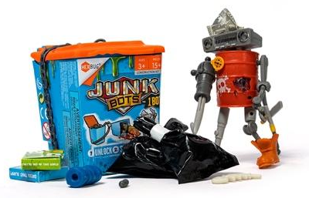
RRP: £4.99
Dig through the rubbish to discover the hidden treasure and clues in their unique trash bin packaging. When they have all 15 pieces, they can build their very own Junkbot character. There are 36 Junkbots to collect! Discover them all for amazing mix-and-match action, allowing kids to create completely new characters too.

Junkbots Dumpster
RRP: £9.99
Dig through the trash to reveal the hidden treasures and pieces to build their very own Junkbot. There are 30 pieces inside, which build two different Junkbot figures. Or, create a new design by fitting together the pieces in a totally new way. There are over 36 Junkbots to collect in the range.

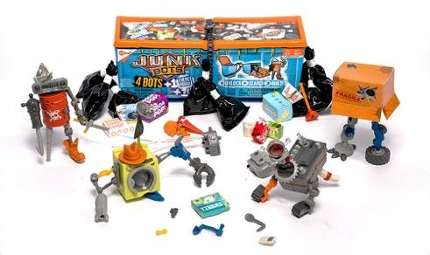
Junkbots Industrial Dumpster
RRP: £19.99
Get ready for the ultimate construction adventure with the Junkbots Industrial Dumpster. This epic set is perfect for little builders. As kids unbox and dig around in the trash for the Junkbot pieces, they’ll find over 50 pieces to help them build four different figures. They can animate their bots with a motor or dynamic vibrations, and add the light-up cover for even more fun.

ENDS

For further information, please contact Laurissa Hackett (laurissa@fullvolumepr.co.uk) or Cait Naven (cait@fullvolumepr.co.uk) at Full Volume PR.

