SmartyPlants: The Smart Gift That Keeps on Giving
Houseplants | Happier | Healthier | Hassle-Free
Looking for the perfect Christmas gift for a houseplant lover in your life? SmartyPlants makes plant care effortless, fun and hassle-free.
44.9 million people in the UK are houseplant owners, but guesswork still leads to tens of millions of plants perishing annually, due to things as simple as lack of water or light in up to 90% of cases.
That’s why SmartyPlants struck such a chord with plant lovers worldwide. The brand has raised more than £140,000 on Kickstarter from 1,500 backers, proving just how frustrating people can find indoor plant care.
SmartyPlants is here to change that. By combining innovative technology with personalised, practical advice, these smart sensors ensure every houseplant thrives, making it the ultimate gift that keeps on giving!
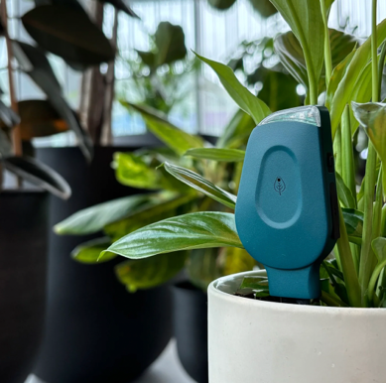
SmartyPlants Single Stem, £39.99 – Available in green or grey from late October at www.smartyplants.ai
Moisture? Light? Nutrients? Thanks to this smart sensor, whatever your plants need, they can now let you know directly instead of dramatically wilting!
With rechargeable batteries offering more than three months of use on a single charge and WiFi connectivity allowing you to check in on your greenery anywhere, at any time, SmartyPlants is the hassle-free way to make houseplants happier and healthier.
How does it work?
- Stick it in the soil: Once nestled in its new home, this smart sensor measures light, temperature, humidity, soil moisture and soil nutrients.
- Connect to the app: Data collected by the sensor is analysed and transformed into tailored, actionable plant care guidance, delivered in real-time via the free SmartyPlants app.
- Let your plant do the talking: The lucky plant parent now knows exactly what they need to do to help their potted pals flourish and thrive, with no more second-guessing.
One stem not enough? No worries! There’s also a Three Pack (£99.99), Five Pack (£154.99) or Ten Pack (£289.99).
-ends-

Media Contact: Holly James | holly@hollyjamespr.com | 07578 929 729

Press Imagery: Download high-resolution imagery (cut out and lifestyle) and logos at this link or on Press Loft.

*Source: Barratt Homes Survey August 2025
https://www.barratthomes.co.uk/advice-and-inspiration/a-beginners-guide-to-houseplants/
Survey revealed that 78% of adult Brits own houseplants. There are 57.5 million adults in the UK, so 78% equates to 44.9 million people.

