Personalised stocking fillers that celebrate treasured memories
Put the magic into Christmas this year by treating your loved ones to a stocking filler that stands out from the rest. Choose a personalised photo gift that will help them celebrate their favourite memories this festive period.
Whether you’re shopping for your partner, children, family or secret Santa, CEWE, photo printing experts, has a gift to suit all styles and recipients. Here’s some stocking filler inspiration:
Photo Mugs - from £9.99
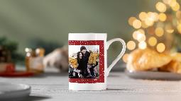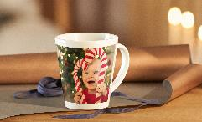
This thoughtful gift will be the perfect way to start their mornings, reminding them of a treasured memory with every brew! Choose a photo, drawing and text of your choice that is sure to put a smile on their face. This is the perfect secret Santa gift for a colleague or a stocking filler for a loved one.
Photo calendars – from £10.99
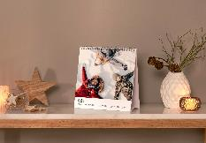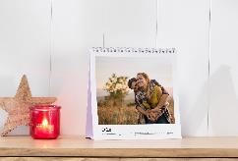
For a gift that they can appreciate all year round, a personalised photo calendar is the perfect choice. Every month throughout the new year they’ll be reminded of a happy memory, helping to brighten up their workspace or keep a busy home life organised. Choose the size and style that will suit them, from kitchen and appointment calendars, to desktop calendars and year planners.
Premium Photo Jigsaw Puzzle – from £24.99

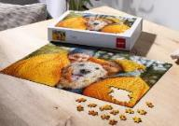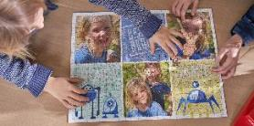

This gift is sure to provide plenty of entertainment over the festive period – for both kids and adults! Create a unique original jigsaw puzzle that features a photo and text of your choice. Choose from a portrait of a beloved pet, a group family photo or a piece of artwork by the kids.

Photo Magnets – from £14.99
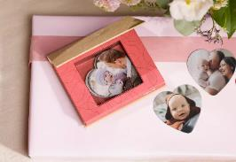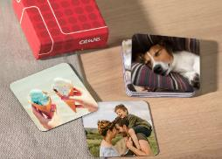
This set of personalised magnets is a unique gift that will help them brighten up any magnetic space in their home or workplace. Customise them with all their favourite photos whether it’s a holiday or milestone. They’re sure to smile when they find this gift in their stocking.
Phone cases – from £16.99

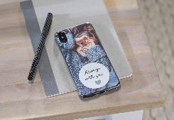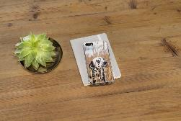

If you’re shopping for someone who always has their phone in their hand, a personalised photo phone case is the perfect gift! Add their favourite family photo, an image of a well-loved pet or something that will make them smile. A unique gift that they’ll utilise every day of the year.

Faber Castell coloured pencils – from £15.99
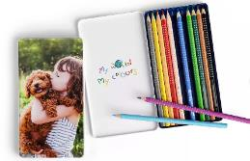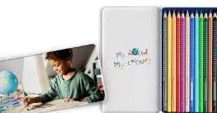

If you want to encourage the little ones to be more creative and artistic over the Christmas period and into the new year, gifting them with their own set of personalised colouring pencils is the perfect place to start! The set comes with 12 pencils complete with a stylish tin case ready for you to personalise with photos and text of your choice, such as a child’s name, class or subject.
Photo Pairs Game - £16.99
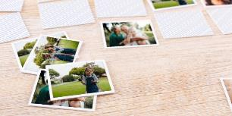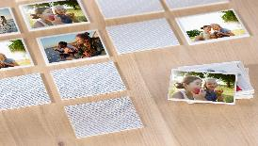
For a gift that will provide hours of entertainment for the whole family, a photo pairs game is ideal. Whether you choose photos of moments from the year gone by or Christmas memories over the years – they’re sure to love this fun and unique gift that gets them to relive precious memories.
Photo Playing Cards – £12.99

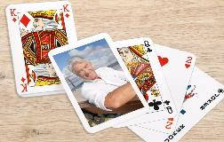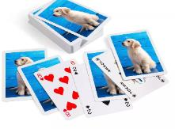

If the recipient you’re shopping for is always the games master at Christmas, then treat them to their very own set of photo playing cards. This unique deck will add a personal touch to every game, as they get to look back at their favourite photos. The perfect thoughtful and fun gift!
Personalised Photo Cushion from £25.99
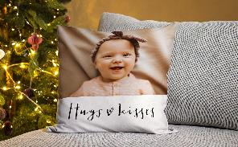
Brighten up their home with a personalised photo cushion that they can appreciate all year round. Choose a photo of their favourite memory that will be displayed across the front and the back of the cushion. This gift is a sure way to bright up their home décor and is a gift that last well beyond Christmas.
Photo Blanket – from £37.99

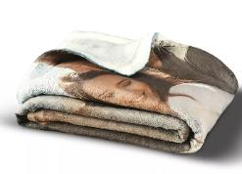

Help them feel snug and warm throughout winter with a personalised photo blanket complete with your favourite photo of a treasured memory. This would make a great gift if you can’t be there in person this year, to give them a big hug from you via a cosy blanket.

Photo Snow Globe – £9.99

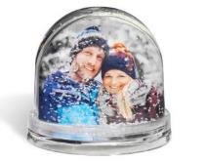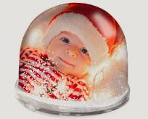

A gift that is perfectly festive and makes an ideal stocking filler. The Photo Snow Globe can be personalised with a photo and text of your choice and comes complete with artificial snowflakes, for that extra Christmas touch.

ENDS

Notes to editors:
For more information, contact the CEWE PR team on cewe@prohibitionpr.co.uk
About CEWE
CEWE is Europe’s leading photo printing company, known for its passion for photography and commitment to delivering outstanding print quality. CEWE is dedicated to helping people share their memories by producing millions of personalised photo products each year.

Based in Warwick near Royal Leamington Spa, the company’s state of the art production facility houses some of the very latest in printing technology and prints photo books, wall art, calendars, gifts and more.
One of its most successful innovations is the award winning CEWE PHOTOBOOK. Drawing on 60 years of printing experience, the CEWE PHOTOBOOK has been awarded the Best Photo Service by the TIPA World Awards (Technical Image Press Association) for six consecutive years.

For more information about CEWE gifts, visit: https://www.cewe.co.uk/photo-gifts.html

