

HISENSE EXPANDS ITS KITCHENFIT RANGE BEYOND REFRIGERATION AND INTO ITS LAUNDRY COLLECTION
The leading appliance brand has launched the brand-new KitchenFit 5i Series laundry range – a seamless, space-saving solution for modern kitchens and utility rooms.
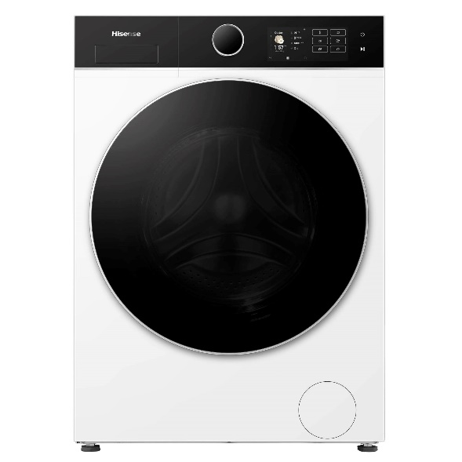
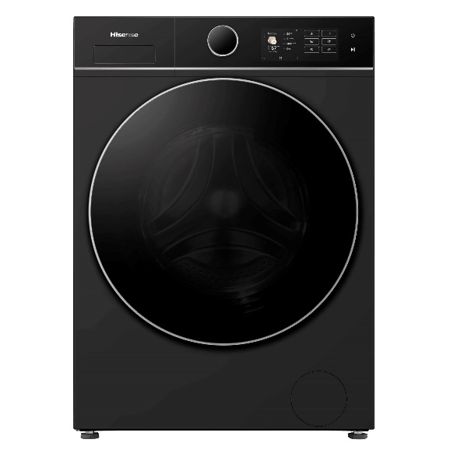

Leading appliance manufacturer, Hisense, has announced the launch of its latest laundry range – the KitchenFit 5i Series.
Designed to meet the evolving needs of modern living, this new range offers a space-saving design with premium performance, allowing consumers to achieve a sleek, fully integrated laundry solution without compromising on capacity or efficiency.
Perfectly suited to compact kitchens or laundry spaces, the KitchenFit 5i Series has been designed with a shallow cabinet depth that enables it to sit neatly within surrounding kitchen units, creating a streamlined, built-in aesthetic.
The range is an extension of Hisense’s KitchenFit offering, which the brand launched in the UK 18 months ago, with numerous refrigeration models.
The range includes two stand-out models:
- The KitchenFit 5i Series Washing Machine
- The KitchenFit 5i Series Washer Dryer
Both models are available in a variety of drum sizes including 9kg, 10.5kg, and 12kg, offering flexibility for a variety of household sizes and laundry needs. This is a first for the industry, with no other manufacturer offering a 12kg capacity model in this type of range.
Despite its space saving design, each appliance comes with an innovative Max Drum which maintains the same height and width while optimising depth efficiency. The new Hisense range offers a 590mm depth versus the industry standard at 640mm. The reimagined drum design allows for a seamless fit and increases the dropping force of clothes during rotation, delivering a deeper, more powerful clean for fresher, spotless results.
Both of these models also come with a Quick Wash Pro feature that allows users to cut down on wash times without compromising on cleanliness and efficiency, helping users save time, energy and utility costs. The Eco-Refresh feature is an innovative way of freshening up dry clothes by releasing a powerful burst of hot steam which will penetrate into fabric fibres and remove wrinkles and allergens, all without the addition of water or detergent. Additionally, the new KitchenFit models include a Cold Wash setting, an energy-saving solution that uses cold water and a longer cycle to achieve effective cleaning whilst reducing electricity consumption by up to 71%.
Each tailored to meet a consumer’s specific laundry needs, the KitchenFit 5i Series also offers further intelligent features designed to simplify the user experience, including the QuickBoost, Stain Removal, Bedding Care and Pet Care.
A feature also available in the 10.5kg and 12kg capacities, is the advanced Pure Jet Pro technology. This dual-spray system uses one jet for pure water and another for recirculating laundry water, maximising cleaning efficiency. The integrated pre-mixing system fully dissolves detergent before it touches your clothes, helping prevent residue buildup and ensuring gentle yet thorough fabric care.
Hisense’s 5i laundry range has achieved Quiet Mark accreditation, the global certification programme that recognises those appliances that reduce noise pollution in your home, making it the perfect range for those who want to do their laundry, without the interruptions.
The Hisense 5i Heat Pump Washer-Dryer has also been recognised in the Tech for Good Social Impact category at the IFA Innovation Awards 2025, praised as the industry’s first three-inverter front-loading combo with AAAA energy efficiency, delivering fast, sustainable wash-dry performance.
Product Marketing Manager at Hisense, Chloe Blanchfield, commented: “The KitchenFit 5i Series offers consumers a sleek, aesthetically pleasing design that suits all kitchens without compromising on efficiency, performance or capacity.
“It’s been thoughtfully engineered for modern living, delivering advanced features and reliable performance that users look for, all while maintaining a seamless, built-in look. This range is perfect for consumers looking to blend style and practicality within their homes.
“Being able to deliver an industry first and provide this seamless finish on our 12kg washing models means that even those larger households can benefit, without having to do multiple washing cycles.
In addition to the KitchenFit 5i Series Washing Machine and Washer Dryer, this range also comes with the 5i Series Tumble Dryer, available in a 10kg capacity.
For more information on the 5i Series range, visit: www.uk.hisense.com/.
The KitchenFit 5i Series is available from selected retailers including Curry’s, AO, Appliance City and Costco with an RRP starting from £499.

ENDS
For more information, please contact the Hisense UK team at Hatch: hisense@hatch.group / 0113 361 3600.
About Hisense
Founded over 50 years ago in China in 1969, Hisense is one of the world’s leading manufacturers of televisions and home appliances. Hisense has a core range of televisions and cooling appliances, alongside a portfolio of cooking and laundry products, featuring hobs, hoods, ovens, dishwashers and washing machines.
Hisense UK is headquartered in Leeds. The brand has become increasingly involved in professional football on a global scale, recently announcing its global sponsorship of UEFA EURO 2024™, following on from past tournament sponsorship in 2016 and 2020, and a successful sponsorship of FIFA World Cup 2022™.
Ranking as the No.2 TV brand in the world and No.3 in the UK**, Hisense continuously invests in research and development and has over 100,000 employees worldwide. For more information visit https://hisense.co.uk/

