STIHL LAUNCHES BATTERY-POWERED KOMBIENGINE, ONE SOLUTION FOR MANY CHALLENGES

The first KombiEngine available in STIHL’s battery-powered AK System, the KMA 80 R is compatible with over 11 interchangeable attachments including a leaf blower, grass trimmer, lawn edger, hedge trimmer, sweeping brush and pruner.
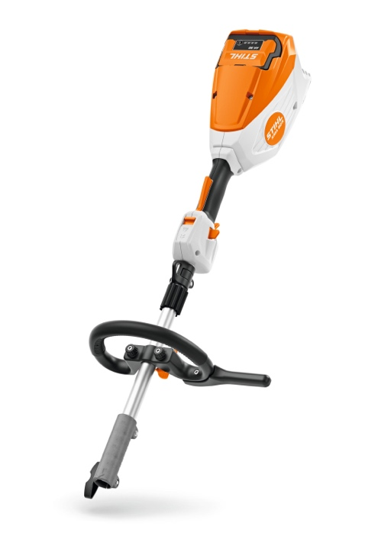
Designed with ease of operation in mind, the lightweight KMA 80 R’s powerful EC motor and Lithium-ion battery guarantee high performance, whatever the gardening task.

The perfectly balanced KMA 80 R features an adjustable loop handle for maximum comfort when carrying out gardening tasks, with an easy-to-use lever under the handle allowing for tool-free adjustment. The ergonomic control handle is made from a comfortable non-slip material, while the adjustable harness hook can be moved along the shaft for optimum comfort and balance.

The working time of the KMA 80 R depends on the battery and attachment in use. There are two speed settings with a variable trigger, including ECO mode which reduces the rotations per minute to maximise working time, ideal for hedge trimming or lawn edging tasks that are less power intensive.

An optional foot support accessory can be fitted to the KMA 80 R, providing additional protection for the battery housing, alongside offering more options for how the tool can be held.

The KMA 80 R is £279 RRP for the tool only, and the optional support foot accessory is priced £21.41 RRP. Available to buy now from STIHL Approved Dealers nationwide. For more information on the new AK System KombiEngine, please visit www.stihl.co.uk.

-ENDS-

About STIHL

It all started with a chainsaw, and to this day, it's still the product for which the STIHL brand is best known worldwide.

Ever since Andreas Stihl invented the first portable chainsaw, the STIHL name has stood for revolutionary technology, driven by significant investments in research and development and a single-minded passion for making people's lives easier when working in nature. It's because of this that STIHL has been the world's best-selling petrol chainsaw brand since 1971.

But the STIHL name is now synonymous with many other industries too, as well as with home gardeners looking for premium quality tools. The extensive STIHL range includes hedge and grass trimmers, multi-tools, pressure washers, construction tools, lawn mowers, lawn tractors, robotic mowers and of course, chainsaws.

A family-owned business based in Germany; STIHL employs more than 20,000 people worldwide and sells products in more than 160 countries globally.

STIHL GB is a wholly-owned subsidiary of the global STIHL Group. In Great Britain, STIHL products are available from more than 700 specialist Approved Dealers who offer expert advice and after sales support. Selected tools are also available from quality garden centres and from STIHL's own online store https://shop.stihl.co.uk/

Whatever STIHL tool you choose and however it's powered - battery, petrol or electric - each features countless innovations, exceptional performance and lasting quality.

Issued on behalf of STIHL GB by HROC Ltd. For further information please contact:

HROC Limited
Tel: 0121 454 9707
E: prstihl@hroc.co.uk

