MEAL PREPARATION MADE SIMPLE WITH THE NEW
FRESH & SAVE SOLUTION FROM ZWILLING

ZWILLING has a long history of championing perfect food preparation and culinary innovation, almost 300 years in fact, and with food waste at an all-time global high, this German company has taken the lead by launching a new FRESH & SAVE vacuum sealing system. Not only will this new collection of kitchen products help to reduce food waste by keeping food fresh for up to five times longer but it will also preserve food’s flavours and vitamins, locking goodness in.

The FRESH & SAVE collection comprises all the elements needed to make meal preparation, storage and serving simple thanks to a range of plastic and glass Vacuum Boxes and Vacuum Bags that seal in freshness in combination with a Vacuum Pump and are perfect for sous-vide cooking, re-heating pre-prepared meals and making the most of leftovers. As well as saving time, which helps to take the stress out of mealtimes, the new ZWILLING FRESH & SAVE food preservation solutions also reduce food waste, helping the planet and saving money on having to rebuy produce.
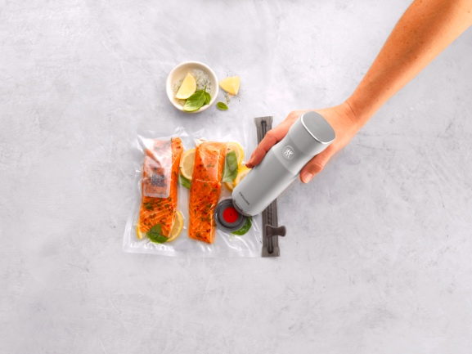

ZWILLING FRESH & SAVE Vacuum Pump, £69.95 with Vacuum Bag, from £5.95 for X3 Large Bags
The new FRESH & SAVE collection from ZWILLING works by using a Vacuum Pump to seal in freshness and flavour to the Vacuum Boxes or Bags, prolonging food’s freshness by up to five times. The wireless Vacuum Pump is always ready to go as it doesn’t require complicated setting up and simply starts at the touch of a button then automatically stops once the correct vacuum is achieved. It only takes a few seconds to complete the vacuum process and it can be recharged using the USB cable included. The Vacuum Boxes and Vacuum bags can then be stored in the fridge or freezer ready for use. They are microwave and dishwasher-proof while the glass boxes are also oven-safe up to 180°C with the lid removed, so meals can be heated without having to empty the dish into another container, simply pop into the oven and serve straight to table.
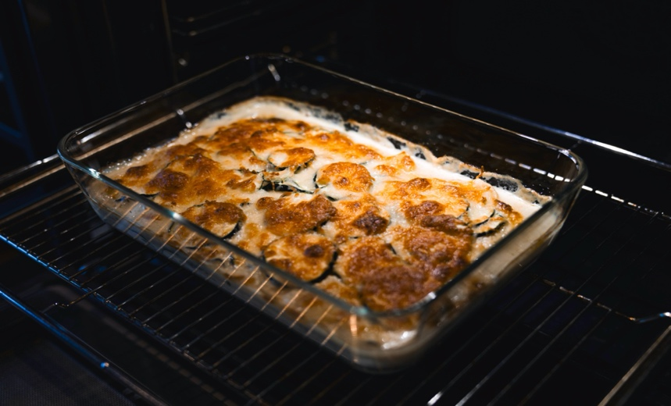

ZWILLING FRESH & SAVE Glass Gratin Dish, £29.95

The advantage of vacuum sealing is that it significantly reduces the amount of air surrounding the food, lowering the oxygen content and delaying oxidisations and the aerobic process. This means that food will keep for up to five times longer. And because the vacuum sealed box or bag has minimal air content, there’s a reduction in moisture so no more mould or limp ingredients. What’s more, food’s flavour, taste, vitamins and nutrients are all preserved for longer, perfect for everything from meat and fish to dairy, herbs, soups and sauces. For best results, allow food to cool to room temperature before sealing and avoid opening the lid unnecessarily to prevent air entering the inside.
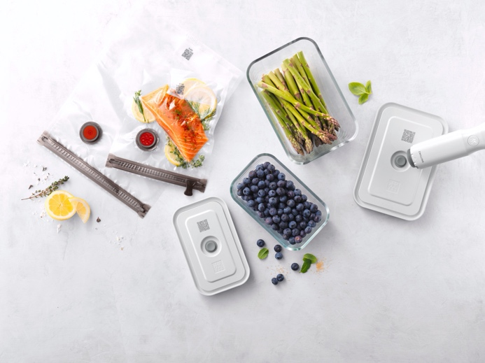

ZWILLING FRESH & SAVE Vacuum Glass Boxes, £39.95 for a Set X1 Small, Medium and Large
Vacuum Bags, from £5.95 for X3 Large Bags and Vacuum Pump, £69.95
Along with keeping food fresh for longer to store in the fridge or freezer, the FRESH & SAVE Vacuum Bags can also be used for healthy sous-vide cooking. This low temperature method of cooking can be used for items such as tough cuts of meat, fish, eggs or vegetables, which are vacuum sealed in the Vacuum Bag and then cooked in a water bath for longer than usual for enhanced flavour, better texture and tenderness and perfect results every time.
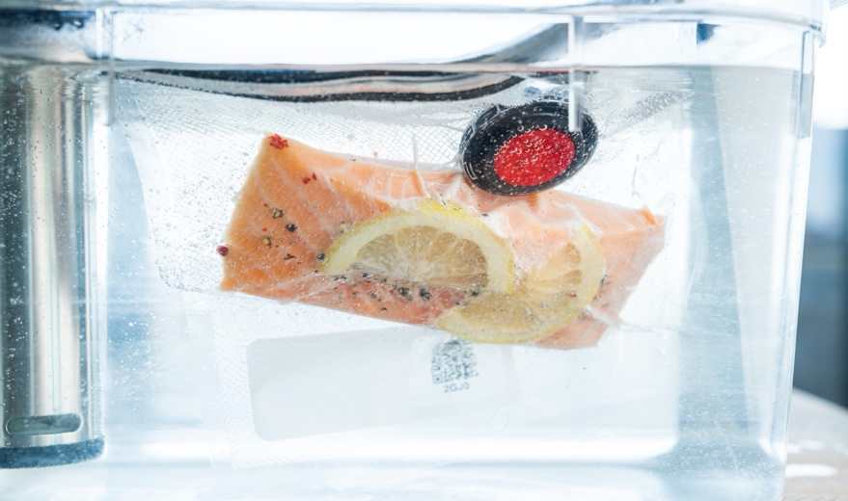

ZWILLING FRESH & SAVE Vacuum Bag, from £5.95 for X3 Large Bags
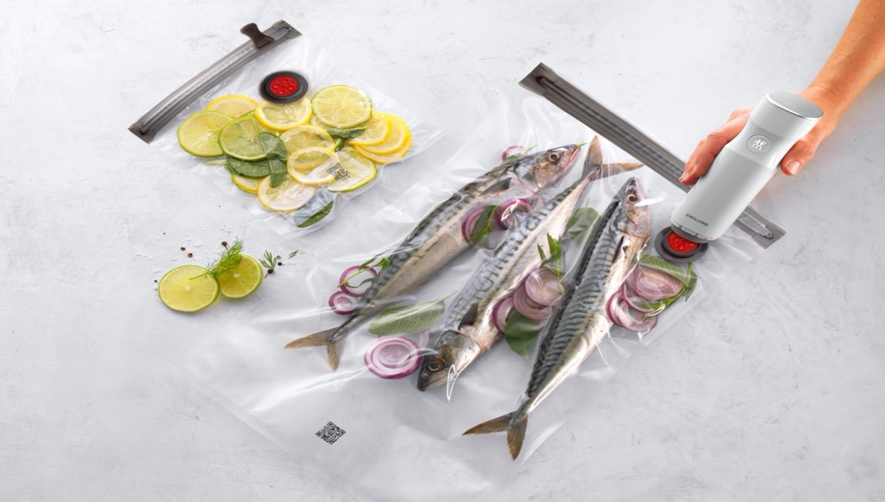

ZWILLING FRESH & SAVE Vacuum Bag and Vacuum Pump, £69.95

To help keep on top of food storage and reduce food waste, ZWILLING has also created a Culinary World app {available to download from the App Store and Google Play}, which can be used to calculate the estimated longevity of food based on its contents and whether it’s to be stored in the fridge, freezer or cupboard. Simply scan the QR code on the FRESH & SAVE Vacuum Box or Vacuum Bag, enter some details and the app will work out a ‘best before’ date, as well as sending a reminder to a smartphone or tablet when that date is coming up. The app can also suggest recipes and help with shopping lists too, making food preparation even easier for busy cooks on the go.

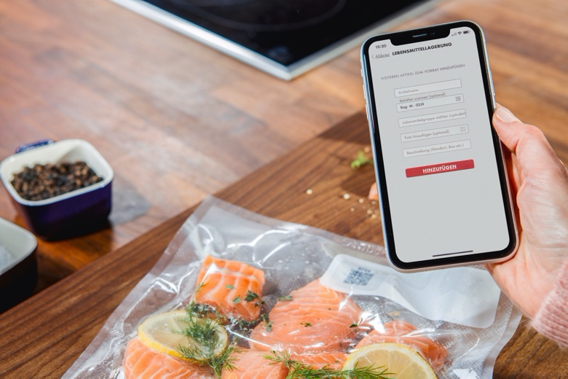

ZWILLING FRESH & SAVE Vacuum Bags with the ZWILLING Culinary World app

The benefits of vacuum-packed food are many. When we store ingredients, meals or leftovers in the fridge, the quality, flavour and freshness decline rapidly and often lead to food waste. In fact, the average food waste per household is 75kg per person per year*. This is because the food comes into contact with air and when food is frozen, this leads to freezer burn, which again reduces its flavour and goodness. To prevent meat, fish, cheese, salads, herbs, spices and more from drying out, becoming mouldy, tasteless or limp, a vacuum seal will keep it all fresh for longer. It preserves taste, keeps cooked and raw produce fresh and saves money!
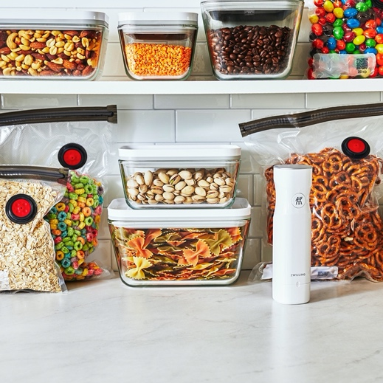
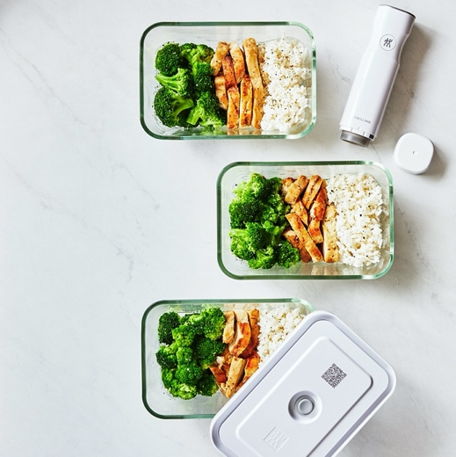

ZWILLING FRESH & SAVE Vacuum Glass Boxes, £39.95 for a Set X1 Small, Medium and Large
ZWILLING FRESH & SAVE Glass Starter Set, £89.95 which includes the Vacuum Pump, a Medium and Large Glass Container and Four Vacuum Bags {two Small and two Medium}.

As well as keeping food fresh for longer in the fridge or freezer, the ZWILLING FRESH & SAVE collection of Vacuum Boxes and Bags can also be used in the larder or food cupboard to keep dried ingredients fresher and close to hand. Perfect for pasta, pulses, nuts, cereals, herbs, spices and more.

ENDS

ZWILLING FRESH & SAVE is available from https://uk.zwilling-shop.com #freshnessextended!

For more information, high res imagery or product loans for testing and photoshoots, please contact francesca@sellerspr.com | katherine@sellerspr.com or call 01962 977950

*Thomas Schmidt, Felicitas Schneider, Dominik Leverenz, Gerold Hafner Lebensmittelabfälle in Deutschland (Food Waste in Germany) – Baseline 2015 – Summary Thünen Report 71 Braunschweig, Germany, September 2019

