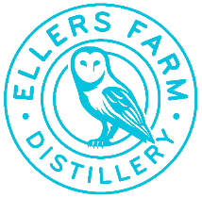
BRAND NEW ECO DISTILLERY NEARS COMPLETION IN NORTH YORKSHIRE
North Yorkshire’s newest distillery and visitor attraction, Ellers Farm Distillery, will be one the largest in the region
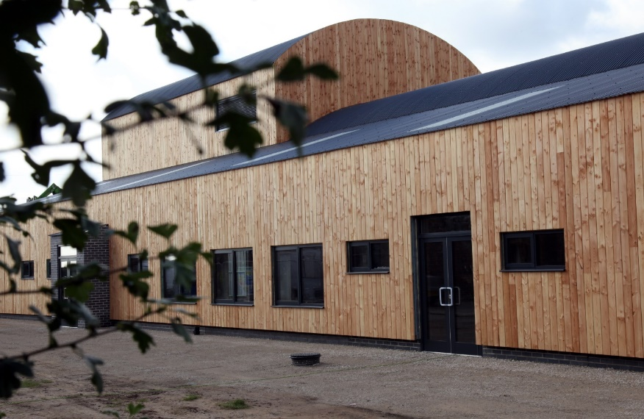
Ellers Farm Distillery is a brand new eco distillery and visitor attraction being built in North Yorkshire. The distillery, expected to be the largest in the region, will be carbon neutral from day one and aims to support and lead the industry in balancing people, profit, and the planet.
The new state-of-the-art facility, when in full production, will initially be able to produce 1.2 million bottles per annum, with room for expansion. Housing two stills, it will be capable of producing a range of products: vodka, gin, whisky, and liqueurs.
Andy Braithwaite, Managing Director at Ellers Farm, said:
“We’re extremely excited to be building a distillery of this scale in North Yorkshire. From day one, we are committed to being eco-leaders within the spirits industry, and we will consider our impacts on people, profit, and the planet in every action we take.”
“In a time when our news feeds are clogged with issues surrounding climate change, it’s vital that businesses such as ours are proactive in our approach and mitigate our environmental impact from the offset.”
Located near the historic village of Stamford Bridge, the distillery is a multi-million-pound investment set to offer sustainable and diversified employment for the region. A stone’s throw away from Yorkshire’s food capital, Malton, the distillery’s visitor centre will enhance the visitor experience as an aligned tourism asset.
In order to help Ellers Farm deliver on its sustainability and environmental goals, Tabatha Hurst joined the team early in the company’s journey as Head of Sustainability. Along with Tabatha the company has already put together a world-class senior leadership team with a wealth of industry experience, including the likes of Heineken, Diageo, Chase Distillery, Molson Coors and Slingsby Gin.
Leading liquid production will be Jamie Baggot, a Master Distiller with multiple awards to his name, including winning Double Gold - Best in the World at the San Francisco Spirit Competition. Working with Jamie will be Steve Hickey - Sales Director, Gee Lilwall - Head of Marketing, Steve Burnett – Head of Finance, along with Rosalin Brolly in the role of Sustainability Analyst.
Ellers Farm is already partnering with Ecologi in helping reforest our planet by planting trees, the aim of being able to offset, to a greater degree, the emissions from the team’s personal and professional lives (driving its Climate Positive Workforce initiative). The distillery’s ‘Plant-a-Tree’ programme is open to consumers, with the company pledging to plant a tree for every person that signs up to their email database.
ENDS
Notes to Editors

For all media enquires please contact the Ellers Farm press team on ellersfarm@hatchpr.co.uk or 0113 361 3600.

About Ellers Farm Distillery
Ellers Farm Distillery and visitor attraction is located in the beautiful county of North Yorkshire, a short distance from the historic city of York and within walking distance of Stamford Bridge, famous for the battle which signified the end of the Viking era in 1066.
The distillery is being built on Ellers Farm, with water sourced from the ground beneath it. Ellers Farm will also be planting twenty acres of trees on the farm.
Once completed, the distillery will host tours welcoming people from near and far. Not only will the visitors be able to see working stills, but also be able to experience Ellers Farm Distillery’s eco-ethos and maybe enjoy a glass as well.
To find out more, visit https://www.ellersfarmdistillery.com/

