C&B Christmas Cocktails

Download imagery here: https://we.tl/t-JuzOZuJXbJ

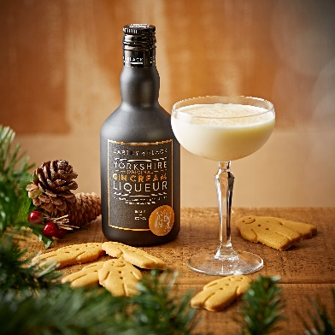
- Tipsy Gingerbread Man
- 50ml Carthy & Black Original Gin Cream
- 15ml Kings Ginger
- 20ml Double Cream
- 1 Egg White
- 10ml Sugar Syrup
Shake all ingredients without ice for 30 seconds. Add ice and shake again until chilled. Strain into a coupe glass and garnish with some gingerbread men!

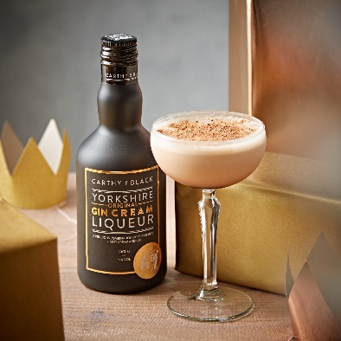
- Tiramisu Served Straight Up
- 50ml Carthy & Black Original Gin Cream
- 10ml Chocolate Sauce
- 15ml Kahlua
- 10ml Double Cream
- 10ml Semi Skimmed Milk
Add the chocolate sauce to the bottom of a martini glass. Shake the Kahlua and Original Gin Cream and layer it on top. Shake the cream and milk until slightly thick and layer again on top. Garnish with grated chocolate and lady fingers.

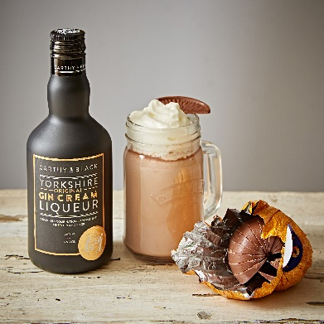
- Hot Chockin’ Orange
- 50ml Carthy & Black Original Gin Cream
- 25ml Cointreau
- Hot Chocolate
Mix all ingredients together and garnish with mounds of whipped cream and Terry’s Chocolate Orange segments.

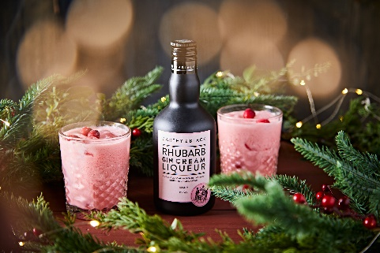
- Twig & Berries
- 50ml Carthy & Black Rhubarb Gin Cream
- 15ml Frangelico Liqueur
- 25ml Cranberry Juice
- 10ml Sugar Syrup
- 15ml Grenadine
Shake and strain over ice in a rocks glass. Garnish with frozen cranberries.

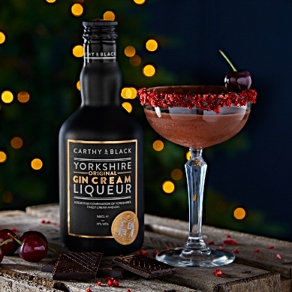
- Merry Cherry
- 50ml Carthy & Black Original Gin Cream
- 20ml Maraschino Liqueur
- 75ml double cream mixed with melted chocolate (melt down 5 squares of dark chocolate and mix with 200ml double cream)
- Chocolate sauce and freeze-dried raspberries for the rim
Firstly, prepare your martini glass by dipping into chocolate sauce then freeze-dried raspberries to decorate the rim of the glass. Then add the C&B, Maraschino Liqueur and cream and chocolate mix to a cocktail shaker. Shake with ice then strain into the glass and enjoy.

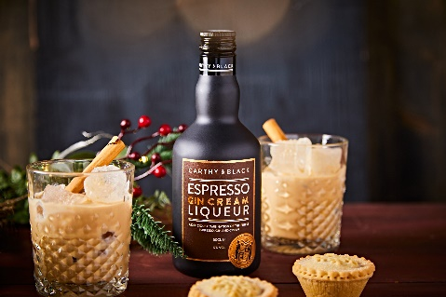
- Pumpkin Spice White Russian
- 50ml Carthy & Black Espresso Gin Cream
- 50ml Cream
- 25ml Pumpkin Spice Syrup
- 25ml Vodka
Shake all ingredients and serve in a rocks glass with ice. Garnish with a smoking cinnamon stick.

