Personalised Christmas gifts that celebrate treasured memories
Put the magic into Christmas this year by treating your loved ones to a gift that is completely unique and meaningful to them. Whether you’re shopping for a sentimental gift for a partner, something thoughtful for a friend or a gift that will stand out, photo printing experts CEWE has the perfect gift to help them celebrate their favourite memories this festive period.
Photobooks
The CEWE PHOTOBOOK is Europe’s number one photobook with a range of unique product features that make them even more special and personal. This includes highlights for a special touch, the ability to add videos via a QR code and a map location of a special place. They can also be beautifully presented with a personalised slipcase and a gift box, making them an ideal gift.
Large Landscape Photo Book – from £21.99
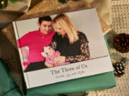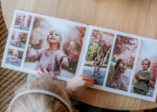

The perfect sentimental gift that shows them just how much you care this Christmas. With every page, they’ll be filled with joy as they get to look back at their favourite memories and moments shared. This large photobook would make the perfect gift to display wedding photos, travel memories or as a recollection of the last year’s family occasions in a yearbook.

Small Square Photo Book – from £8.99

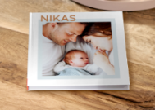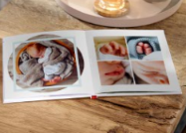

This photobook has a fresh, modern look that’s ideal for displaying a small selection of your favourite images - making it the perfect choice to showcase memories from family celebrations or photos with friends. It can be designed quickly and easily, so is perfect for creating photo books to gift to the whole family and celebrate any occasion together. They’ll be blown away when they get to look back at their cherished memories.

XXL Landscape Photobook – from £59.99
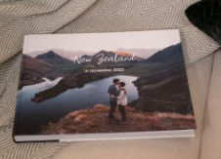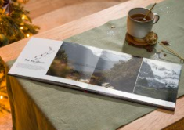
If you really want to go the extra mile this Christmas, gift them a XXL photobook that will fill them with joy with every page turn as they get to look back on fond memories. This book would be ideal for the ultimate trip down memory lane to display a large selection of photos, whether that’s a wedding, travel memories or milestones throughout the years. It is also available in portrait or square format to suit your style.
Calendars
Desk Calendar – from £10.99
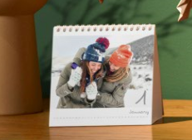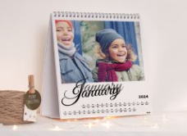
Help them to brighten up their desk at home or in the office with a Desk Calendar. Complete with 12 photos, the calendar can be filled with memories that are sure to put a smile on their face from holiday memories to family occasions. This calendar will add a personalised touch and remind them of the places and people that mean the most.
Appointment Photo Calendar – from £22.99
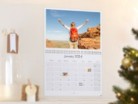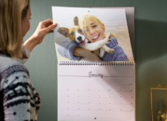
If the person you’re shopping for this Christmas has a busy schedule, then this Appointment Photo Calendar is the ideal gift for them. This calendar comes complete with two pages for each month, providing the perfect space for their favourite photos - as well as keeping track of appointments, meetings and their social calendar! They’re sure to feel organised and prepared for the new year with this calendar.

Family Photo Calendar – from £19.99
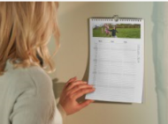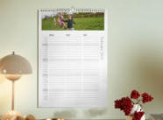
Keeping track of the whole families’ schedules can be difficult with playdates, school trips and dentist appointments that need to be on radar to name a few! Give them a helping hand in 2024 with this Family Photo Calendar, the perfect way for them to get organised for the year ahead. With enough space to add five names, and a family photo per month, you can rest assured everyone's schedules will be accounted for.
Wall Calendars – from £10.99
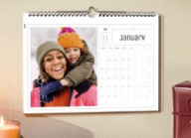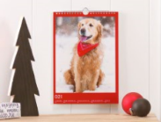
Available in both landscape and portrait formats, a wall calendar is the perfect gift to add a unique touch to any space – including their kitchen, bedroom or office. There are a range of templates to choose from, so the calendar can be personalised to suit their own style and taste. With every month they will be greeted with an image that reminds them of a treasured memory – for a gift that keeps on gifting in the new year.
Wall art
Streetmap Photo Poster – from £16.99
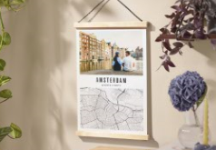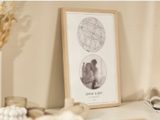
Show just how much you care this Christmas with a gift that is completely personal and unique, celebrating the unique bond the two of you share. This Streetmap Photo Poster will help you showcase your happy place whether it’s where you met, your first date or when you got engaged. It’s the perfect thoughtful gift that they can admire in their home.

Photo Poster With Wooden Hanger – from £12.98
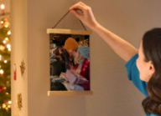
Give them a gift that they can appreciate all year round and proudly display in their home. This stylish and unique photo poster complete with a sustainable wooden hanger would brighten up any space, adding a personal touch. Choose a photo that best captures the two of you and add text of your choice.
Canvas Prints - from £13.99
A beautiful gift for a loved one to display a treasured moment in their home. Choose from a family memory, a newborn photoshoot or your favourite photo of the two of the you – it’s something that they can appreciate all year round and will brighten up any room in the house. These prints also make for a great way to create a photo collage, filled with all their favourite memories.
hexxas wall art – from £9.99
Hexxas wall tiles provide a unique gift that allows them to create a showstopping display in their home. The magnetic hanging system means they can reposition their pictures and rearrange the display whenever they fancy – the possibilities are endless! This stylish statement piece will add a personal touch to any room in their home.

ENDS

Notes to editors:
For more information, contact the CEWE PR team on cewe@prohibitionpr.co.uk
About CEWE
CEWE is Europe’s leading photo printing company, known for its passion for photography and commitment to delivering outstanding print quality. CEWE is dedicated to helping people share their memories by producing millions of personalised photo products each year.

Based in Warwick near Royal Leamington Spa, the company’s state of the art production facility houses some of the very latest in printing technology and prints photo books, wall art, calendars, gifts and more.
One of its most successful innovations is the award winning CEWE PHOTOBOOK. Drawing on 60 years of printing experience, the CEWE PHOTOBOOK has been awarded the Best Photo Service by the TIPA World Awards (Technical Image Press Association) for six consecutive years.

For more information about CEWE gifts, visit: https://www.cewe.co.uk/photo-gifts.html

