MEDIA INFORMATION
22nd October 2020

RIDE LIKE YOUR WELLNESS DEPENDS ON IT
- Commute for mind, body and soul -

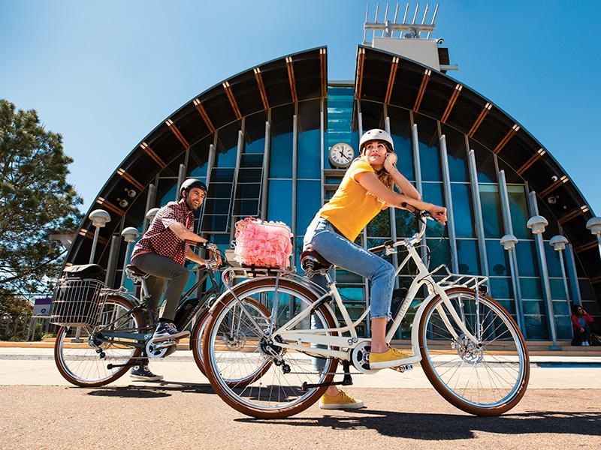

Let’s face it, 2020 has been a difficult year and it’s never been so important to focus on mind, body and soul. Getting on a bike and hitting the open road has been a source of respite for many during these troubling times. Government statistics tell us cycling to work has increased 300% over the past few months. Cycling means less time stuck in traffic, starting the day feeling energised and it’s an easy way to travel around during your day.

Cycling could not only be the easiest and quickest way to commute, but it is also much better for the environment and your wellbeing - 82% of Cycleschemers say they are less stressed in the office when they cycle to work and 48% of Cycleschemers reported feeling happier and more confident after cycling to work.
Cycling not only has a positive impact on wellbeing, but also on the environment and of course daily living costs with a reduction in parking fees, fuel and road maintenance. BikeRadar has discovered that 20 bicycles can be parked in the same space as one car, it takes around 5% of the materials and energy used to make a car to build a bike, and a bike produces zero pollution. Not only this, but bikes are efﬁcient too: you travel around three times as fast as walking for the same amount of energy and, taking into account the ‘fuel’ you put in your ‘engine’, you do the equivalent of 2,924 miles to the gallon.

Alongside mental wellness and the benefits to the environment there is of course the benefit to physical fitness. Researchers from the University of Illinois found that a 5% improvement in cardio-respiratory ﬁtness from cycling led to an improvement of up to 15% in mental tests. In fact, according to research from the University of North Carolina, people who cycle for 30 minutes, ﬁve days a week, take about half as many sick days as couch potatoes!

With the mental benefits, the environmental benefits and of course the benefits to physical fitness, surely it’s time for us all to jump on our bikes. There are plenty of bikes to pick from and your choice should be guided by your commuting needs. Whether it’s hilly or flat, or on tarmac or towpaths, you need the right tool for the job. Electra has a varied selection of lines, each model carefully designed with the ride in mind. A Loft for the city from work to yoga, or a Townie GO! for those longer early morning commutes.

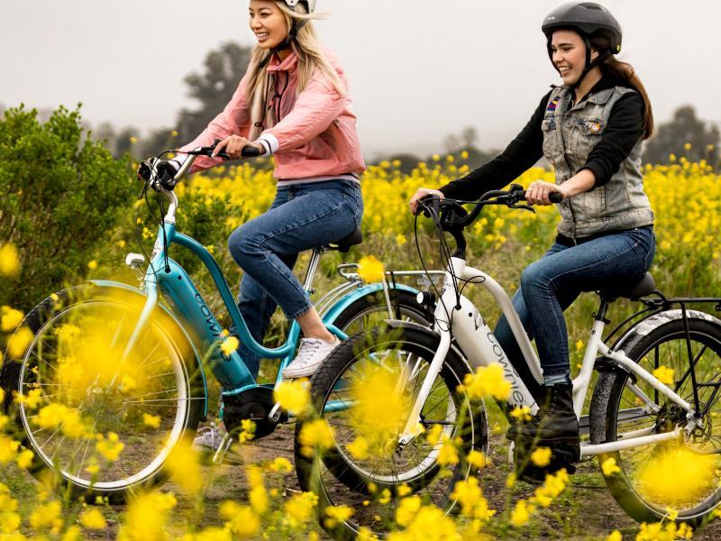

For those that are seasoned cyclists, it’s important to make sure that safety precautions are taken when on the road. Helmets, bells and reflective gear are essential - especially when commuting on roads - helping to keep both cyclists and other road users safe. Electra offers a range of helmets that are as stylish as they are safe, choose from a variety of styles and colours, with or without MIPS (Multi-directional Impact Protection System) technology.

As we look to 2021 we expect to see more and more people hit the road and jump on their bikes, it’s time to commute for mind, body and soul.

Way to roll…

Shop online https://www.trekbikes.com/gb/en_GB/bikes/electra-bikes/c/EB100/
Facebook: https://www.facebook.com/ElectraBicycleCompany
Instagram: https://instagram.com/electra_bicycle
Vimeo: https://vimeo.com/118342551

Ends
Editor’s Notes

Issued on behalf of Electra by In The Bag PR
For more information please see www.electrabike.com
For further information please contact; Sophie Kermani, Director – In The Bag PR
TEL: 07739554794 and EMAIL: sophie@inthebagpr.co.uk

Helpful links
- Use our Store Finder to find your local Electra retailer or to book a service with our master mechanics.
- Electra City bikes
- Electra ebikes

Electra Bicycle Company is the leading lifestyle bicycle brand in the U.S. They make bikes to ride - not like 45 miles in tight shorts and clicky shoes ride - just ride. Everyone has a place to go and it’s way more fun on an Electra. The Southern California-based company boasts some of the most comfortable and beautiful bicycles on the market today, fuelling their growth throughout Europe, Asia Pacific and Latin America. Their accessories and signature bike collections – Loft™, Cruiser and Go! E-bikes - come in a variety of colour palettes and playful personalities for those ready to outrun boring. While Electra is serious about making bikes, they aren’t so serious about riding them, making them the official bike of nothing official.

Helen Guesford – UK
Marketing Manager UK
Trek | Electra | Bontrager
Trek Bicycle Corporation Ltd
TEL: +44 (0) 1908 360160
Helen_Guesford@trekbikes.com

