PRESS RELEASE

Dualit Introduces Versatile Espresso Coffee Machine for
Barista Quality Coffee at Home
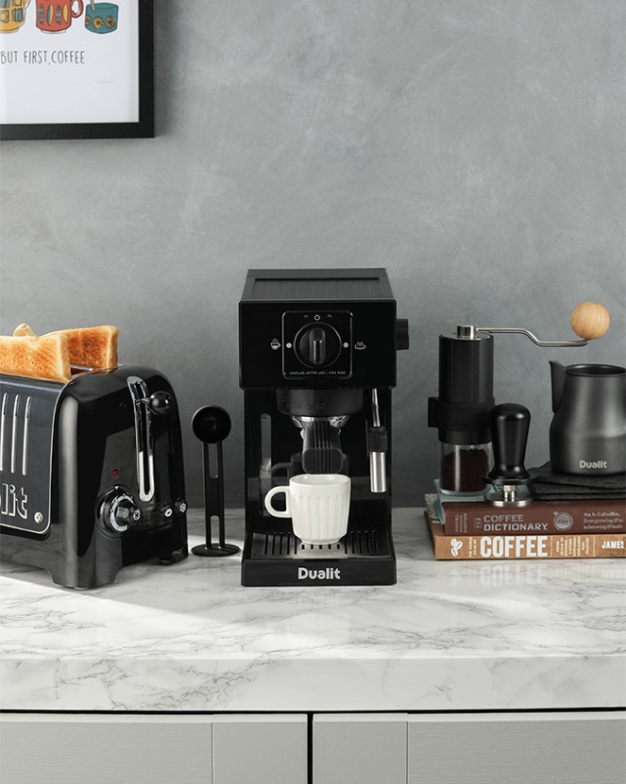
Dualit Espresso Coffee Machine in Black – Price Guide from £149.99

As people look to invest in appliances that improve their day-to-day, the coffee machine is an essential for those working from home on a more regular basis. Iconic British appliance brand, Dualit is pleased to announce the launch of its Espresso Coffee Machine, boasting coffee-shop standard quality without the fuss. It is fast, easy to use and makes consistently good coffee all in a sleek and compact design that won’t take up too much space on the worktop.

Dualit’s Espresso Coffee Machine is compatible with both freshly ground coffee or mess-free ESE pods and has a powerful, built-in boiler that heats water and creates steam. It has an impressive capacity to extract between 10-15 espresso shots or steam enough milk for two lattes before the boiler will need to re-prime. The built-in boiler also helps to maintain a consistent water temperature so each espresso will extract at the optimal temperature.

The machine comes with two different sized portafilters to make either one cup or two cups of coffee, is ready to use in just 90 seconds and can produce a single espresso, double espresso or two single espressos at the simple turn of a dial. Benefitting from a 20 Bar pump that ensures a perfect crema every time, the machine also includes manual dosing for ultimate control over coffee extraction. When a cup has been filled to the desired level, simply stop dispensing.

Catering to the needs of all kinds of coffee lover, an easy-to-use Milk Frother is on board to create a range of indulgent drinks with lashings of froth, such as cappuccinos, lattes, hot chocolates or even babycinos! However, not everyone likes a frothy coffee so Dualit’s Espresso Coffee Machine can simply steam milk instead, enough to liven up a classic Americano.

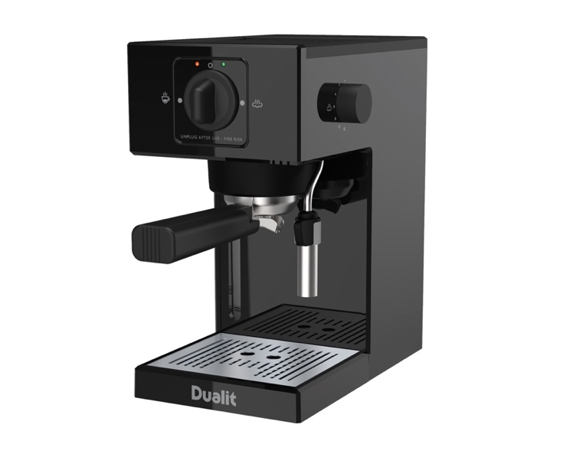
Dualit Espresso Coffee Machine in Black – Price Guide from £149.99

This versatile counter-top addition can also dispense hot water for brewing tea or making longer hot drinks. It features a 1.4L water tank and a handy water tank level indicator on the front of the machine to alert users when a refill is required. A build-up of limescale can cause issues with the efficiency of a coffee machine as well as affecting the taste of the coffee, so Dualit has included a water softener bag within the box to help soften the water to reduce limescale build-up.

Perfect Partners

ESE Coffee Pod Flavours
Dualit’s mixed and single origin coffee pods combine the flavours of Central and South America to deliver tasting notes that linger on the palate. ESE Coffee Pods are compatible with ESE Pod Machines including Dualit’s 3 in 1 and Espress-auto coffee machines.

Colombian – Price £19.99
A single origin coffee, infused with notes of sweet tangerine, raw sugar and roasted walnuts. It’s smooth and light with a refreshingly mellow, clean character and a citrusy aroma.
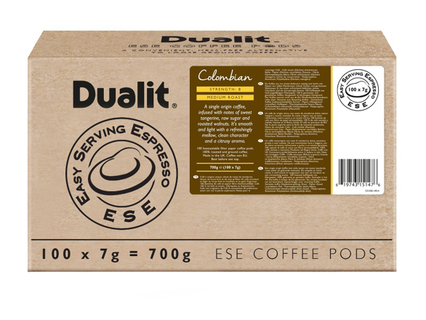

Intense Espresso – Price £19.99
A dark roasted blend of high grown Central and South American coffees that is rich and dramatic, offering notes of sweet fruits and roasted nuts, with a chocolatey finish.
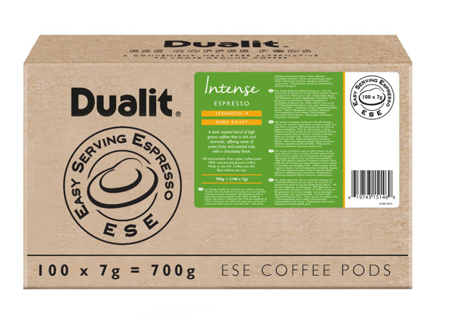

Lungo Americano – Price £19.99
Lungo is grown in rich, volcanic soil, with cedar notes, sweet tropical fruit aromas and a rich, indulgent finish.
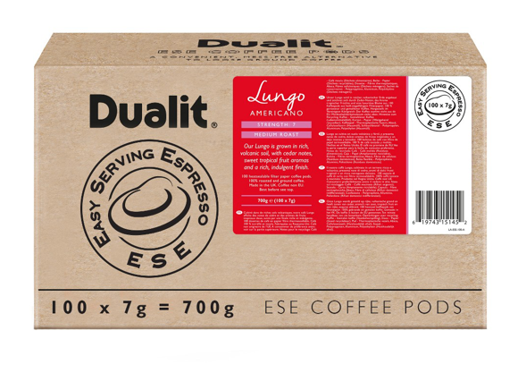
Decaf – Price £24.95
Decaf is a light bodied coffee with a very mild acidity, delivering subtle chocolate notes, a sweet, nutty finish and a refreshing piquant taste.
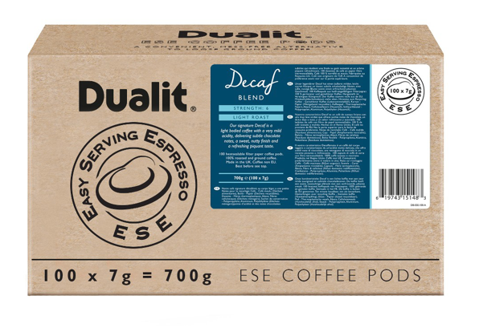

Stockists
Available exclusively from Dualit, www.dualit.com and Amazon

ENDS
Notes to Editors
For more information, high resolution images or samples for review, please contact: Sophie Anderson or Francesca Sanchez at Sellers PR on 01962 977 950 or email: sophie.anderson@sellerspr.com l francesca@sellerspr.com

