Style and Play at the NEW
Sylvanian Families Pony Stylish Hair Salon!

Step in to the new Sylvanian Families Pony’s Stylish Hair Salon and hone your hairdressing skills on Sally the Pony Girl!
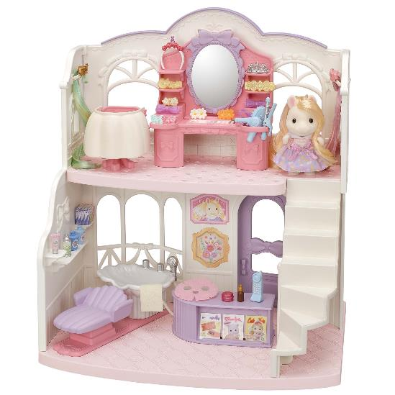
Pick a hair style from the styling book and give Sally a makeover while sat at the beautiful dresser. Wash, brush and blow dry her long, silky mane before using a curling iron. Then, finish by adding cool extensions and cute clips! Afterwards, treat her to a pampering face mask, and use the colourful cosmetics to apply a slick of lipstick and a sweep of eyeshadow.
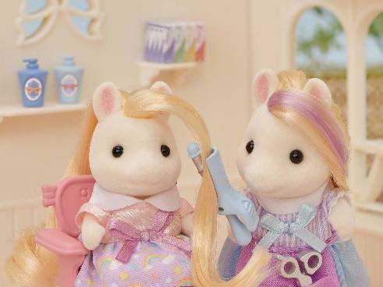
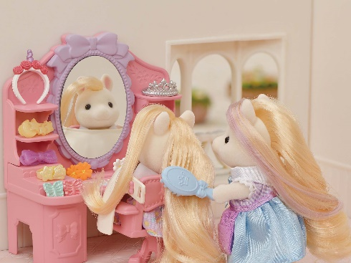
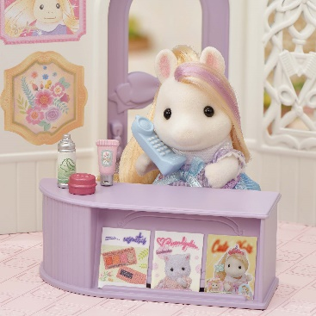

The centre of Sylvanian Families’ new ‘Style & Play’ theme, the highly detailed two-storey beauty salon features a shampoo station with shower head on the side of the sink, hair and make-up station, and reception desk.

It also comes with over 30 cute accessories for imaginative hair and makeup role play including hairbrush, hair dryer, curling irons, face mask, make up palettes, hair bands and clips. Arrange them all neatly on the dresser and hang the extensions up on the salon walls.

Pair with the Pony's Hair Stylist Set for even more creative styling fun. Featuring a cart, hair accessories, and Pony mother, Serafina, the silky-haired hairdresser, accessories are the star of the show in this set. It includes everything you need to brush and style Serafina’s hair; from a curling iron to a headband.
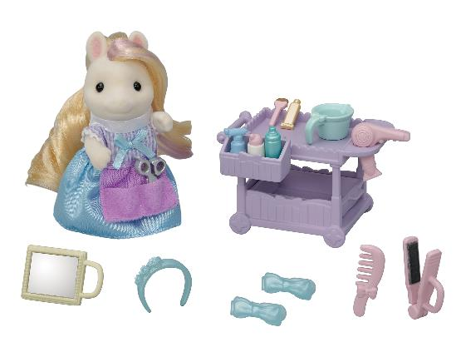

Sylvanian Families are suitable for ages 3+

- The Pony Stylish Hair Salon, RRP £69.99, and the Pony's Hair Stylist Set, RRP £22.99, are available from sylvanianfamilies.co.uk, Smyths, Very, John Lewis and Selfridges.

For further information please visit www.sylvanianfamilies.co.uk

- ends –

Sylvanian Families is a 37-year-old brand built on the pillars of nature, family and love which has been delighting children for over two generations.

For Further Press Information:
Please contact Playtime PR:
Claire Down – claire@playtimepr.com – 07786430077
Kelly Jones– kelly@playtimepr.com – 07717214040

