RUSSELL HOBBS LAUNCH BRAND NEW ATTENTIV TOASTER DESIGNED TO MAKE BURNT TOAST A THING OF THE PAST
The brand-new attentiv Toaster from Russell Hobbs makes toasting a breeze using Colour Sense Technology to achieve your perfect level of browning
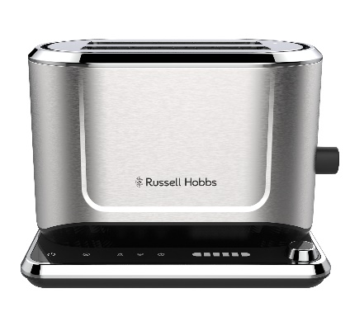

Russell Hobbs, one of the UK’s leading and most loved household brands, has announced the release of its brand new attentiv Toaster. Available in major retailers across the UK, the attentiv Toaster is a must have for toast lovers everywhere!
The attentiv Toaster’s colour technology automatically adapts the toasting time to your bread type, stopping the toasting cycle when the correct shade has been achieved. The innovative technology of the toaster monitors the bread type, moisture content, gluten content, thickness along with the thickness and freshness of the bread – simply choose your preferred browning level and let burnt toast become a thing of the past.
Plus, the attentiv Toaster remembers the settings used last, even after it has been unplugged. So, whether you love sourdough, bagels, or day-old white bread, this toaster will get the shade of golden perfection just the way you like it. The attentiv toaster also features longer and wider slots to fit a whole range of different breads and sizes, putting an end to half toasted slices!
With a touch screen interface and frozen, reheat and cancel functions this user-friendly toaster offers complete control for all your toasting needs.
Cira Jones, Assistant Brand Manager at Russell Hobbs, comments: “The new attentiv range has been designed with personalisation in mind, to make breakfast time just right for everyone. Everyone has a personal preference on the perfect slice of toast along with the ultimate cuppa, and this range makes life that extra bit easier with its high-tech features. This is one of our most advanced kettle and toaster sets ever produced and we’re confident customers will love it.”
The attentiv Toaster is available to buy from uk.russellhobbs.com. For further information please visit uk.russellhobbs.com.
-ENDS-
Notes to Editors
For more information, please contact russellhobbs@hatchpr.co.uk
Product Features
- Touch control
- Colour Sense technology
- Traditional mode
- Favourites memorised
- High lift
- Long and wide slots
- Frozen, Reheat and Cancel functions
- Bun warmer
- Deep crumb tray

About Russell Hobbs
Every ingenious Russell Hobbs creation is here to help you do you. That’s because we’re inspired by the things that matter to you.
Just-in-time brews. Tackling creases on your own terms. Giving new recipes a go. We get what’s important, especially when life’s hectic and, let’s face it, far from perfect. That’s why our ideas are beautifully British and ready for living.

