Gift Guide under £10

Looking for a unique gift for kids for under £10? STEM robotics toy manufacturer HEXBUG has a range of collectible toys and playsets that don’t break the bank.

The full range is available now on Amazon and the HEXBUG website, as well as Smyths Toys, The Entertainer, Toymaster and other local independent retailers.

Junkbots Trash Bin
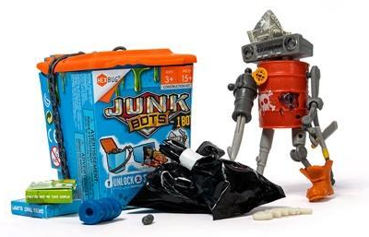
RRP: £4.99
Dig through the rubbish to discover the hidden treasure and clues in their unique trash bin packaging. When they have all 15 pieces, they can build their very own Junkbot character. There are 36 Junkbots to collect! Discover them all for amazing mix-and-match action, allowing kids to create completely new characters too.

Junkbots Dumpster
RRP: £9.99
Dig through the trash to reveal the hidden treasures and pieces to build their very own Junkbot. There are 30 pieces inside, which build two different Junkbot figures. Or, create a new design by fitting together the pieces in a totally new way. There are over 36 Junkbots to collect in the range.

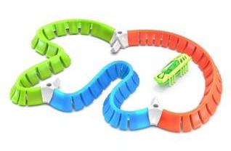
HEXBUG nano® Flash Starter Set
RRP: £7.99
This build-it-yourself mini playset features three jelly walls, three connectors and of course a HEXBUG nano® Flash.

HEXBUG nano Glow in the Dark
RRP: £3.99
The robotic creature that behaves like a real bug and glows in the dark, now the fun can come to life during the day or night! This robotic bug uses the physics of vibration to skitter along and explore its environment on smooth surfaces.

Mobots: Mimix
RRP: £8.99
Mobots are your interactive robotic sidekicks. Talk to them to record your voice – they can play it back, and even modify it with effects! The Mobots can speed up or slow down the playback of your recording. Use the voice effects to make yourself found like a robot and change the pitch from low to high. Mimix is the posable friend who can repeat what you say and modify your voice recording.

HEXBUG Beetle
RRP: £9.99
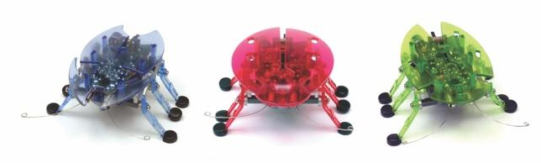
The HEXBUG Beetle crawls around, sensing objects in its path and avoiding them using its bump sensor feelers. With the clap of your hands, you can make the Beetle change direction and watch as it scurries away. Available in blue, red and green.

The full HEXBUG range is available now on www.hexbug.com and Amazon.

ENDS

For further information, please contact Laurissa Hackett (laurissa@fullvolumepr.co.uk) or Cait Naven (cait@fullvolumepr.co.uk) at Full Volume PR.

