MAKE MEALS FASTER AND EASIER WITH RUSSELL HOBBS’ BRAND NEW SATISFRY AIR & GRILL MULTI COOKER
Russell Hobbs has launched its brand-new SatisFry Air & Grill Multicooker so you can cook up a storm in confidence

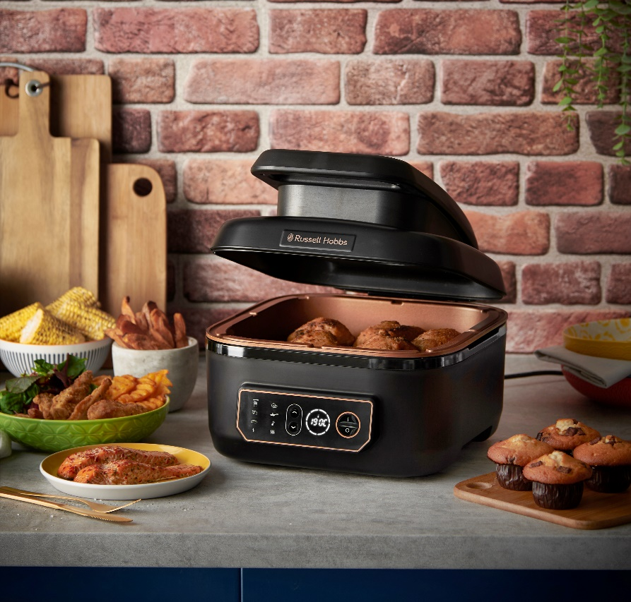

Russell Hobbs, one of the UK’s most popular household brands, has revealed its brand-new SatisFry Air & Grill Multicooker for 2022. The SatisFry - available in major retailers across the UK from August - has eight cooking functions so you can cook with confidence, whether you’re air frying, roasting, baking, slow-cooking (low and high), searing, grilling or simply keeping meals warm.
The SatisFry Air & Grill Multicooker produces up to 70% faster results than previous models and is up to 76% faster than a conventional oven, so you can have delicious and nutritious meals in no time at all!
Most other air fryers only use heat from the top of the appliance, but the Russell Hobbs SatisfFry Air & Grill Multicooker circulates air temperatures up to 260°C from the top and bottom, for even cooking and all-round searing for perfect results.
Get stuck in to not-so-naughty favourites made with little to no oil where you can reduce the amount of fat you use without compromising on taste and flavour. Try out all sorts of new dishes with seven ways to cook at your fingertips. And just stick the pot in the dishwasher* to clean up. Yes, you can do whatever you want with SatisFry.
The Air Fryer technology crisps, browns and bakes meaning meat stays succulent, and natural juices are retained during the cooking process. So, if you’re thinking of a takeaway, why not save the pennies and try guilt-free fast food from the SatisFry Air & Grill Multicooker?
The audible ready alert will help prevent any kitchen disasters like cremated chips, so even if you’re in a different room of the house, you can hear the sweet sound of dinner being ready. The SatisFry will turn off automatically after 5 minutes of no use, to save power giving you that extra peace of mind that you definitely haven’t left the appliance on. There is also an in-built heat protection feature which adds an extra layer of safety, ensuring the appliance never overheats.
The SatisFry also helps you keep the purse strings tight, using up to 44% less energy when cooking, compared to conventional oven – an overall great way to save on your energy bills.
Super easy to keep clean, the SatisFry has a removable Cooking Pot and Grill Plate which are all dishwasher safe^. The special coating on the removable grill plate is 3x more durable than a standard non-stick coating for added protection, ensuring your SatisFry stays looking brand new for longer.
The SatisFry Air & Grill Multicooker has a 5.5L capacity. There are also two smaller sized air fryers within the Satsifry family, which come in a 1.8L capacity and 5L capacity.
Caitlin Wood, UK Brand Manager at Russell Hobbs, comments “Our new SatisFry Air & Grill Multicooker offers a way to cook with confidence. With so many meal options to cook with the different cooking functions, it’s a great addition to any home. We wanted to make the SatisFry Air & Grill Multicooker easy to use for all our customers, with our intuitive touchscreen.”

-ENDS-
For more information, please contact russellhobbs@hatchpr.co.uk

*Vs previous Russell Hobbs models
^Tested on 100 dishwasher cycles
Notes to Editors
About Russell Hobbs
Every ingenious Russell Hobbs creation is here to help you do you. That’s because we’re inspired by the things that matter to you.
Just-in-time brews. Tackling creases on your own terms. Giving new recipes a go. We get what’s important, especially when life’s hectic and, let’s face it, far from perfect. That’s why our ideas are beautifully British and ready for living.

Product Spec List

- Fan circulated 360° Air Frying
- 5.5 Litre Capacity
- Additional Functions: Sear, Slow Cook, Roast, Bake and Keep Warm
- Little or no oil required
- Up to 70% faster results*
- Dishwasher safe coating^
- Adjustable thermostat with precise temperature control (60-260°C)
- Dishwasher-safe^ non-stick coated grill plate
- Dishwasher safe^ cooking pot and grill plate
- Auto shut-off function
- Audible ready alert
- Overheat protection
- Non-slip feet
- Intuitive touchscreen digital display
- 1745W

