“It’s-a-me! Mario!”
Two exciting Super Mario Games to launch ahead of new movie release!

The much-loved Mario is back in two exciting NEW Super Mario Games from Epoch Games this season. Just in time for the new movie which hits cinemas on the 5th April, the new games are perfect for fun with family and friends.

The Super Mario Bros. Movie Route ‘n GO! (RRP £34.99)
Help Mario and Luigi navigate through the city in their plumbing van with the Super Mario Bros. Movie tie-in, Route ‘n GO! It’s a challenging, fast-paced, track ‘puzzle’ game. The aim of the game – to slide the panels to create a route for Mario and Luigi’s van to reach the goal without falling from the track! For single-mode play, try and reach the end with the least amount of moves possible! For two player mode you can play co-operatively, or you can try and hinder each other’s progress and play competitively when each player takes their turn to move the van towards the goal – the first player to get the van to the goal wins! Suitable from age 5+.
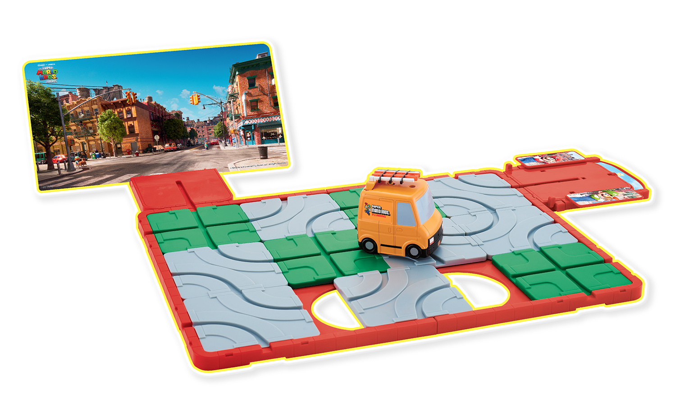

Super Mario Rally Tennis (RRP £29.99)
In this action-packed tabletop tennis rally game, players must slide their characters left and right to receive the ball and hit the button at the right time to serve and return! The scoreboard helps you keep track of the match in true tennis style so you can see who will become the Rally Tennis champion! The game comes with collectible Mario and Luigi figures that can be used interchangeably with other Super Mario games that are part of the Epoch Games Link System. No batteries required and suitable from age 5+.
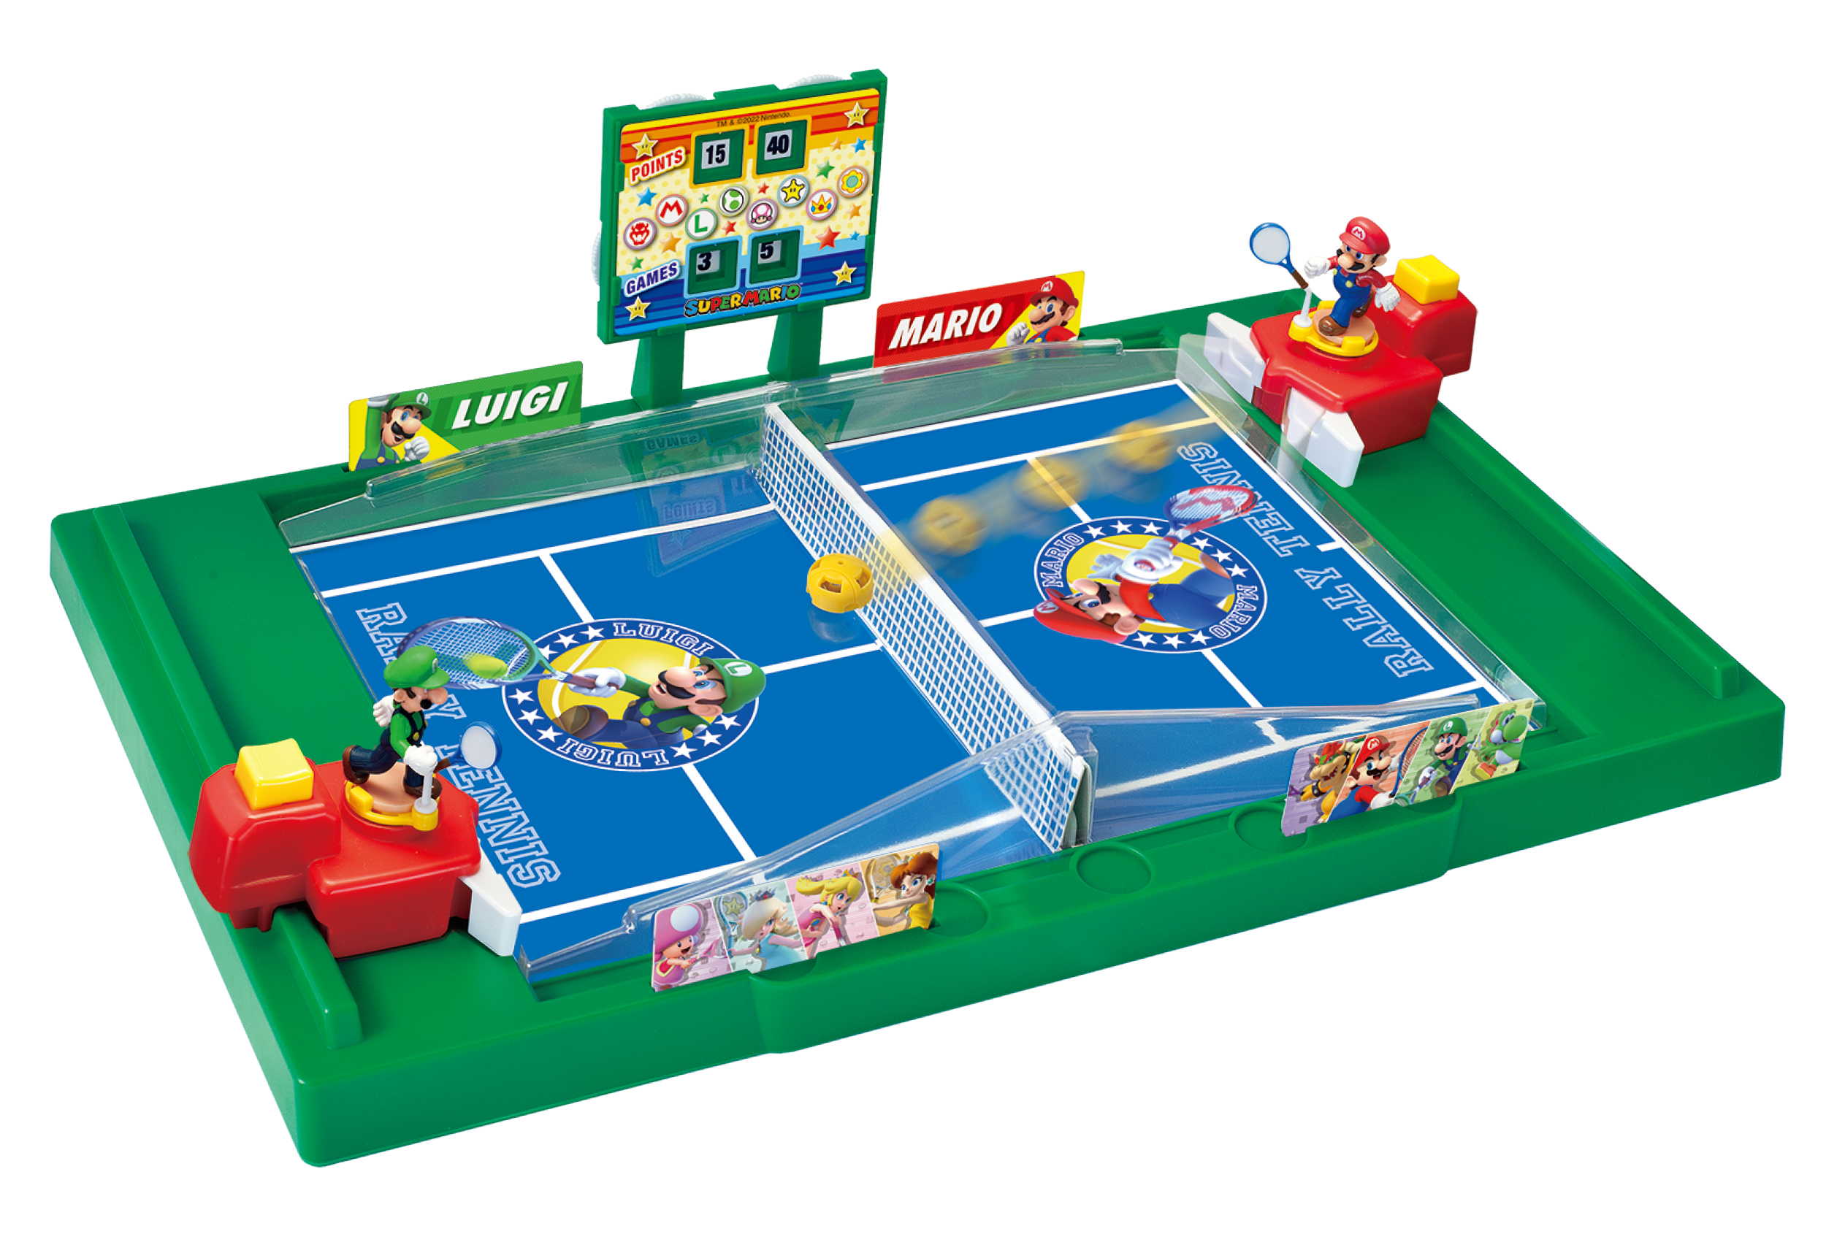

Available from Smyths.

Download images HERE.

- ends –

About Epoch Games
Super Mario™ and Mario Kart™ games from Epoch Games incorporates a range of officially licensed, exciting, and unique tabletop action and family board games based on the popular Nintendo video games and its characters.

Whether you’re racing around the track, defeating Bowser and Mario’s foes, or playing classic arcade-style games, there’s an unlimited amount of fun to be had with Epoch Games.

The Epoch Games Super Mario™ LINK System enables players to swap the highly detailed and collectible playing figures between games.

For Further Information:
Please contact Playtime PR:
Claire Down – claire@playtimepr.com – 07786430077
Mary Bobroff – mary@playtimepr.com – 07968 996782

