WITH UP TO 87% LESS SMOKE* GEORGE FOREMAN’S NEW SMOKELESS GRILL LOCKS IN THE FLAVOUR WITHOUT THE MESS
The world’s number one electric grill brand has developed a new Smokeless Grill, transforming the way we enjoy delicious grilled flavours
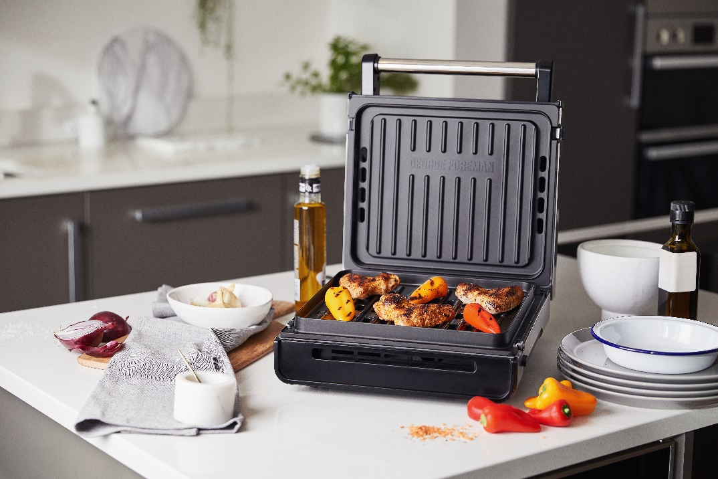
The world’s favourite electric grill brand**, George Foreman, has launched a newly developed Smokeless Grill. Developing a much-loved gadget, this new model cuts the smoke, meaning smoke filled kitchens are a thing of the past.
Now with up to 87% less smoke*, grilling experts and novices alike can cook up a feast of flavour, without smoke and grease smells filling the room. Smartly engineered Smokeless Technology whisks hot cooking juices away, cooling excess fat immediately to eliminate the burning that creates lingering smoke and grease smells.
Taking versatile cooking to a whole new level, the Smokeless Grill’s floating hinge accommodates up to a 1.5” cooking height, meaning you can cook a variety of meats, fish, vegetables and more, making this grill the best kitchen companion, no matter what’s on the menu.
The functional Smokeless Grill not only delivers on flavour, but packs a punch on style too, with a premium stainless steel finish to complement your kitchen countertop, bringing a contemporary feel to every kitchen.
Ideal for modern lifestyles, the Smokeless Grill cooks up flavoursome food in record time. Designed to cook 3x faster***, and 70% more energy efficiently than an oven***, this grilling machine ensures a mean dish can be served to the plate in minutes.
Aside from premium performance, the Smokeless Grill is loaded with features to make food prep easy. With an advanced non-stick coating and dishwasher safe removable grill plates, cooking with the Smokeless Grill is an effortless and mess-free experience, allowing more time for achieving the perfect dish, no matter what your preference is.
Cira Jones, UK Assistant Brand Manager at George Foreman comments: “The new Smokeless Grill is an exciting addition to the already popular roster of George Foreman grills. For those looking to transform their cooking experience, without compromising on flavour, this is definitely the product to try.”
For some mouth-watering recipe inspiration visit: https://www.georgeforeman.co.uk/recipes
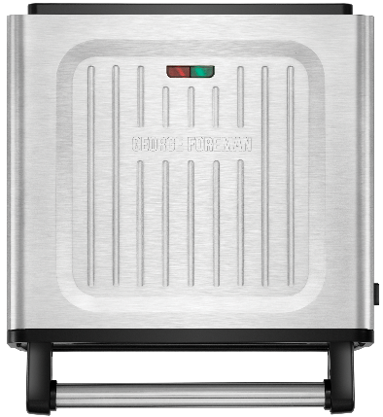

RRP: £129.99
Available from: Amazon
-ENDS-

For more information please contact Fergus Murphy at: george@hatchpr.co.uk
Notes to Editors

*vs George Foreman Classic Grill 24330/56 when grilling 20% fat content beef burgers (113g) with a clean grill and drip tray
**Market research institutes. Consumer Appliances 2019, per electric grills category

***vs a conventional electric oven when grilling 20% fat content beef burgers (113g) at 190°C
About George Foreman

Product Features:
- Premium look stainless steel grill
- Removable, dishwasher safe grill plates
- Removable, dishwasher safe drip tray (drawer with side access)
- Smokeless technology
- Integrated vents
- Floating hinge (accommodates up to 1.5” cooking height)
- Single temperature
- Red/green indicator light
- Handle - straight rod w/ plastic caps
- Closed top, open bottom grill plates

