THE BEST VALENTINE’S DAY GROOMING GIFTS FOR HIM
With Valentine’s Day just around the corner, now is the perfect time to start thinking about what to treat your partner this 14th February.
Bored of the classic chocolate box and bottle of his favourite tipple? Why not treat him to a new gadget from grooming connoisseurs, Remington. From electric shavers and hair clippers to ultimate precision hybrid groomers, Remington has got the tool to help every man look sharp this Valentine’s Day.
OMNIBLADE PRECISION
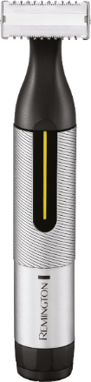
Does he like to keep his look clean-cut? Remington’s Omniblade Precision Groomer offers complete precision styling with skin close cutting performance to just 0.15mm*, 2 Micro Trimmer Combs (3 & 6mm) and an adjustable precision dial comb with 10 length settings, meaning he’ll be looking super slick this Valentine’s Day.
With a stylish, sleek colourway and innovative design, and a premium travel pouch to pop it in, the Omniblade Precision is already gift-ready for your other half this February 14th. Plus, it has a 5 Year Blade Life** - it’s the gift that keeps on giving!

The Remington Omniblade Precision is available from Amazon and Argos for £69.99 RRP.
*Doesn’t shave as close as a traditional blade
**Based on 2 minutes usage, 7 days per week
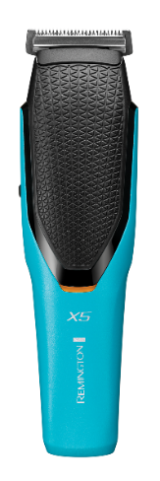
POWER-X SERIES X5 HAIR CLIPPER
Has your partner become a lockdown pro barber? Remington’s Power-X Series is the ideal Valentine’s gift for anyone who wants to confidently cut their hair from the comfort of home.
The most powerful of the pack is the X5 Hair Clipper, engineered to deliver three times the cutting performance* thanks to the powerful V3 motor.
With Comfort Glide adjustable combs (3-35mm, 0.5mm without comb), 72 Length Settings and up to 75 mins cordless run time, the Power-X Series X5 Hair Clipper delivers innovative tech and premium results.
What’s more, it’s black and turquoise colour scheme makes this present a style statement packed with the latest in grooming technologies.
The Power-X Series X5 Hair Clipper is available from Amazon, Very, Argos, Boots at an RRP of £69.99
*vs a predecessor Remington model

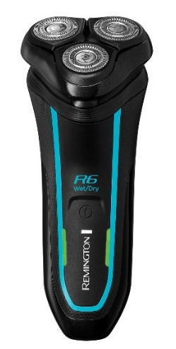
STYLE SERIES AQUA SHAVERS
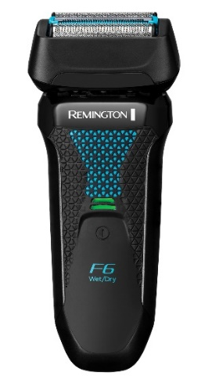
For the other halves that just want to try something new, Remington’s latest grooming innovation will certainly put a smile on his face this Valentine’s Day.
Featuring both a foil and rotary shaver, the Style Series Aqua Shavers range has got everyone covered, for a smooth, snag-free shave.
Being 100% waterproof, these handy tools will let him shower, shave and style with complete ease and less irritation, with the added benefit of easy cleaning too. The R6 Style Series Aqua Rotary Shaver boasts dual track blades that target hairs in all directions, while the F6 Style Series Aqua Foil Shaver features ControlCut Technology for a close and comfortable shave.
The ergonomic grip provides comfort and control, and both have a handy 5-minute quick charge feature for when he’s in a hurry.
R6 Style Series Aqua Rotary Shaver is available from Boots, Amazon, Very and Argos at an RRP of £109.99.
F6 Style Series Aqua Foil Shaver is available from Boots, Amazon, Very and Argos at an RRP of £109.99
ULTIMATE SERIES RX5 HEAD SHAVER
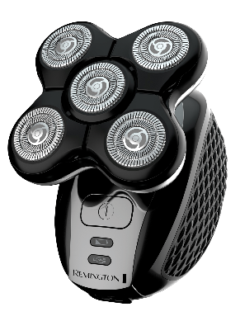
For the guys who sport the no-fuss, closely shaved look, the Ultimate Series RX5 Head Shaver is the perfect go-to gadget to gift.
The RX5 Head Shaver fits perfectly into the palm of the hand and the five cutting heads glide over the tricky contours of the head for a super quick and smooth shave in less than 2-minutes*, plus it’s 100% waterproof too.
Cleaning up also won’t be a problem after shaving, as the RX5 Head Shaver also comes with an easy to clean hair pocket that collects all the hairs, ensuring minimal mess in the bathroom. Result!
The Ultimate Series RX5 Head Shaver is available from Argos and Amazon at £62.99 RRP.
*On 2 days growth (1mm).

ENDS
For further information, high-res product images and samples please contact remington@hatchpr.co.uk or call 0113 361 3600.
About Remington
As a division of Spectrum Brands Holdings powered by innovation, Remington has been helping the world get ready for 80 years. We pride ourselves on being at the very cutting-edge of technology and work with top salon professionals from all over the world to produce electrical personal care products that really work, care for you and deliver superior results every single time. For more information about Remington, please visit www.remington.co.uk.
About Spectrum Brands Holdings, Inc.
Spectrum Brands Holdings (NYSE: SPB), a member of the Russell 1000 Index, is a global and diversified consumer products company and a leading supplier of residential locksets, residential builders' hardware, plumbing, shaving and grooming products, personal care products, small household appliances, specialty pet supplies, lawn and garden and home pest control products and personal insect repellents. Helping to meet the needs of consumers worldwide, our Company offers a broad portfolio of market-leading, well-known and widely trusted brands. In Europe, these brands include Remington, Russell Hobbs, George Foreman, Tetra, 8in1, FURminator, IAMS and Eukanuba, DreamBone and SmartBones. For more information, visit www.spectrumbrands.com.

