THE DISHWASHER MISTAKES THAT COULD COST YOU: THREE THINGS TO ALWAYS WASH BY HAND
This key appliance might be damaging your favourite kitchen staples without you even realising it – here’s what the experts say
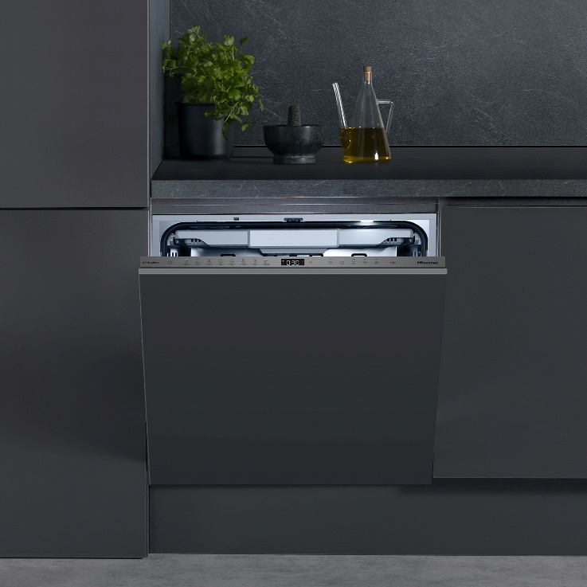
You might think your dishwasher can handle anything you throw at it, but while it may be one of the hardest-working appliances in the kitchen, there are some everyday items that simply aren’t built to survive a dishwasher’s high heat, harsh detergents, and powerful water jets. Put them through a cycle and you could be left with cracked plastics, warped wood or even rusting metal.
According to appliance experts at Hisense UK, there are three surprising kitchen utensils you’re most likely cleaning in your dishwasher, that in reality you should always keep out if you want them to last:
1. Plastic food containers (like Tupperware)
It might feel easy to throw in your lunch Tupperware or leftover containers for a quick wash in the dishwasher, but many plastics can’t withstand repeated exposure to a dishwasher’s heat. Over time, lids can warp, containers can crack, and colours fade, making them less airtight, less hygienic, and far more likely to break.
2. Wooden utensils and spoons
Wood and water don’t mix well. The intense heat and moisture inside a dishwasher can cause wooden spoons and spatulas to swell, crack, and even harbour bacteria in the splits. Before long, your trusty wooden utensils will lose their smooth finish and could become a breeding ground for germs.
3. Stainless steel and metal-rimmed items
From mixing bowls with a metal edge to stainless steel mugs, the dishwasher’s detergent and hot water can cause deterioration, rusting, and discolouration. That shiny metal finish won’t stay sleek for long and once corrosion sets in, it’s impossible to reverse, causing regular replacement of those kitchen items.
While it’s tempting to take shortcuts; a little extra effort at the sink can save you money and protect your kitchenware in the long run. When it comes to the items that are dishwasher-safe, choosing the right model can also make all the difference in protecting and cleaning your utensils. The Hisense HV693A60UVADUK Integrated Dishwasher includes advanced UV and ion technology, going further than a standard clean by neutralising bacteria and mould for superior hygiene, and its energy-efficient A rating and seven versatile programmes ensures spotless results, protecting your kitchenware.
Chloe Blanchfield, Product Marketing Manager at Hisense, said: “Dishwashers are brilliant for saving time and ensuring hygienic results, but not everything belongs in one. Plastic containers, wooden utensils, and metal-rimmed items in particular should always be washed by hand if you want them to stay safe, functional, and long-lasting.
“Choosing the right dishwasher model can make all the difference in ensuring all items in the appliance are protected yet cleaned to perfection.”
For more information on Hisense’s dishwasher range, please visit: https://uk.hisense.com/.

ENDS
For more information, please contact the Hisense UK team at Hatch: hisense@hatch.group / 0113 361 3600.
About Hisense
Founded over 50 years ago in China in 1969, Hisense is a leading global home appliance and consumer electronics brand and was Official Partner of the UEFA EURO 2024™, following on from past tournament sponsorship in 2016 and 2020, and a successful sponsorship of FIFA World Cup 2022™.
Hisense UK is headquartered in Leeds. The brand has a core range of televisions and cooling appliances, alongside a portfolio of cooking and laundry products, featuring hobs, hoods, ovens, dishwashers and washing machines.
According to Omdia, Hisense ranked No. 2 globally for TV shipments and No. 1 in 100" TVs in both 2023 and Q1 2024. The company has expanded quickly to operate in more than 160 countries and specialises in multi-media goods, home appliances, and intelligent IT information. Hisense continuously invests in research and development and has over 100,000 employees worldwide. For more information visit https://uk.hisense.com/

